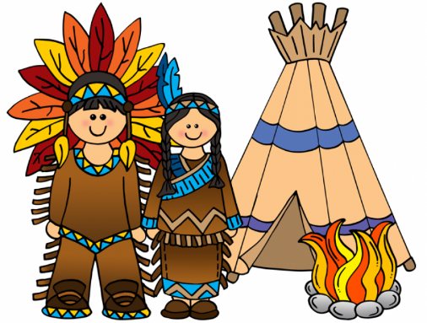
A NATIVE AMERICAN
SPEAKS OUT

a member | član
a tribe | pleme
tribal (adj.) | plemenski
grow up | odrasti
a reservation | rezervat
a conflict | konflikt, spor
poverty | revščina
unemployment | brezposelnost, nezaposlenost
to employ | zaposliti
a protest | protest, ugovor, nasprotovanje
a demonstration | demonstracija
a college | visoka šola, kolidž
an education (noun) | izobraževanje, šolanje, izobrazba
to educate (verb) | izobraževati, šolati, poučevati
educated (adj.)  (educated Indians) | izobražen, šolan
to cope with something/somebody | spopadati se z, shajati z,
a sunrise / sunset | sončni vzhod / zahod
a custom | navada
a goal | cilj, gol
indigenous people | avtohtoni prebivalci, domorodci
to fight for | boriti se za
to claim (back) | zahtevati (nazaj)
to be proud of | biti ponosen na

