PREVERIM, KOLIKO ŽE ZNAM
9. 12. 2021, 2. B

IME: ______________________________

Standard: Razume poimenovanja za obravnavano besedišče.

- LISTEN AND WRITE 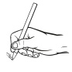 THE NUMBERS ON THE LINE.

_____, _____, _____, _____, _____, _____, _____, _____, _____, _____

- LISTEN AND CIRCLE  THE OBJECTS THAT YOU HEAR.
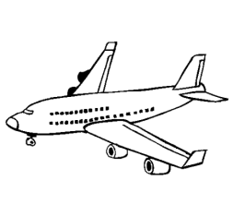

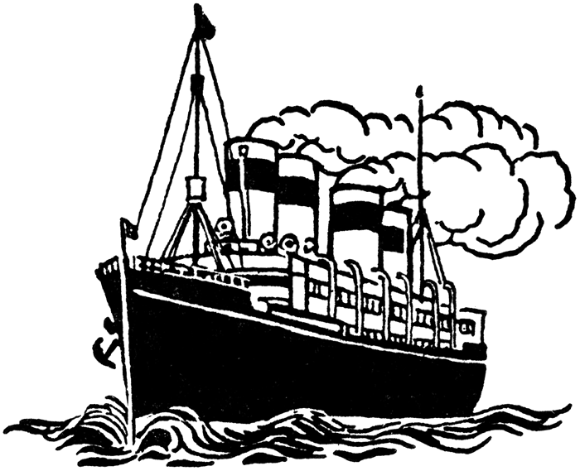
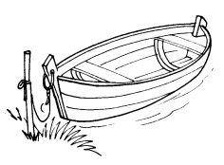
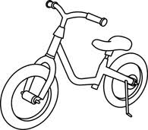
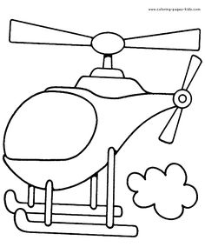

- LISTEN AND DRAW  WITH THE APPROPRIATE COLOUR.

- LISTEN AND CIRCLE THE OBJECTS THAT YOU HEAR.
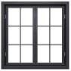

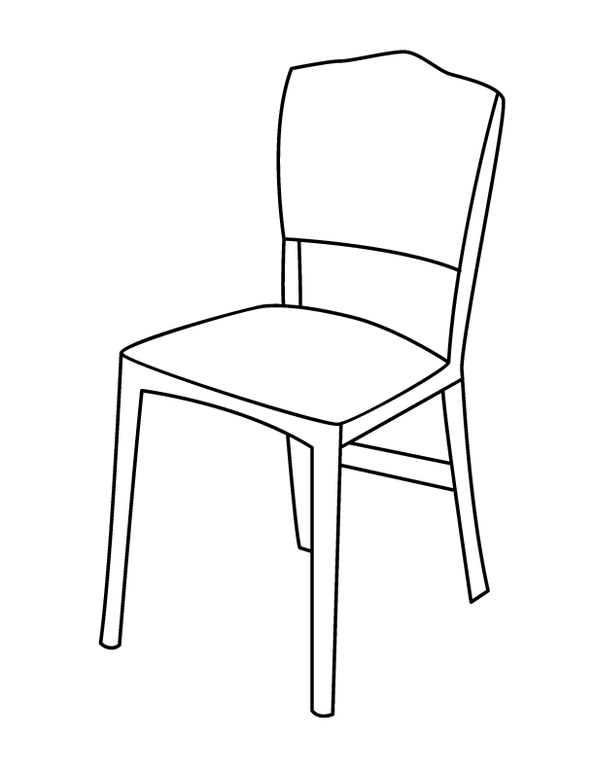
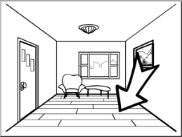

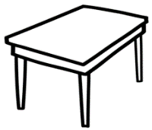

- LISTEN AND COLOUR  THE SHAPES.

- LISTEN AND DRAW THE BALOON 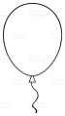:

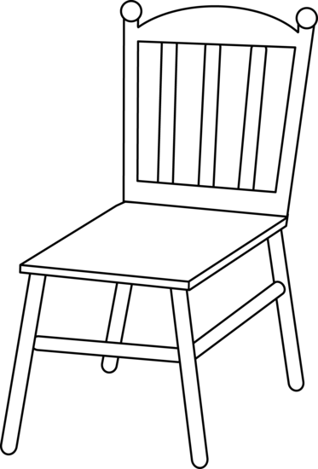

1. 5, 7, 10, 12, 3, 14, 16, 19, 17, 11
2. Obkroži: Boat, airplane, train
3. Green car, blue bus, orange bicycle
4. Obkroži: window, blackboard, floor
5. pink rectangel, red triangle, yellow circle, orange square
6. ON the chair, UNDER the chair

