OCENJEVANJE ZNANJA
2. B

IME: ______________________________

Standard: Razume poimenovanja za obravnavano besedišče.

- LISTEN AND WRITE 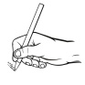 THE NUMBERS ON THE LINE.

_____, _____, _____, _____, _____, _____, _____, _____, _____, _____

- LISTEN AND CIRCLE  THE OBJECTS THAT YOU HEAR.
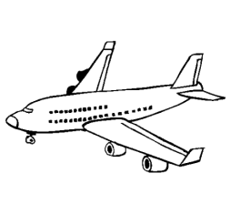
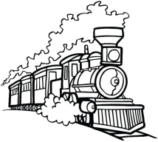
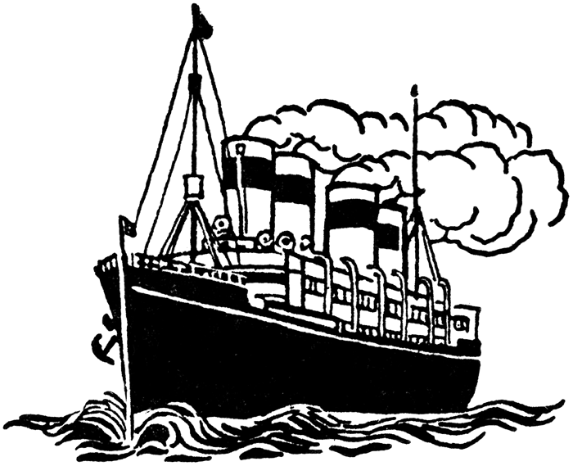
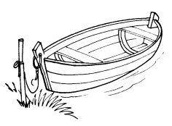
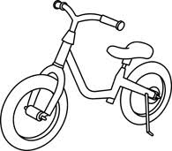
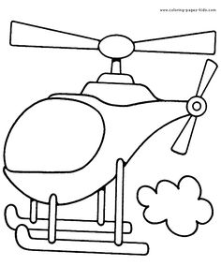

- LISTEN AND DRAW  WITH THE APPROPRIATE COLOUR.

- LISTEN AND CIRCLE THE OBJECTS THAT YOU HEAR.
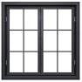
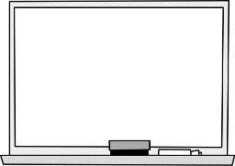
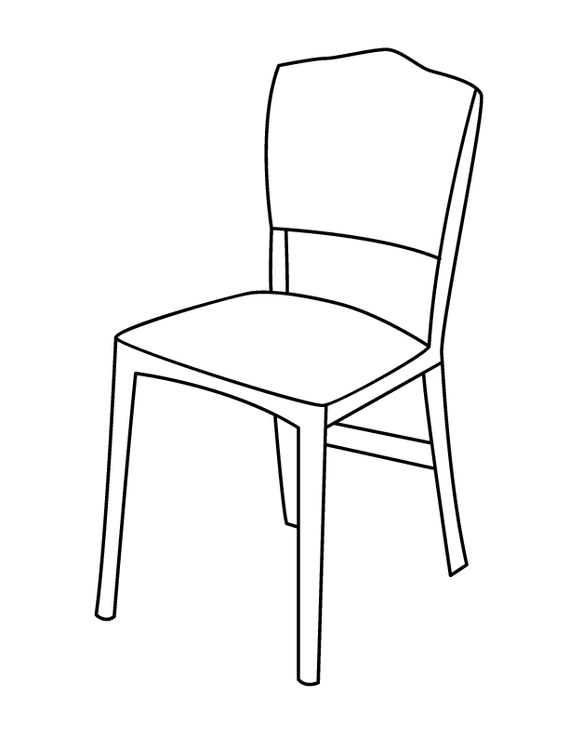
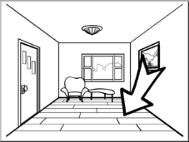

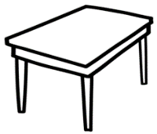

- LISTEN AND COLOUR  THE SHAPES.

- LISTEN AND DRAW THE BALOON 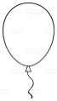:

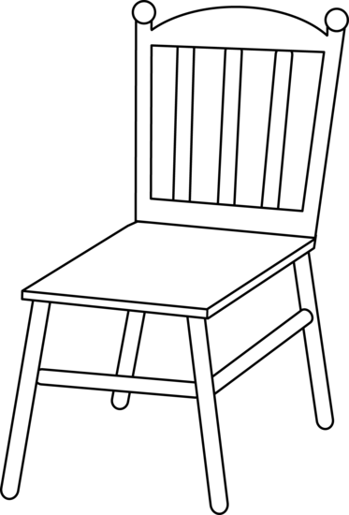

1. 18, 13, 20, 10, 11, 9, 12, 19, 14, 6.
2. Obkroži: BICYCLE, TRAIN, SHIP
3. YELLOW CAR, ORANGE BOAT, BLACK BUS
4. Obkroži: CHAIR, LIGHTS, FLOOR
5. pink rectangel, red triangle, yellow circle, orange square
6. ON THE LEFT SIDE of the chair, ON the chair

