OCENJEVANJE ZNANJA IZ ANGLEŠKEGA JEZIKA – NIP (2. in 3. leto učenja)

1. Poslušaj in na črto napiši številke.

______ ______ ______ ______ ______ ______ ______ ______ ______ ______

2. Zapiši števila z besedo ali številko.

a hundred ___________ 72 _ _ _ _ _ _ _ - _ _ _
seventeen ___________ 67_ _ _ _ _ - _ _ _ _ _
fifteen _________ 8 _ _ _ _ _
ninety-five ________ 18 _ _ _ _ _ _ _ _
forty-three ________ 12 _ _ _ _ _ _
1 Hello! | _____ It's a book!
2 What's your name? | _____ I'm Greg!
3 What's this? | _____ I’m eleven.
4 How old are you? | _____ It’s Jack.
5. How are you? | _____ Hi!
6. Do you like pizza? | ______ Yes, I have.
7. Who’s this? | _____ I’m great.
8. Have you got a car? | _____ Yes, I do.

3. Preberi in poveži. Na desno vpiši ustrezno številko.

4. Prevedi besede. (Pomagaj si s črkami v okvirčkih.)

riž ________________ (CERI) jabolko an ______________
pomaranča an _______________ (ROGAEN) (APLEP)
sladoled an ___________________ (CRICEMEA) hruška a _____________
zrezek __________________ (KTSEA) (PARE)
tovornjak a _________________ (ROLRY) čoln a _____________
sir ___________________ (ECHSEE) (BOTA)
jajca ____________________ (SGEG) žoga a _______________
punčka a ___________________ (LODL) (LABL)
grozdje ____________________ (PESGRA) kruh ________________
radirka a ___________________ (ERBUBR) (BADER)
voda ____________________ (ERWAT) kosmiči _________________
(CRAELE)
5. V okvirčke vpiši ustrezne besede.
kite bike teacher plane strawberry pen ruler glue garlic beans onion car

FOOD | TOYS | SCHOOL

6. Napiši vsaj 1 igračo, ki jo imaš in 1, ki je nimaš.
______________________________________________________________________________
7. Poglej slike in iz okvirčka prepiši ustrezne pozdrave.
Good morning. Good night. Goodbye.

Nice to meet you.

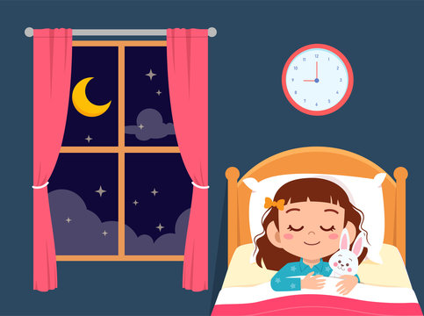



________________________ ____________________ ________________________

8. Poimenuj barve.

_ _ _ _ _ _ _ _ _ _ _ _ _ _ _ _ _ _ _ _ _ _ _ _

9. Napiši krajši pisni sestavek o sebi. (Vključi podatke: ime, kraj, država, najljubša barva, najljubša številka; Kaj imaš rad? Česa ne maraš?) Pomoč: favourite (najljubši)
_______________________________________________________________________________________________________________________________________________________________________________________________________________________________________________________________________________________________________________________________________________________________________________________________________________________________
______________________________________________________________________________________________________________________________________________________________________

