I INTRODUCE MYSELF / PREDSTAVIM SE!

HELLO!

I AM _____________. / MY NAME IS _____________. IME MI JE
I AM __________ YEARS OLD. STAR/A SEM ______ LET.
MY FAVOURITE COLOUR IS _____________. MOJA NAJLJUBŠA BARVA JE ______.

OBKROŽI PRAVI STAVEK. / CIRCLE THE CORRECT SENTENCE:
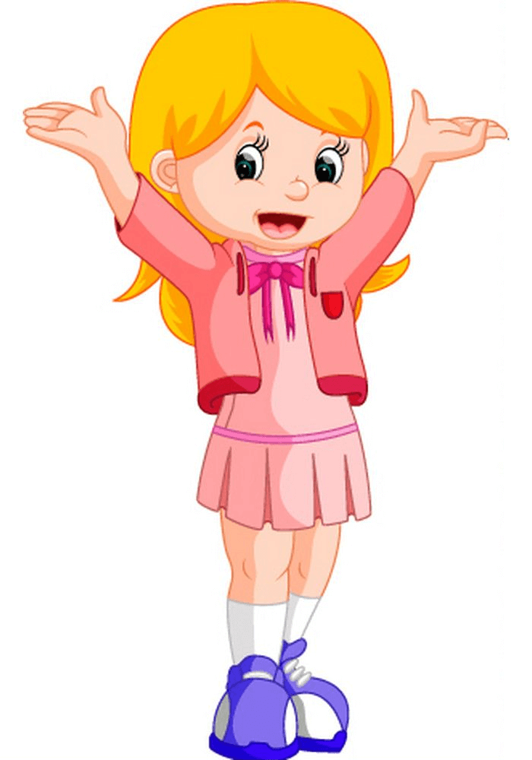
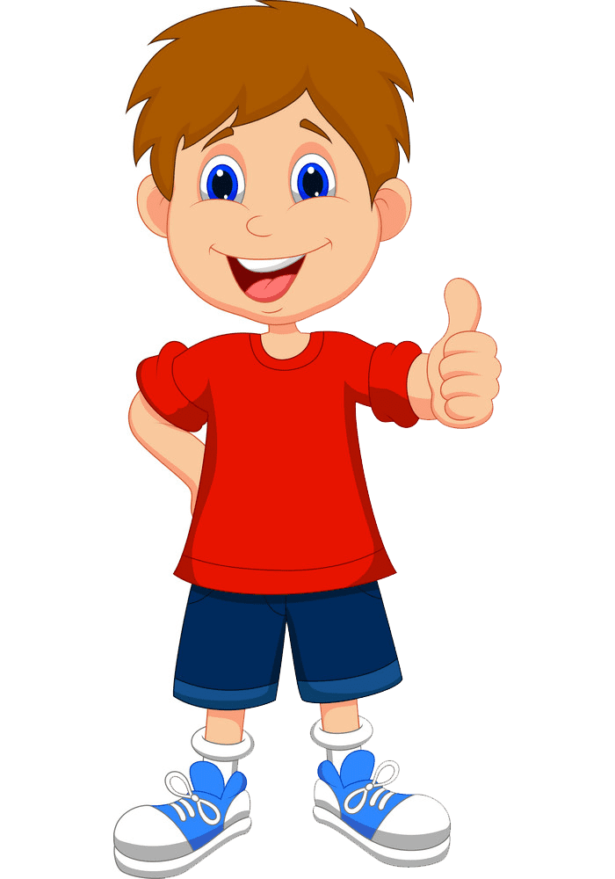
I AM A BOY. / I AM A GIRL.
SEM DEČEK. SEM DEKLICA.

I HAVE GOT A BROTHER. / (AND) I HAVE GOT A SISTER.
IMAM BRATA. (IN) IMAM SESTRO.

MY MUM'S NAME IS __________________. MAMICI JE IME
MY DAD'S NAME IS ___________________. ATIJU JE IME

