REVISION EXERCISES

Exercise 1.

a. Decide which stage of life these words relate to. Find the synonyms.

newborn grown-up adult adolescent infant pensioner toddler child middle-aged person teenager elderly baby senior citizen youngster juvenile school-aged child

b. Decide which age group the following relate to.

Career retiring learning to talk pension learning to drive starting a family university start elementary school get married
promotion

Exercise 2.

Find the synonyms.
depressed cheerful stressed frustrated relaxed joyful aggressive furious optimistic exhausted heart broken fantastic terrified pessimistic nervous

funny - sad - tense -
angry - tired - scared –
lonely - worried - calm –
glad - impatient - great –
excited - positive - negative -

Exercise 3.

Look at the horoscope signs, then answer the questions.

What horoscope sign are you?

When were you born?

What horoscope signs are they: someone who is born on 10 April?
someone who is born on 25 October?
someone who is born on 1 January?

How do we call a person who predicts the future?

Do you believe in horoscopes?

Why/when do you think people go to fortune tellers?

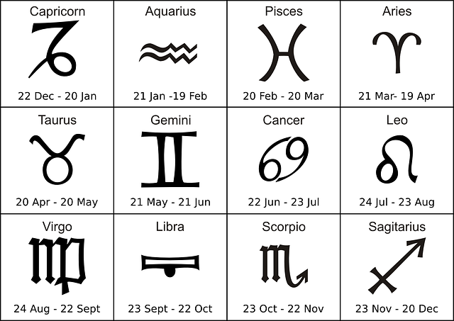

Exercise 4.
Translate.
1 Kellyin pradedek je bil vojni ujetnik.
2 Optimistični ljudje imajo pozitiven odnos do življenja.
3 Košarka je zaposlitev za poln delovni čas.
4 Če gre kaj narobe v življenju, je pomembno, da se učimo iz svojih napak.
5 Po zaključeni univerzi je začela kariero v politiki.
7 Moja tašča je zelo prijazna oseba.
8 Moj dedek se je v mojo babico zaljubil pri 15.
9 Moj stric se je upokojil en mesec nazaj.
10 Moja prijateljica se je poročila z Benom.

