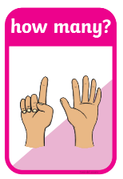
1. Answer.
How many boys are there?
There are ____________ _______________.

How many birds are there?
There is _______________ _______________.

How many snowballs are there?
____________ _________ _________ ____________.
How many houses are there?
____________ _________ _________ ____________.

How many hats can you see?
I can see _____________ ________________.

How many icy ponds can you see?
_______ ___________ __________ _____________ ________ _________.

2. Circle./Write.
Can you see a tree?
Yes, I can. No, I can't.

Can you see a dog?
_________________________
3. Look at the picture. Answer.
Is this a/ an _______________?
Yes, it is. No, it isn't. It is __________.

Are these _______?
Yes, they are. No, they aren't. They are ________

