WE LIKE TO MOVE! (RADI SE GIBAMO!)


RUN

GO




WAVE

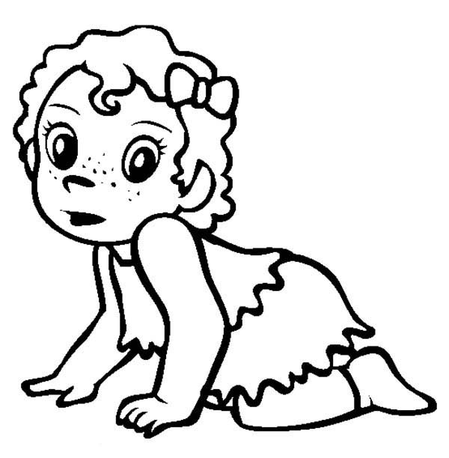

DANCE

CRAWL
https://www.youtube.com/watch?v=bJnfhYCC-Bo

WE LIKE TO MOVE! (RADI SE GIBAMO!)
RUN

GO

WAVE

DANCE

CRAWL

https://www.youtube.com/watch?v=bJnfhYCC-Bo

