Trgovina, srednjeveška mesta in meščani – delovni list
- Opiši napredek v evropskem kmetijstvu med leti 100 in 1300.
________________________________________________________________________________________________________________________________________________________________________________________________________________________________________________________________________________________________________________________________________________________________________________________________________________________________________________________
- Opiši značilnosti srednjeveške kolonizacije.
________________________________________________________________________________________________________________________________________________________________________________________________________________________________________________________________________
- Pojasni, kaj je vplivalo na oživitev trgovine in nastanek mest po letu 1000.
________________________________________________________________________________________________________________________________________________________________________________
- S pomočjo zemljevida opiši glavne trgovske smeri v Evropi.
________________________________________________________________________________________________________________________________________________________________________________
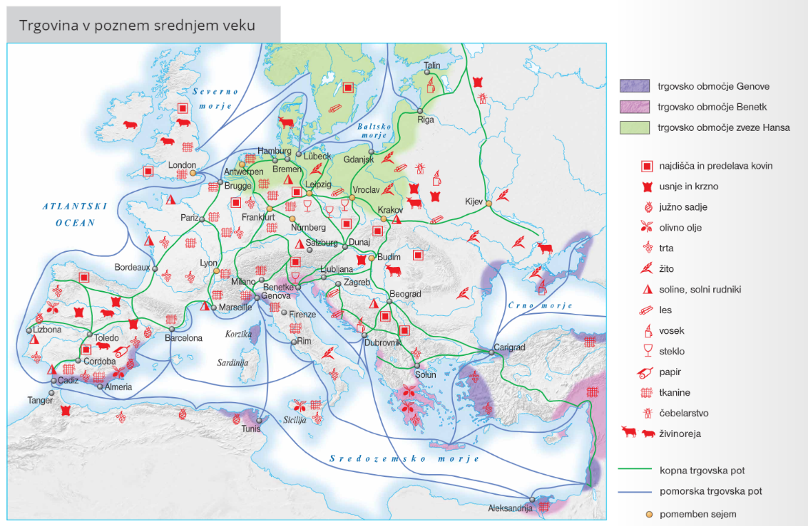

- Katero blago je na sejme prihajalo iz juga in katero iz severa?
________________________________________________________________________________________________________________________________________________________________________________
- Naštej glavna trgovska območja v Evropi.
________________________________________________________________________________________
- Pojasni;
  - triletno kolobarjenje
______________________________________________________________________________________________________________________________________________________________________________
  - plug
_______________________________________________________________________________________
  - sejem
_______________________________________________________________________________________
  - bančništvo
_______________________________________________________________________________________
- Pojasni, kaj so cehi.
________________________________________________________________________________________
- Kakšna so bila cehovska pravila?
________________________________________________________________________________________________________________________________________________________________________________________________________________________________________________________________________
- Kako so kaznovali goljufive peke v Ljubljani?
________________________________________________________________________________________
- Kje so nastajala srednjeveška mesta?
________________________________________________________________________________________________________________________________________________________________________________
- Kdo je bil mestni gospod?
________________________________________________________________________________________________________________________________________________________________________________
- Naštej mestne pravice in pojasni pravico do osebne svobode.
________________________________________________________________________________________________________________________________________________________________________________________________________________________________________________________________________________________________________________________________________________________________

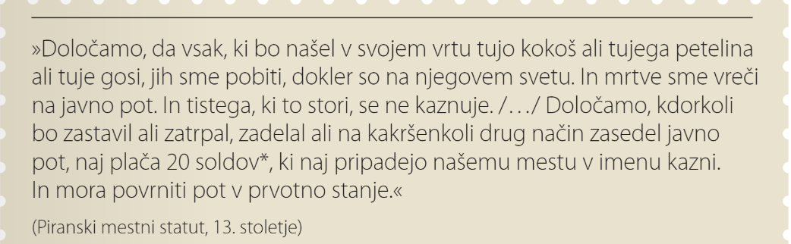
14. Preberi vir in odgovori na vprašanja.

  - Oceni strogost zapisanih določil.
______________________________________________________________________________________
  - V katerem mestu so veljala ta določila?
______________________________________________________________________________________
  - Pojasni, kaj je sold.
______________________________________________________________________________________

- Pojasni:
  - mestni statut
______________________________________________________________________________________
  - »mestni zrak osvobaja«
______________________________________________________________________________________
  - Hansa
______________________________________________________________________________________
  - monopol
______________________________________________________________________________________
- Opiši življenje meščanov.
________________________________________________________________________________________________________________________________________________________________________________________________________________________________________________________________________________________________________________________________________________________________________________________________________________________________________________________________________________________________________________________________________________

