Code of Honour
Business, politics, and media are much like education, including universities - all built on competitive individualism (“I must do better than everyone else”). But competitive individualism inside a team causes two very common behaviours that will damage your team's chances of success no matter how hard you work, or how often you meet. The very first work-focused team meeting is crucial. That’s where the team dynamics – the style of personal interactions with each other – determine how (and whether) the team is going to progress together.

What are these behaviours?
The first is a tendency by some team members to monopolise team meetings - over talk - so that others don't get much chance to speak (Yalom and Leszsz, 2005).

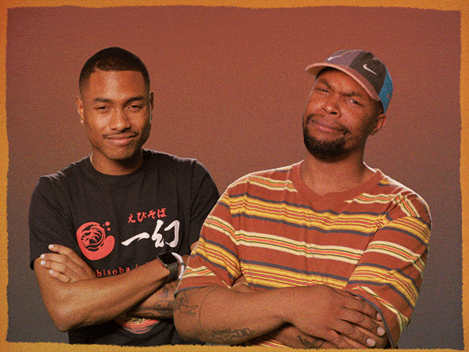

Source: https://media.giphy.com/media/3s27N9iSefL3VjgJMm/giphy.gif

The second is non-contributing - not speaking during team meetings and that's often due to feeling a bit lost, but it means meetings are not fed and enriched by all members. None of this is any individual’s fault.

Still, with this Code of Honour that hundreds of UH students have helped put together through their own personal experience of group/teamwork (Gilbert, 2018), you’ll see how to dismantle both of these common behaviours without silencing anyone - and you will see real benefits.
Here are UH students from many schools who helped make this short practical film on how to manage your team dynamics in your meetings: Embedding and Assessing Compassion on the University Curriculum (Part 1) - YouTube This will give you real insight into what follows, below.
1. Language use for international/colleagues - keep it plain and simple. This is great to learn to do in your writing too. Tutors love it. Your colleagues need it.

2. Silences: Try not to jump into every silence. Reasonable silences are vital to help the group pause to think - and the shyer students really need these to enter the discussion (Turner, 2009).

3. Essential eye contact.

- When you meet in person/offline. Keep looking around at all members in your group as though it were all one person, whenever you speak (Gilbert, 2016a). Both researchers and students have found that when this happens, participation in the group equalises and with that the quality of the group's thinking is enhanced. Remember though, that a monopoliser is often more comfortable fixing eye contact with just one person. If that person, is you, be careful; you are now enabling a very excluding behaviour. Others notice quickly. So, break eye contact with the monopoliser gently and direct their eye contact to the left and to the right, that is, directly to the other team members. You are gently channelling the monopoliser to include them too. This is a powerful, non-verbal technique because when people take cues from eye contact that they are also included, participation equalises and quality of criticality in the group increases (Vertegaal et al, 2002; 2003). Many students do encourage you to use that easy strategy from the start of your very first meeting because team dynamics can be spoiled if you don't act quickly on this.

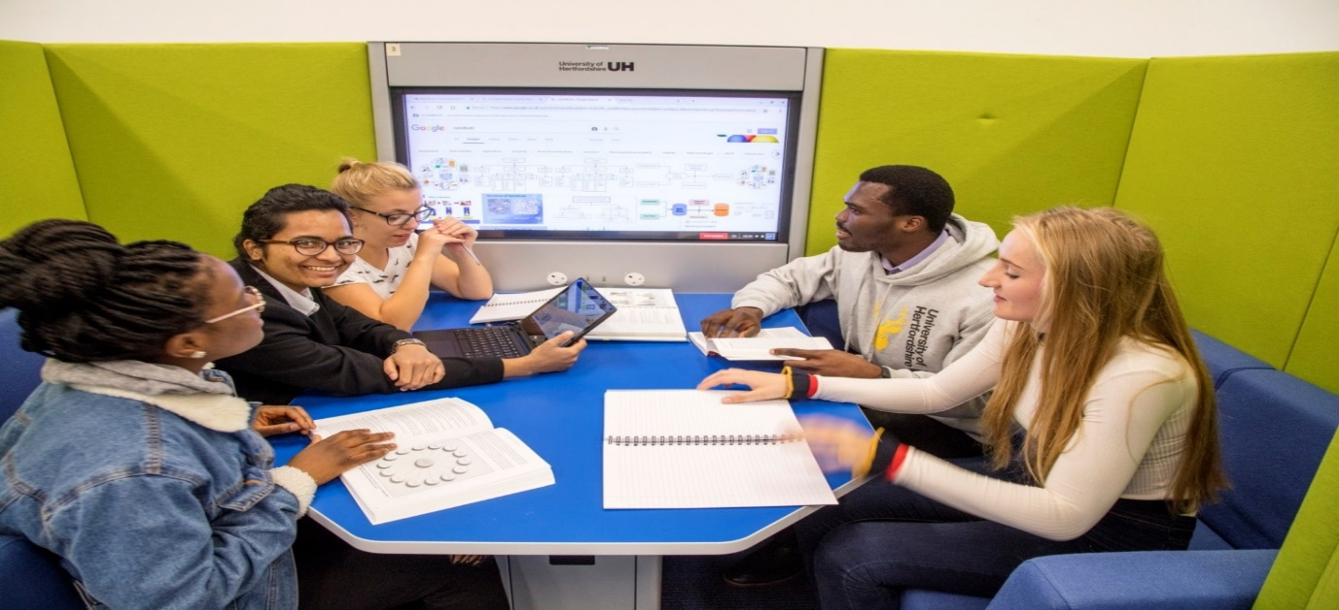

This is not so easy if you are meeting online of course, so see the next advice that fellow students want to offer you.

- When you meet online - Camera on or off? No matter how anxious your fellow students may be to speak, if your camera is on you are already helping them enormously. Instead of a black box to represent you, they can now see you nodding, leaning forward, your attention on them with sustained screen gaze. Many shy and nervous students have told us this has supported them greatly; it keeps them safe from their fear that their ideas have nothing valuable to offer the group because it reduces their fears that what they are saying has no value for the group (Jayasundara et al, 2022). In the Business School, even students with Study Needs Agreements (SNAs) for extreme anxiety (who therefore don’t have to switch on their cameras) have changed their minds and switched them on in recorded assessed professional discussions in order to help others out who may be just as anxious. Compassion and courage like this are increasingly linked in the literature these days.

Here is a short film for you to see of students being assessed in research skills, critical thinking and compassionate group management in a recorded, online professional discussion. Once again, students wanted to help and gave their permission for you to see this in case it helps you. Student Guidance on Compassion in Teams meetings - YouTube

Shared Virtual Background? Students are using one shared background in their team meetings. Many of these are turning out to be of outside, natural environments – beaches, forests, lakes. That means distractions in the room you are in are not seen. You share one space together away from everything else (Jayasundera et al, 2022).

3. Don't normalise (don’t accept) seeing others excluded in a meeting. Here are two examples. Imagine that Ben won’t stop talking. Don't blame him. It turns out, the monopoliser is often the most anxious member in the team. Wait for him to take a breath and slip in fast with a gentle tone and use his name. "Ben, that's a good/great/interesting point you made about...because..." Be real about this. You're putting him at ease while you have to disrupt his behaviour. Next, imagine that when you do this, Ben has also just talked over Keisha in the group. In that case, add something else immediately to what you have just said to Ben: "Keisha what you were just saying about xxx is interesting. Can you tell us anymore about that?" Use her name; keep your tone warm and welcoming. She may already have had low confidence and now even that may be draining away:


Act quickly.
By now, do you see how your help here can never be replaced or substituted?

[Sidebar Title]

4. Bringing others into the discussion: Tone and name. Imagine that Mingwei is the shyest person in the group. If you and your group can gently invite her, often, to speak: "What's your view Mingwei?" you're working together to get her out of the cold dark water and into the boat with you all. Excellent. If, like Mingwei, you freeze sometimes, just ask someone else in the group - by name: "Olu, can you help me here?" (Try not to ask the monopoliser.)

In many modules using this honour code in teamwork, the shyest, most anxious students have been seen to aid others courageously when asked for help directly like this when they were too anxious to speak on their own behalf before. This is just one reason why the UH has put this honour code of compassionate team management by students into its five-year institutional strategy (2020-2025) for curriculum development including to assess (reward) it, per individual student, with credit.

5. Thanking each other. The power of gratitude for bonding teams - never overlook this one and make it transparent in team meetings so that everyone hears and is included.

6. Checking your own, as well as others’ body language. Google spent five years and $5 million dollars finding out that one of the key features of their highest performing teams when they met (they looked at 180 teams in all) was: obvious listening to each other - nodding, showing they were paying close attention to each other, so that no one's ideas were lost because of fear of saying something wrong. Everyone wanted to hear them, even if they disagreed; no idea of good intention is ever stupid. All ideas expressed light the way for the groups critical thinking journey. This is another reason to keep your camera on if you possibly can.

7. Working with non-readers who haven’t prepared for the work/meeting. Frustrating? Yes, but when this happens students have found that two (not one) other members of the group can help solve this problem fast if they act together quickly and help that team member learn how to contribute. You'll be amazed at what you will discover your fellow student didn't know how to do that they thought everyone else knew about. Examples are reading strategies, research skills and so on, but it could also be about how to cope with another kind of problem that many of us have dealt with before.

8. Two questions to keep in your mind. Make good use of teamwork where you are all marked individually; especially, where you are marked on how you support others in the group in practical, sensible ways as above that other students have been using to help themselves and others do well. Here are the two questions that are an assessed assignment on some degrees at the UH and require only your very close observation:

- What do I do to enhance my colleagues' social and learning experiences in this teamwork that they most value in me?

- What do my colleagues do to enhance my social and learning experiences in this teamwork that I most appreciate in them?

A final piece of important advice from many current and past UH students.
'Self-esteem' means measuring yourself against everyone else in some aspect of your performance. That's a destructive, toxic concept that can lead to far too much self-criticising that demoralises and weakens you and makes you feel alone (Neff, 2011; Kingston, 2008). Yet the truth is we all share so much: TV 2 | All That We Share.

So, take a deliberately kinder, more compassionate approach to yourself and others. Results will show you made the right choice when it comes to your grades. Look in the literature for plenty of evidence on that one. You'll also find evidence that teamwork is a great opportunity to take the best care of yourself and others in ways employers are specifically looking for in workplace teams now. The UH is being asked by employers to visit and deliver this team code into their own workplaces nationwide; and you are the best of pioneers that made it happen for the kinder smarter workplaces we hope will be waiting for you. If not, you’ll know what to do because of who you already are.
Who We Really Are... When Everything Goes Wrong – YouTube

References:

Gilbert, T. (2018), ‘Embedding and assessing compassion on the university curriculum University of Hertfordshire Video file’, 19 January, available at: www.youtube.com/watch?v=3jFVTCuSCOg

Gilbert, T., Martina Doolan, N.T.F., Beka, S., Spencer, N., Crotta, M. and Davari, S., (2018). Compassion on university degree programmes at a UK university: The neuroscience of effective group work. Journal of Research in Innovative Teaching & Learning.

Gilbert, T. (2016a) Assess compassion in Higher Education? Why and how would we do
that? LINK, 2(1) : Available at: Assess compassion in Higher Education? | LINK (herts.ac.uk)

Gilbert, T. (2017) ‘When looking is allowed: What compassionate group work looks like in a
UK university.’ In P. Gibbs (Ed.) The Pedagogy of Compassion at the Heart of
Higher Education. Springer: London. Chapter 13, pp 189-202.

Jayasundara, J. M. P. V. K., Gilbert, T., Kersten, S. & Meng, L. (2022). How UK HE STEM
Students Were Motivated to Switch Their Cameras on: A Study of the Development of Compassionate Communications in Task-focused Online Group Meetings. Education Sciences, 12(5), 317. MDPI AG. Retrieved from http://dx.doi.org/10.3390/educsci12050317

Kingston, E. (2008). ‘Emotional competence and dropout rates in higher education.’ Education
and Training, 50(2), 128-139.

Like Stories of Old (2021) Who we really are when everything goes wrong. YouTube. Uploaded: 6 May, 2022. Available at: Who We Really Are... When Everything Goes Wrong - YouTube

Neff, K.D., (2011). ‘Self‐compassion, self‐esteem, and well‐being.’ Social and personality psychology compass, 5(1), pp.1-12.

Turner, Y. (2009). Knowing me, knowing you, Is there nothing we can do? Pedagogic
Challenges in Using Group Work to Create an Intercultural Learning Space. Journal
of Studies in International Education, 13(2), 240-255.

TV2 Denmark (2017) All That We Share, YouTube. Uploaded 6 May, 2022. Available at: TV 2 | All That We Share.

Vertegaal, R. & Ding, Y. (2002). ‘Effects of eye gaze on mediated group conversations:
Amount or synchronization?’ Proceedings of the 2002 ACM Conference on Computer Supported Cooperative Work. (pp. 41-48). New Orleans.

Vertegaal, R., Weevers, I., Sohn, C. & Cheung, C. (2003). ‘GAZE-2: Conveying eye contact
in group video conferencing using eye-controlled camera direction’. Proceedings of
the SIGCHI Conference on Human Factors in Computing Systems. Lauderdale.

Yalom, I. & Leszsz, M. (2005). The theory and practice of group psychotherapy. (5th ed.).
New York: Basic Books.

