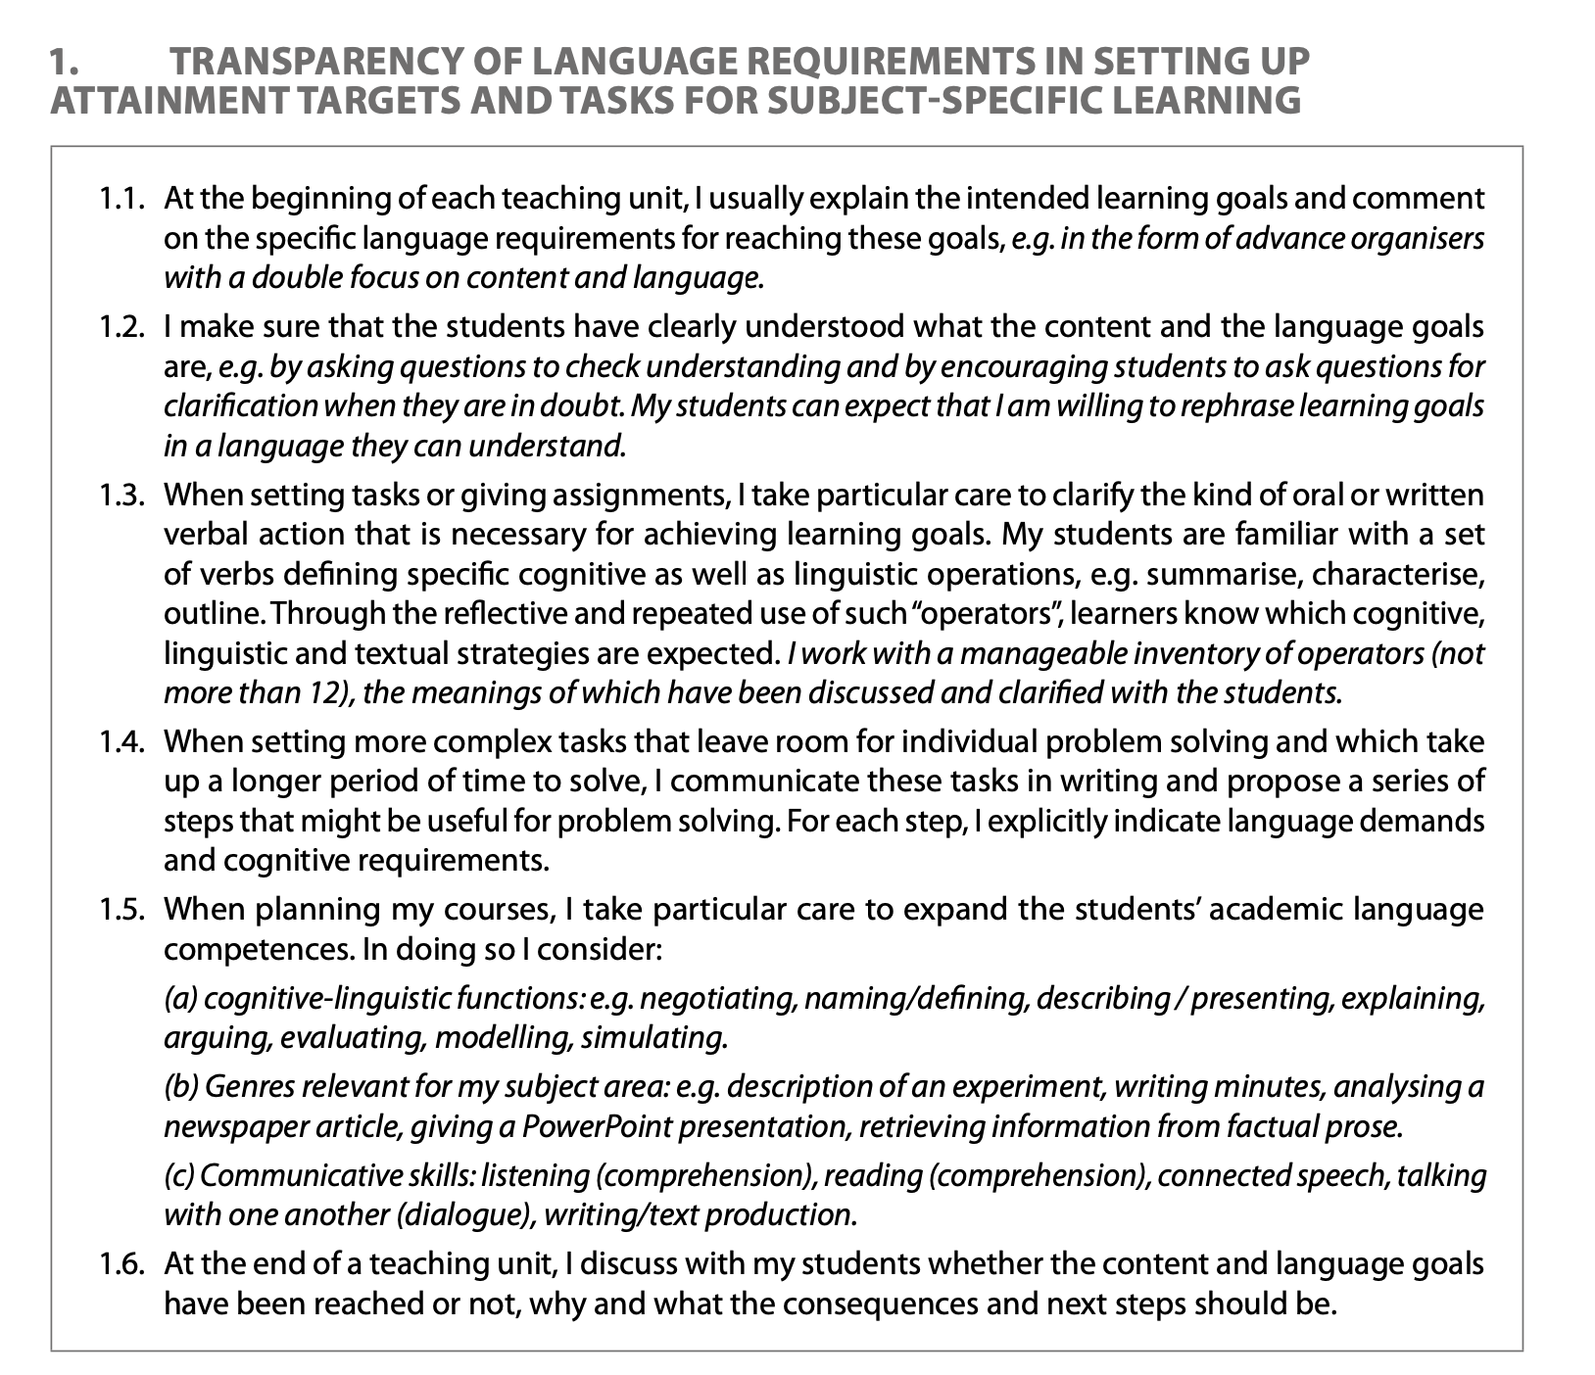

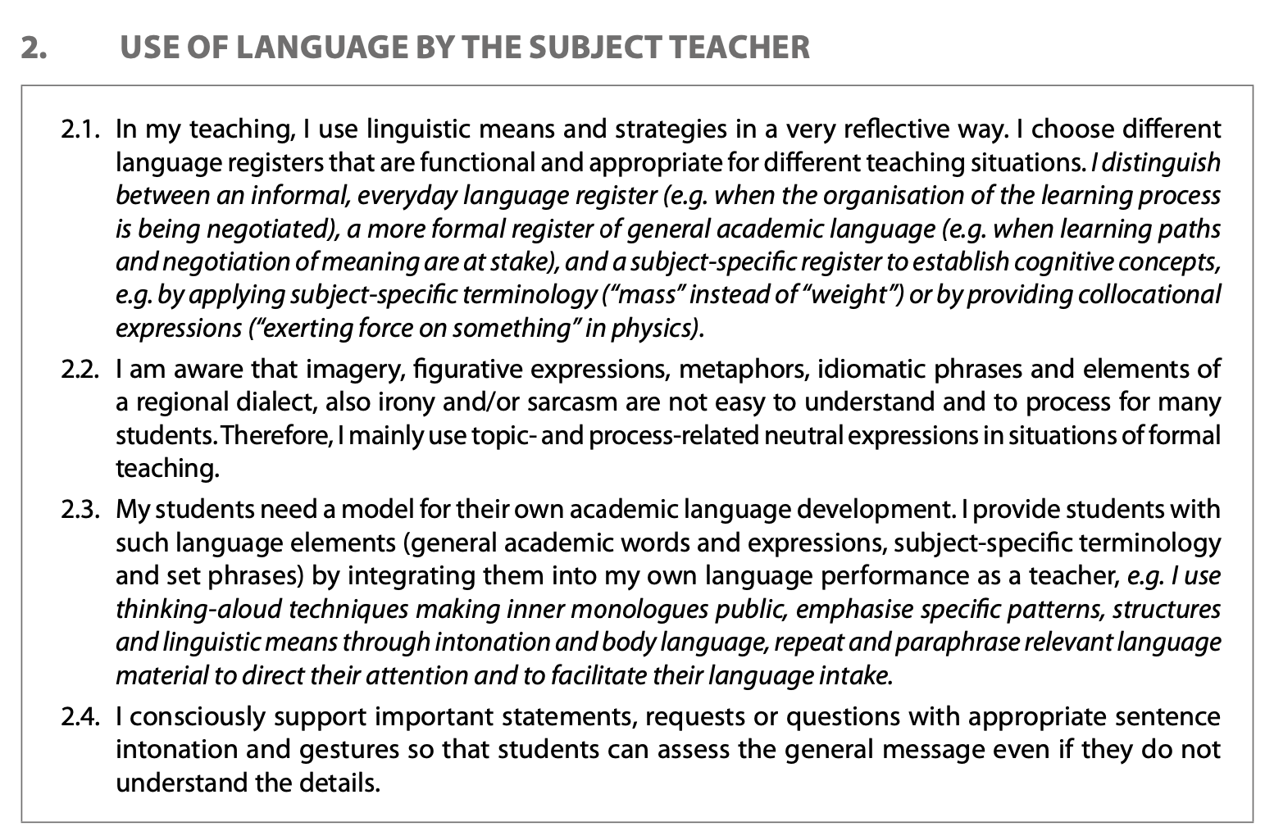
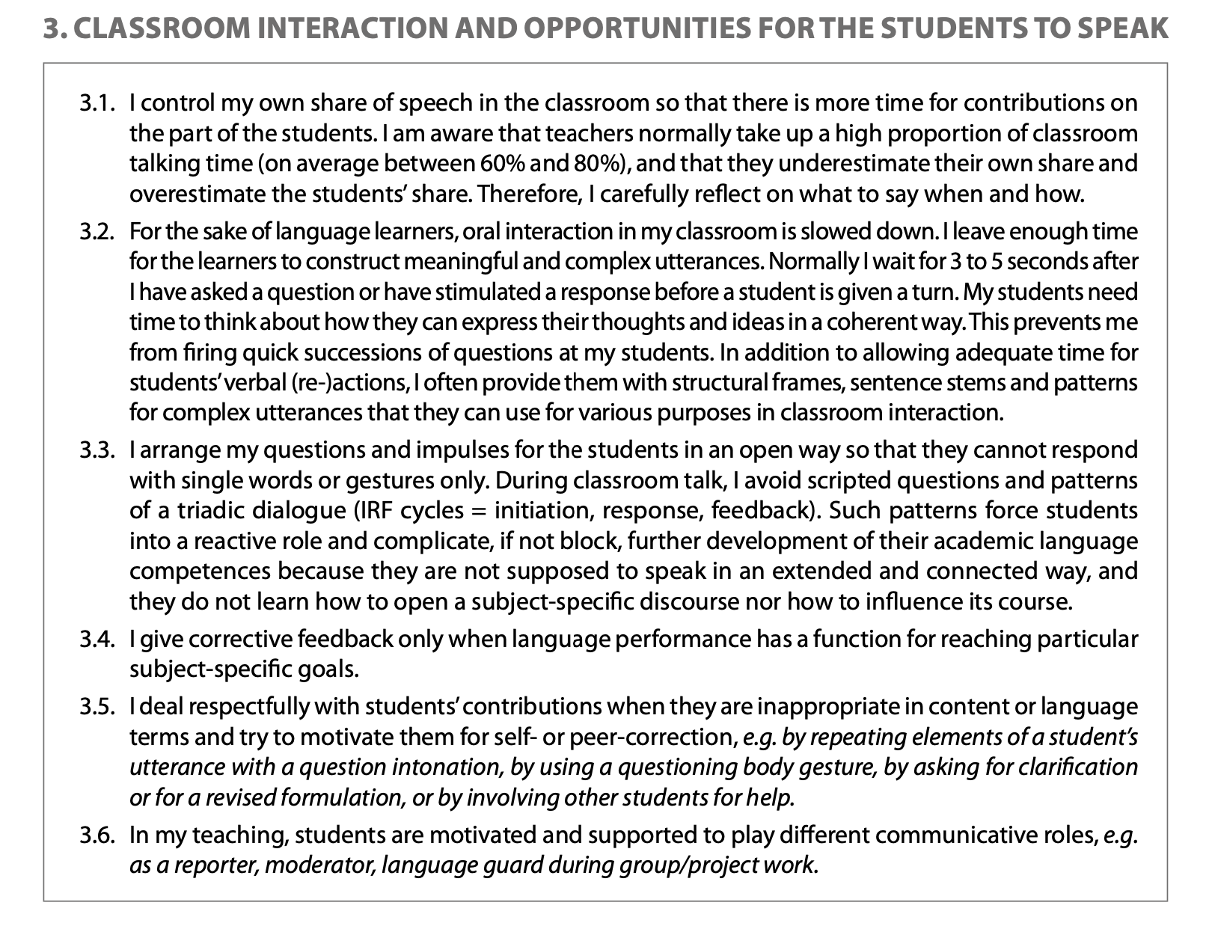

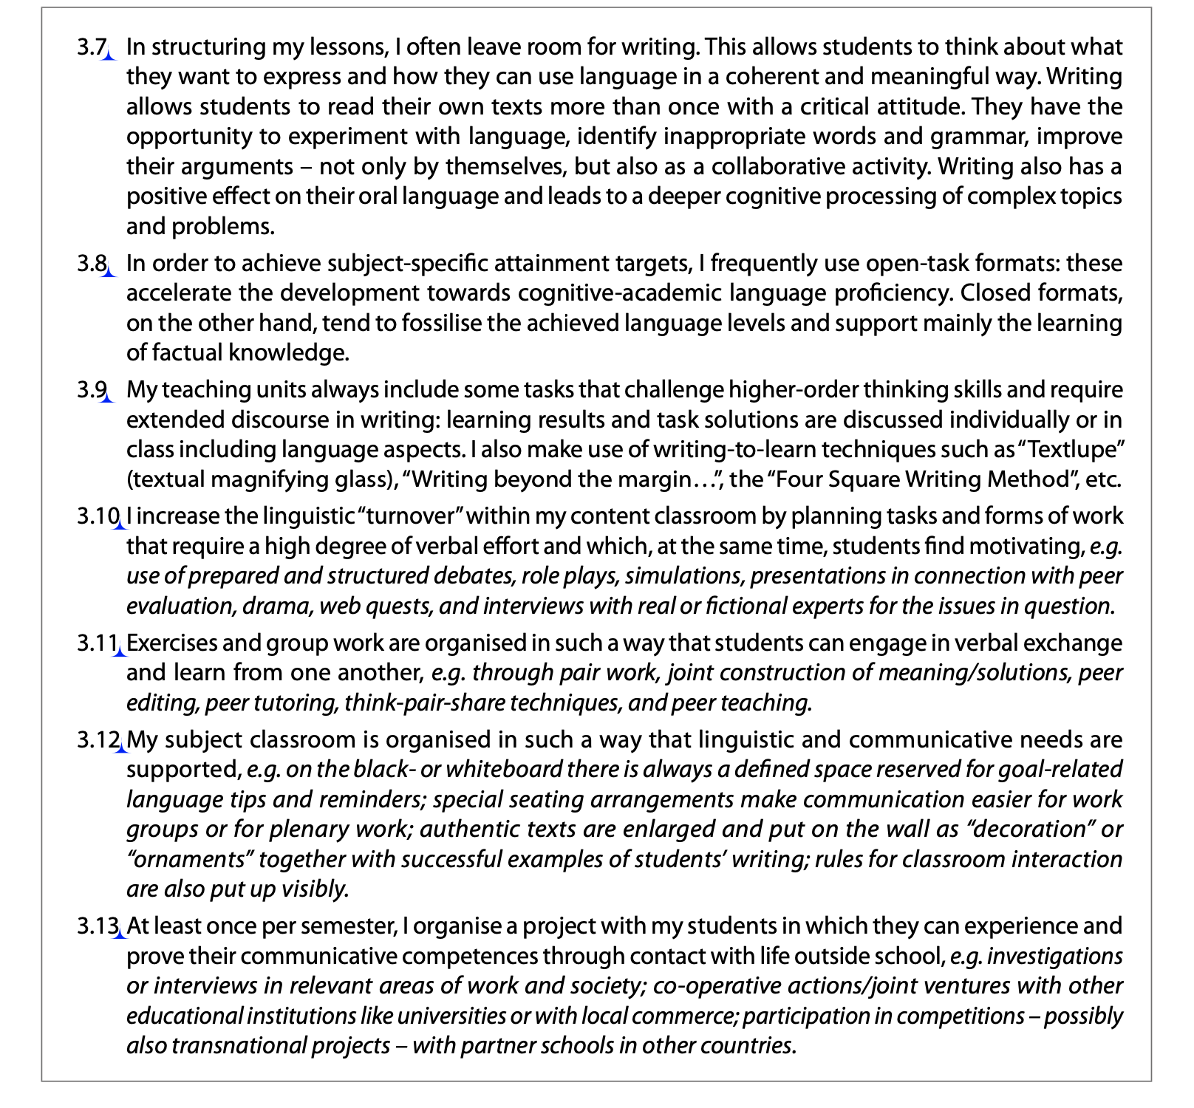
Culturally Responsive Teaching and Learning.flv

https://www.youtube.com/watch?v=_uOncGZWxDc

Supporting cultural and linguistic diversity in early childhood
https://www.youtube.com/watch?v=XWg-ZrV3wPk

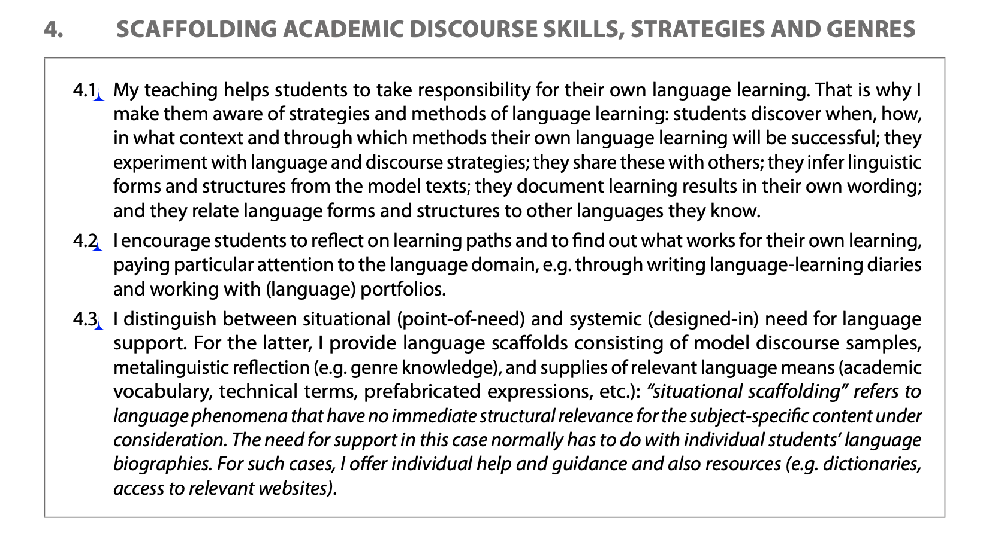
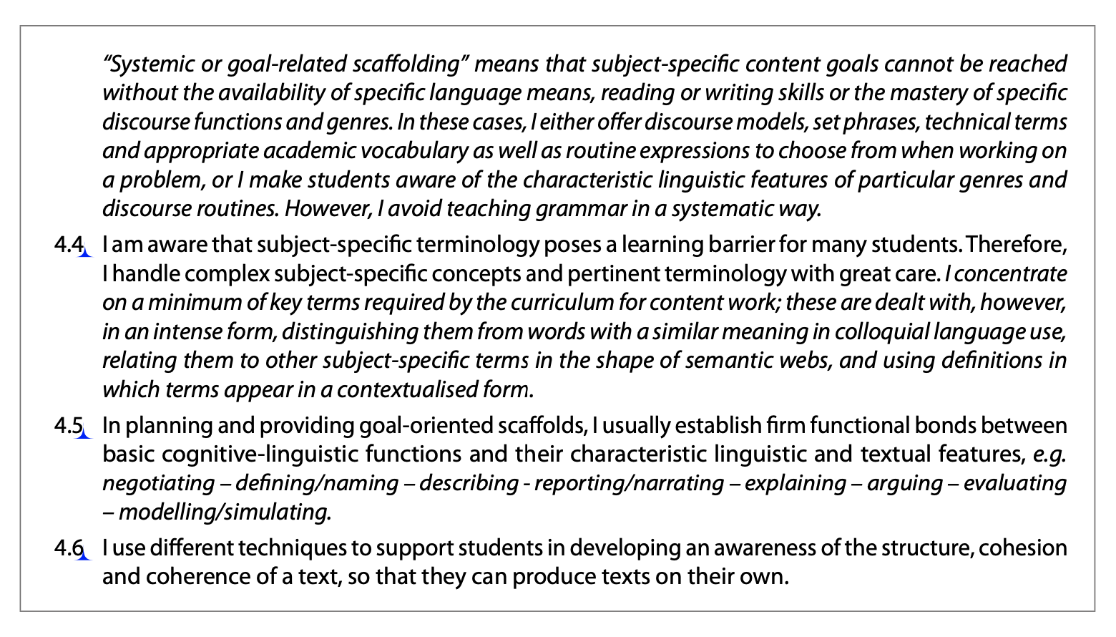

Culturally and Linguistically Responsive Teaching and Learning
https://www.youtube.com/watch?v=T4k3X6dphnw

Culturally and Linguistically Responsive Teaching Lab Classroom

https://www.youtube.com/watch?v=mJpwOJi2Bxg

Supporting English Language Learners in the Preschool Classroom

https://www.youtube.com/watch?v=09PrmLppQ1A

