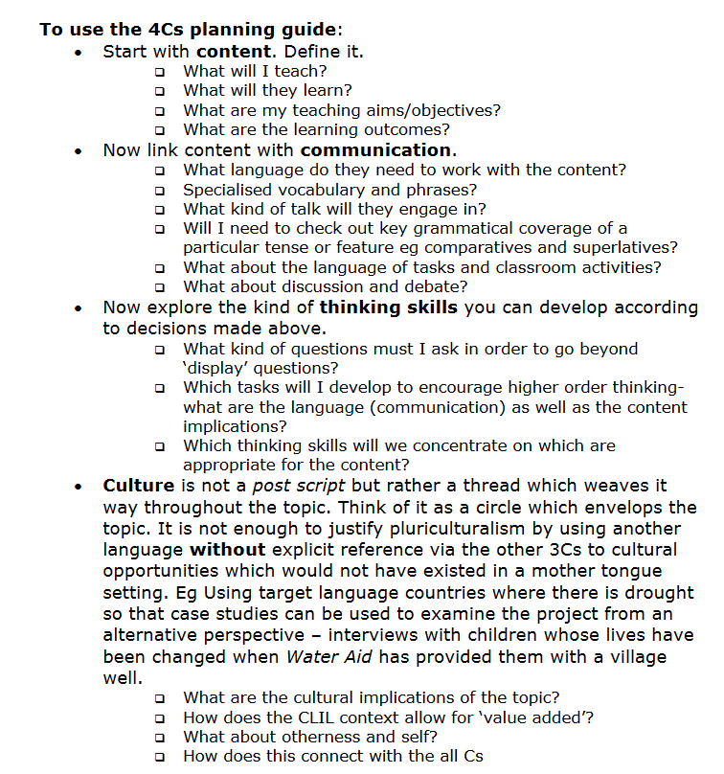
https://www.unifg.it/sites/default/files/allegatiparagrafo/20-01-2014/coyle_clil_planningtool_kit.pdf

