SMILE too - Training Program for Parents
Script PowerPoint Presentation

To develop empowerment for parents & children

Needed for the training:
Every participant has a green and red item (paper/object)

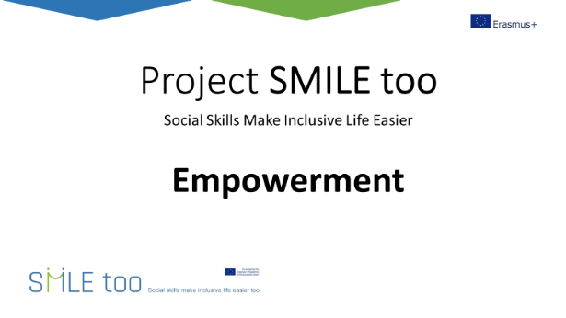

Explanation:
When we talk about the development of children with blindness and low vision there are several factors that influence development. Factors that can cause limitations or promote development. A very important factor is the immediate environment of the child.

The way that society/the environment perceives people with disabilities is an important factor. If children with blindness and low vision grow up in an environment where people around them look towards them from a perception of deficiencies and limitations, this can have a big impact on development and how children see themselves as they are treated very differently.

Question:
What kind of limitations do you experience for your children in the society they live in?

-----------------------------------------------------------------------------------
Explanation:
How do we think about the changeability of abilities, development, and talents of our children? I would like to use a few statements. If you agree with the statement hold up your green item, if you disagree hold up red.

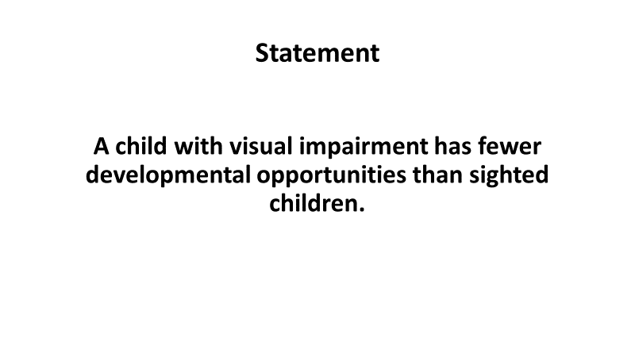

Question:
Ask parents with red: Why did you put up red?
Ask parents with green: Why did you put up green? What differences do you see between VI and sighted children?
-----------------------------------------------------------------------------------

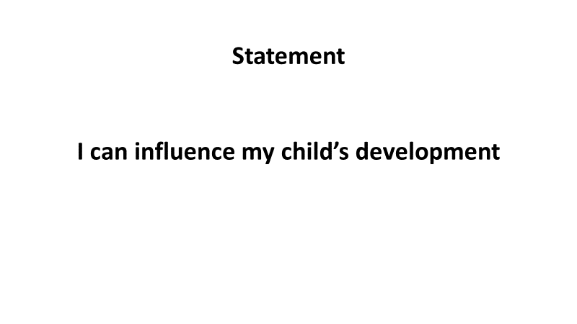

To ask the parents:
Ask parents with red: Why did you put up red?
Ask parents with green: Why did you put up green? What do you do to influence your childs development?
-----------------------------------------------------------------------------------
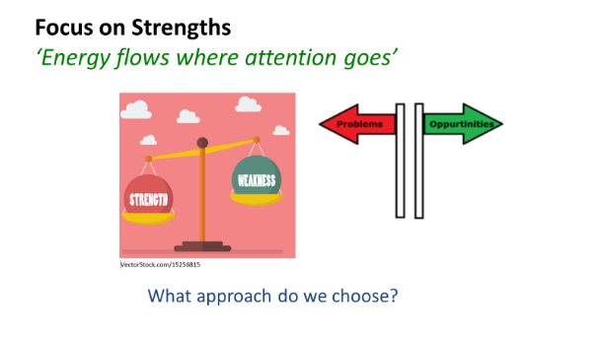

To tell:
How can we stimulate the development of our children?
There is a saying: ‘Energy flows where attention goes’
It means that things you give your attention to, will grow bigger.

When people around the child, focus mainly on the deficits, the impairment, the shortcomings and weaknesses, they emphasize on what the child cannot do. Therefore, the child becomes more limited instead of becoming stronger. With this focus the child gets the label of ‘incapability’, which in turn has a huge impact on how the individual sees themselves, making them feel worthless.

A child with a visual impairment is so much more than the visual impairment!

This problem-oriented focus creates helplessness, avoiding risks and challenges. And that is the opposite of what we want for our children: growth and learning.

When professionals and parents focus more on strengths, abilities, and opportunities for children, they then have found a way to support and empower the child to become as independent and autonomous as possible. All children need people around them who believe in them, providing opportunities to develop and grow.

Question:
What is a strength or talent of your child with a visual impairment?
-----------------------------------------------------------------------------------

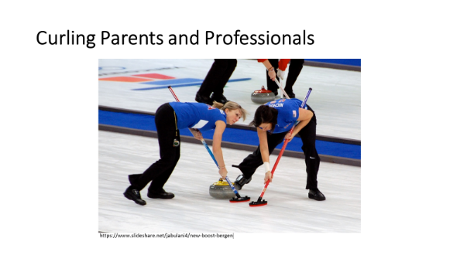

To share:
There is an interesting sport, called "curling." It’s an Olympic sport, where one player slides a stone across the ice. Two team members use special brooms to sweep the surface of the ice in the stone’s path, to help the stone slide. The term ‘curling parents’ is a metaphor for parents (and it can also be used for professionals!) who overprotect a child by sweeping all the obstacles and difficulties out of the way. This stops children from experiencing failure and the negative feeling associated with it. The effect of this approach is that the child feels incapable, not having the skills to change the situation by themselves.

We do not help our children grow when we remove all obstacles in their lives. Instead of sweeping all the obstacles away, we need to support and help our children to deal with failure, setbacks, obstacles, and the frustration associated with this.
-----------------------------------------------------------------------------------

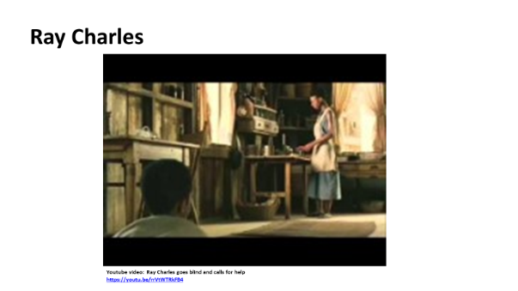

Explanation:
A beautiful example of keeping away from curling is this video of Ray Charles.

Question:
What helps you to let your child try, practice, and develop?
-----------------------------------------------------------------------------------

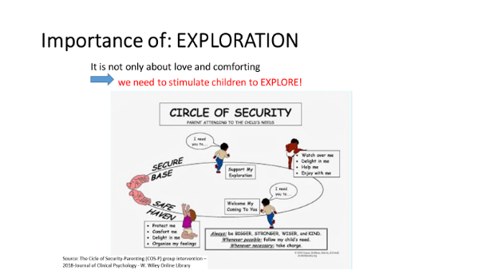

In this slide we see an important part of parenting is to form an attachment with your child. In that way a child feels secure and confident to go into the world. If something frightens the child, for example a sound or an odd feeling, the parents have formed a safe environment, and the child will go back to the parents for proximity, consolation, and reassurance: ’that was funny, scary or something else’. Due to this feeling of security, the child can continue with more exploration…

When a child experiences a secure base, they can explore the world, learn, and develop. This picture shows the importance of having a supportive and loving relationship.

Question:
What do you do to let your child explore his or her environment?
----------------------------------------------------------------------------------
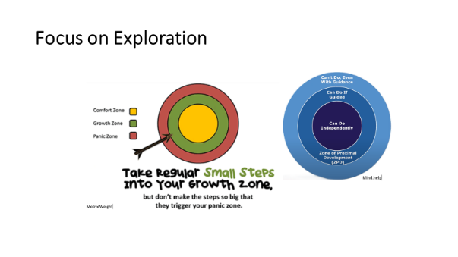

Explanation:
Many children with a visual impairment are ‘stuck’ in their comfort zone. If we want to help them explore and broaden their world, we have to create accessible opportunities, outside the comfort zone, in the growth zone.

Learning new things and developing skills takes place in the growth/learning zone. We can support children to step more often into the learning or growth zone by going step by step up the stairs. This approach provides the chance to gain a successful experience whilst building his or her self-confidence. It is important to praise the effort the child puts in and all the small steps forward! Mistakes are part of the learning process.

Examples to stimulate and broaden their world:
- Be proactive to nurture your child’s hobbies/interested/sports.
- Encourage them to join clubs, this will help to develop new social circles.
- Socialize by participating in clubs.
-----------------------------------------------------------------------------------

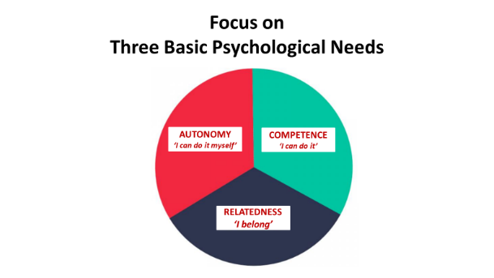
(Model of Ryan an Decy 2012)

Explanation:
To stimulate the empowerment of children with VI it is important to consider and support three psychological needs that every human being has:
Autonomy: I can do it myself; I can make my own decisions.
Relatedness: The feeling of belonging, do I feel connected to other persons?
Competence. Do I feel competent and capable in certain tasks and skills? Do I know my talents?

The more these three psychological needs are supported, and the child has positive answers to these questions, the more motivated the child will be to put effort into his or her own development. The child will then benefit from psychological well-being and high self-esteem.

Examples to extend their world:
- Relatedness: to put emphasis and effort into creating valuable relationships with sighted and non-sighted peers, e.g., inclusive projects during free time.
-----------------------------------------------------------------------------------

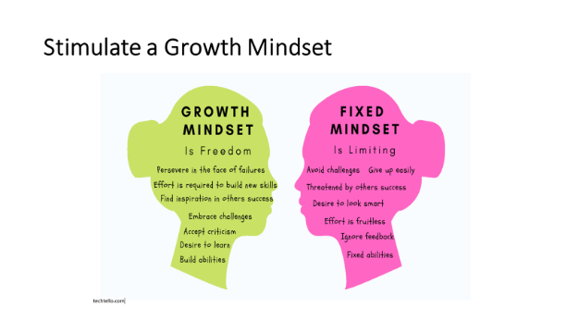

Explanation:
Mindset plays a part in a child’s development. What does the child believe about themselves? Do they believe in their own abilities and talents and in the changeability of his or her talents?

Explain the consequences of a Fixed mindset and Growth mindset:
Fixed mindset: people who have mainly a fixed mindset believe that if you are not good at something, then you never will be. ‘I’m just born this way’. They have the tendency to avoid challenges and failure. People with a fixed mindset see effort as proof of low ability. They belief that if you have to try hard, that means you aren’t very smart or don’t have talent for it. Believing this about yourselves can hold you back “I’m either good at it, or I’m not good at it, so what’s the point of trying?” And if you have talent, effort is not needed. Negative feedback hurts. You blame others. You feel easily threatened by the success of others.

Growth mindset Helps you to embrace challenges. Challenges and mistakes help you learn. The obstacles you encounter will only make you stronger. With a growth mindset you believe that you can improve with effort. The belief that your abilities and talents can be developed gives pleasure in what you want to learn and makes failure, how painful at times, easier to accept because it is simply part of the learning process. Failure in the growth mindset doesn’t define who you are. You learn from criticism. You feel inspired by the success of others.

As a parent you can play an important role in increasing your child’s self-confidence by influencing the mindset of your children. Encourage and compliment them on the effort they put into their learning process,

The mindset of parents and teachers also plays an important role. Are you aware of your own mindset, your beliefs about the changeability of intelligence, talents and learning ability?

Question:
Do you put effort into something you want to learn?

