Power Point Presentation Script: Training of Parents, Teachers and Educators 03 - Smile too

Enhancing the development of parents, teachers, educators and children/ students

Necessary for training:
Each participant has a green and red object (card / object)



Developement
Empowerment of parents, teachers and children

Explanation:
When we talk about the development of children with severe MDVI or with deafblindness we have to think that there are several factors that influence development. Factors that can cause limitations or promote development. A very important factor is the surrounding environment of the child.

How society/the environment perceives people with disabilities is an important factor. If children with severe MDVI or with deafblindness grow up in an environment where the people around them look at them from a perception of shortcomings and limitations, this can have a great impact on development and how children/students see themselves treated in a way. very different from their peers.

Ask parents, teachers and educators:
What kind of limitations do you experience for your children/students in the society they live in?

-----------------------------------------------------------------------------------
Explanation:
How do we think about the changing abilities, development and talents of our children/ students? I would like to use some statements. If you agree with the statement, raise your green object, if you disagree, raise the red.
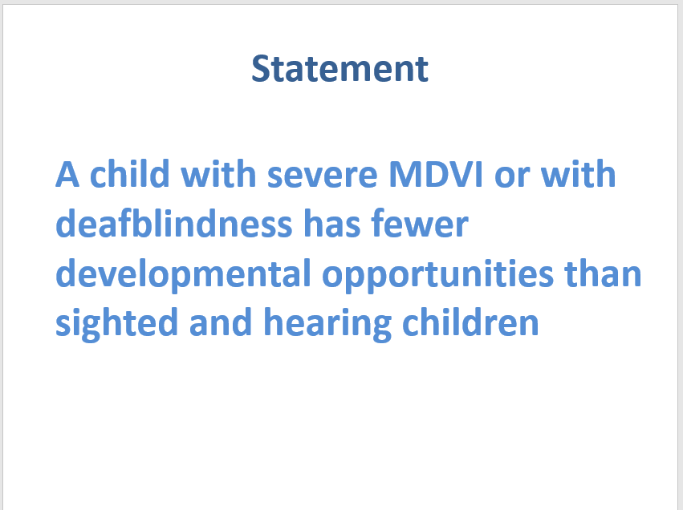

Question:
Ask parents, teachers and educators with red: why did you put red?
Ask parents, teachers and educators with green: why did you put green? What differences do you see between children with severe MDVI or with deafblindness and sighted and hearing children?

-----------------------------------------------------------------------------------
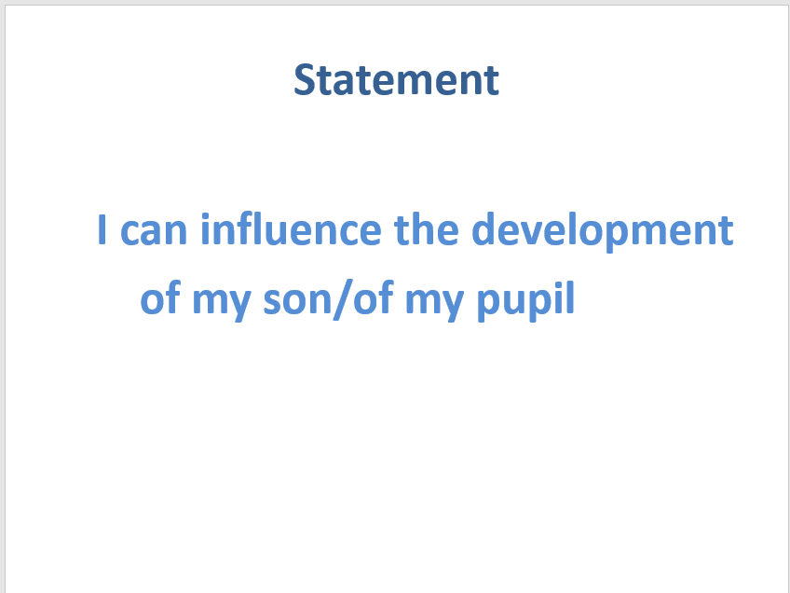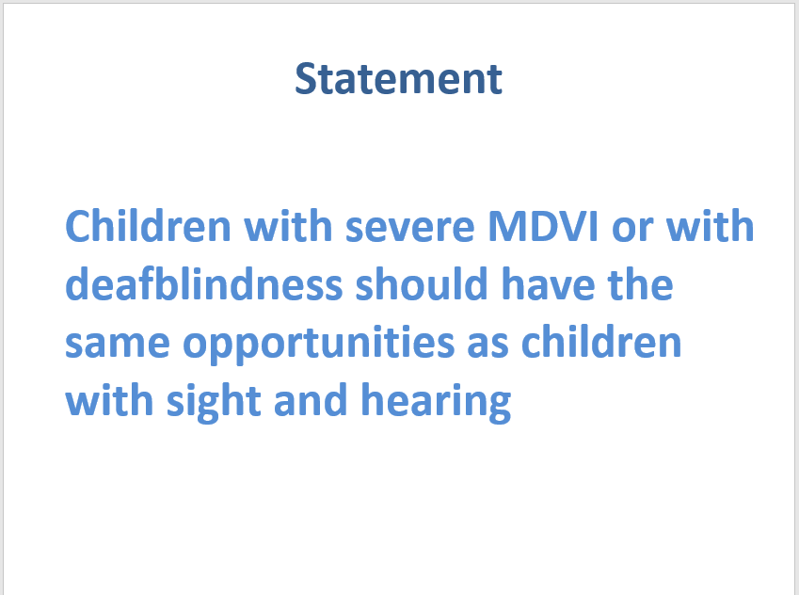

Ask parents, teachers and educators:
Ask parents, teachers and educators with red: why did you put red?
Ask parents, teachers and educators with green: why did you put green? What do you do to influence your baby's development?

-----------------------------------------------------------------------------------
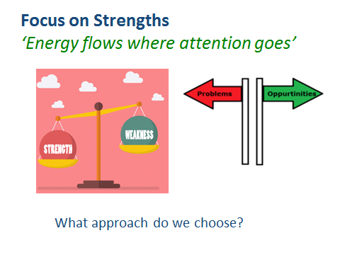

To tell:
How can we stimulate the development of our children/students?
There is a saying: "Energy flows where attention goes"
It means that the things you pay your attention to will get bigger.

When people around the child focus primarily on the deficits, impairments, shortcomings and weaknesses, they emphasize what the child cannot do due to her disability. Therefore, the child becomes more "limited" instead of becoming stronger.
With this focus the child gets a label of "inability", which in turn will have a huge impact on how the individual sees himself. It can make him feel useless and incapable.

A child with visual impairment or severe MDVI or with deafblindness is much more than this disability. This problem-oriented focus creates helplessness, avoiding risks and challenges. And it is the opposite of what we want for children / students: growth and learning.

When professionals and parents focus more on children's strengths rather than deficits, abilities and opportunities, then t they found a way to support and enable the child/ student to become as independent and autonomous as possible.
All children need people around them who believe in them, offering opportunities for development and grow.

Question:
What is the strength or talent of your child/student with severe MDVI or with deafblindness?

-----------------------------------------------------------------------------------
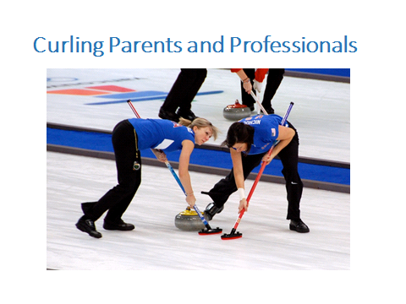

To share:
There is an interesting sport called "curling". It is an Olympic sport, in which a player slides a heavy polished granite stone across an ice floor. Two team members use special brooms to help the stone slide to a target area. The term "curling parents, teachers and educators" is a metaphor for parents and professionals who over-protect a child by wiping out all obstacles and difficulties. This prevents children from experiencing failure and the negative feeling associated with it. The effect of this approach is that the child feels incapable, not having the skills to change the situation on his own.

We don't help our children grow when we remove all obstacles in their lives. Instead of sweeping away all obstacles, we need to support and help our children cope with failures, setbacks, obstacles and the frustration that comes with them.

-----------------------------------------------------------------------------------
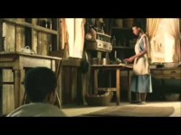

Explanation:
A good example of how to avoid curling is this video by Ray Charles.

Question:
What helps you to allow your child/student to try, practice and develop?

-----------------------------------------------------------------------------------
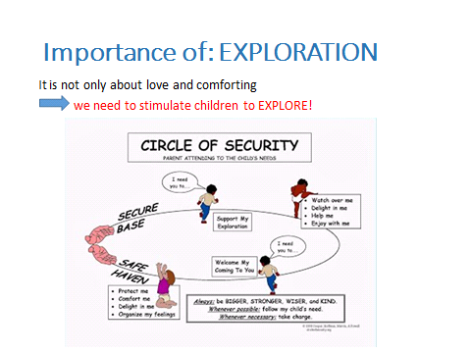

In this slide we see that an important part for parents, teachers and educators is creating an affection with their child. In this way the child will feel safe and confident enough to enter the world to grasp, understand, feel, know everything around him. If something scares the child, such as a strange sound or sensation, if parents, teachers and educators have created a safe haven, the child will return to parents, teachers and educators for closeness, comfort and reassurance: "was it funny, scary or something else". This feeling of security leads the child to continue exploring ...

When a child experiences a secure foundation, he can explore the world, he is able to learn, develop and grow. This image shows the importance of having a supportive and loving relationship.

Question:
What do you do to allow your child/student to explore his or her environment?

-----------------------------------------------------------------------------------
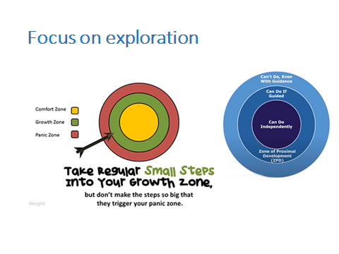

Explanation:
Many children with severe MDVI or with deafblindness are "stuck" in their comfort zone. If we want to help them explore and expand their world, we need to create accessible opportunities, outside the comfort zone, in the growth zone.

Learning new things and developing skills takes place in the growth/learning zone. We can help children enter the learning or growth zone more often. Learning is like climbing stairs step by step. This approach offers child/student the opportunity to gain a successful experience while building self-confidence. It is important to praise the effort that the child makes and all the small steps forward! Mistakes should be considered as part of the learning process.

Examples to stimulate and expand your world:

- Be proactive to cultivate your child / student's hobbies / interests / sports.
- Socialize by participating in pleasant / recreational, daily / school, religious and, when possible, sports experiences

-----------------------------------------------------------------------------------
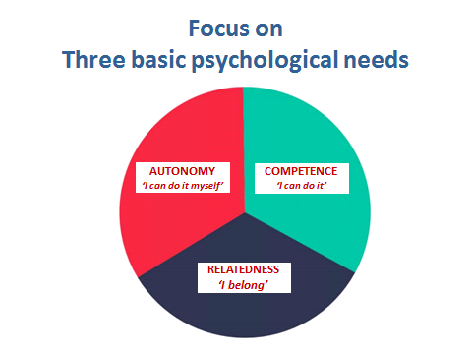
(model of Ryan e Decy 2012)

Explanation:
To stimulate the empowerment of children with severe MDVI or with deafblindness it is important to consider and support three psychological needs that every human being has:
Autonomy: I can do it by myself; I can make my own decisions.
Relationship: the feeling of belonging, am I in contact with other people?
Competence: do I feel competent and capable in certain tasks and skills? Do I know my talents?
The more these three needs are supported and the child has positive answers to these questions, the more motivated the child will be to engage in their own development. The child will therefore benefit from psychological well-being and high self-esteem.
Examples to extend their world:
- Relationship: Put emphasis and commitment in creating valuable relationships with sighted, hearing and non-seeing peers, such as inclusive projects during free time.

-----------------------------------------------------------------------------------
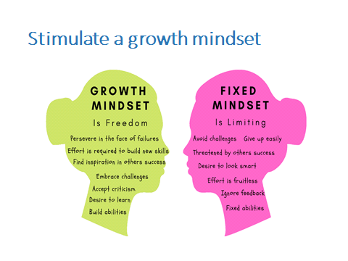

Explanation:
Mindset plays a role in a child's development. What does the child believe about himself? Do you believe in your abilities and talents and in the changeability of your talents?
(Explains the consequences of a rigid mindset and a growth mindset mindset)
Rigid mindset: People who have this attitude mainly believe that if you are not good at something, you never will be. 'I was born this way'. They have a tendency to avoid challenges and failures. People with a rigid attitude see effort as evidence of poor ability. They believe that if you have to force yourself, it means that you are not very smart or have no talent for it. Believing this about yourself can hold you back "Either I'm good or I'm not good, so what's the point of trying?" And if you are talented, the effort is not necessary. Negative feedback hurts. Blame it on others. You feel easily threatened by the success of others.
Growth mindset: Helps you face challenges. Challenges and mistakes help you learn. The obstacles you will encounter will only make you stronger. With a growth mindset you believe you can improve with effort. The belief that your skills and talents can be developed gives pleasure to what you want to learn and makes it easier to accept failure, even if it is sometimes painful, because it is simply part of the learning process. Failure to grow does not define who you are. You learn from criticism. You feel inspired by the success of others.
As a parent, teacher, educator you can play an important role in increasing self-confidence by influencing the mentality of your children/students. Encourage them and compliment them for the effort they put into their learning process,
The mentality of parents and teachers also plays an important role. Are you aware of your mindset, your beliefs about the mutability of intelligence, talents and learning ability?
Question:
Do you commit to something you want to learn?
Conclusion:
It is important that the child is always put at the Center, both by the family and by the teachers, educators and that everyone works in synergy to allow him to maximize his value. Even the comparison and the relationship between family members is necessary and important so that the child can develop all his skills and talents.

