1. Z VELIKIMI TISKANIMI ČRKAMI dopolni razpredelnico z nepravilnimi glagoli
8/
PISNO PREVERJANJE ZNANJA-TJA 9.r november 2022
Ime in priimek:___________________

Kriterij: 0-31 (nzd 1) 31,5-39 (zd 2) 39,5-48,5 (db 3) 49-56 (pdb 4) 56,5-63 (odl 5)

SLOVENE | INFINITIVE | PAST TENSE | PAST PARTICIPLE
 | BITE
UJETI
 | FLY
 |  |  | KNOWN
 |  |  | RIDDEN
 |  | STOLE
 |  | STOOD
IMETI OBLEČENO
2. POSTAVI GLAGOLE V USTREZNI ČAS (Present simple, Present continuous,
Past simple, Past continuous)
18/

James ______________ (be) a diligent young boy from Toronto, Canada. Last year he

________________ (work) as a delivery man for this famous company called FedEx. Because

he _____________(have) to work a lot during the night, he ___________________(need) to

find a better job. He now _______________(have) a new job at a local supermarket. He

_________________(go) there every day at 3 o'clock in the afternoon and _________________

(finish) his shift at 10 o'clock in the evening. At the moment James ______________________

(wait) his sister in the car and he ____________________ (listen) to some loud rock music to

relax after a long day at work. Yesterday he __________________ (have) a day off, so he

______________________ (garden) all the afternoon. While he ___________________ (work)

in the garden, some of his old friends _____________________(pass) by. First, he

________________ (cut) the grass, then he__________________ (rake) the leaves and finally he

______________________ (plant) some seeds. James always _________________ (buy)

vegetable but this year he ______________________ (grow) his own food.

THINK AGREE WAIT LOOK 3X TURN
ARGUE BLOW TALK

7/

3. Napiši povedi na drugačen način. Uporabi glagole v okvirju in dodaj ustrezen
predlog. TRIJE glagoli so odveč. Pazi na ustrezni glagolski čas v povedi.

- She often has a conversation with her neigbour.

- My mother always says yes to my ideas, plans and suggestions.

- My granny is trying to find her glasses.

- Sorry, I didn't hear you. I am observing the stars. They are so beautiful tonight!

- A: I don't know what this word means. B: Use a dictionary and find out.

- I don't need the light anymore. The sun is shining directly through the window.

- When the fire reached the oil tanks, there was a huge explosion.
4. Pravilno zapiši manjkajoče besede, prva črka besede je že zapisana.
10/

- On Sunday I had a dream about spiders. The next day I found two spiders climbing up
the wall next to my bed. What a c __ __ __ __ __ __ __ __ __ __ !
2. Around the campfire the campers tried to scare one another with ghostly legends.
Some girls were really f __ __ __ __ __ __ __ __.
3. Finally he saw her in the middle of a crowded street. He ran towards her, hugged her
and gave her a p __ __ __ __ __ __ __ __ __ kiss.
4. I live in a block of flats in the city centre; however, I still have lots of flowerpots on my
w __ __ __ __ __ __ __ __ __ .
5. It is believed that twins have a t __ __ __ __ __ __ __ __ __ connection. They always know
when their twin brothers or sisters are in trouble.

6. The whole journey was a n __ __ __ __ __ __ __ __! We lost our luggage and
both flights were delayed.
7. We were all delighted by my aunt’s g __ __ __ __ __ __ __ __ __. She brought nice
presents for all of us.
- My grandfather was a deeply r __ __ __ __ __ __ __ __ man. He started his day attending
Church service every single day.
- It is high time that my father employs a new s __ __ __ __ __ __ __ __ in his office.
She will organise meetings and answer the phone calls.
- He was not ready to make a p __ __ __ __ __ __ __ __ __ about which of his books will be a best seller in the coming year.
4. Preberi besedilo in vstavi ENO smiselno besedo..
12/

We live in a small __________________ of flats. My room is _____________________ the
second floor. It ___________________ onto the garden. From my room I can see beautiful flowers and trees. My mum is a very t___________________ person, she often thinks of our
________________________, when we have a barbecue in the garden and she invites them to join us in our garden. I like hanging __________________ with them. We get ___________ well together. When I was little, I ______________ to dream about living in the beach house near the ocean. I __________________ I was a pirate and I had many i_______________________
friends. We enjoyed freedom in _____________________ open air. I still ________________________ about buying a house like that when I earn enough money.

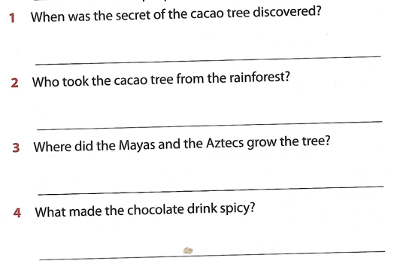

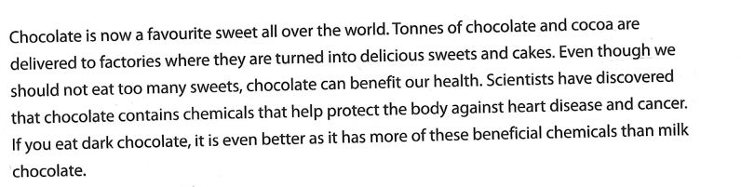
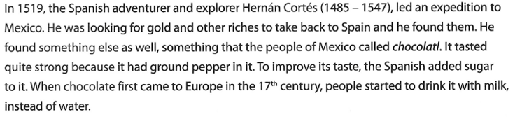
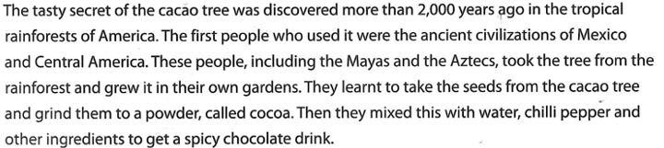

8/

6. Natančno preberi besedilo in odgovori na vprašanja.

