What are classroom regarding languages today like?

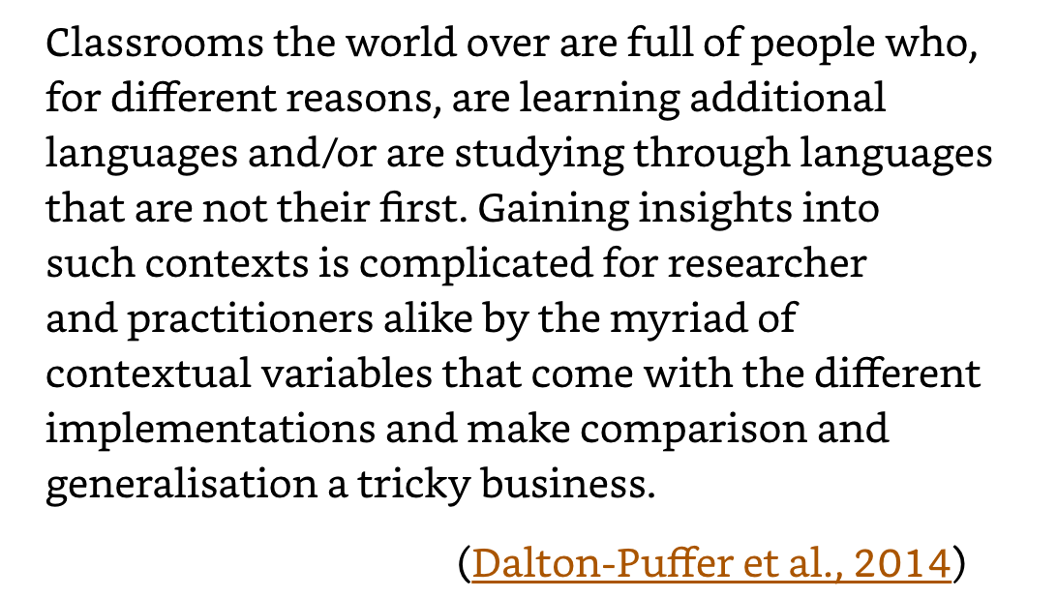

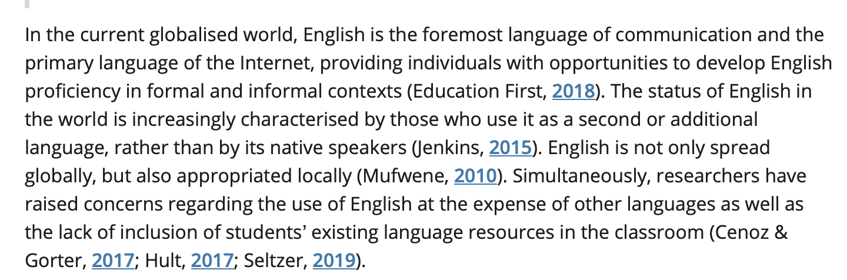

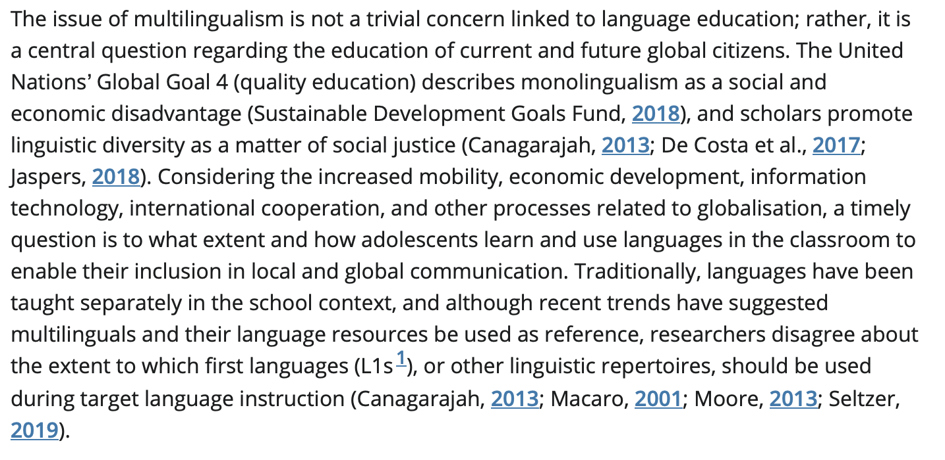

Brevik, L.M. and Rindal, U. (2020), Language Use in the Classroom: Balancing Target Language Exposure With the Need for Other Languages. TESOL J, 54: 925-953. https://doi.org/10.1002/tesq.564

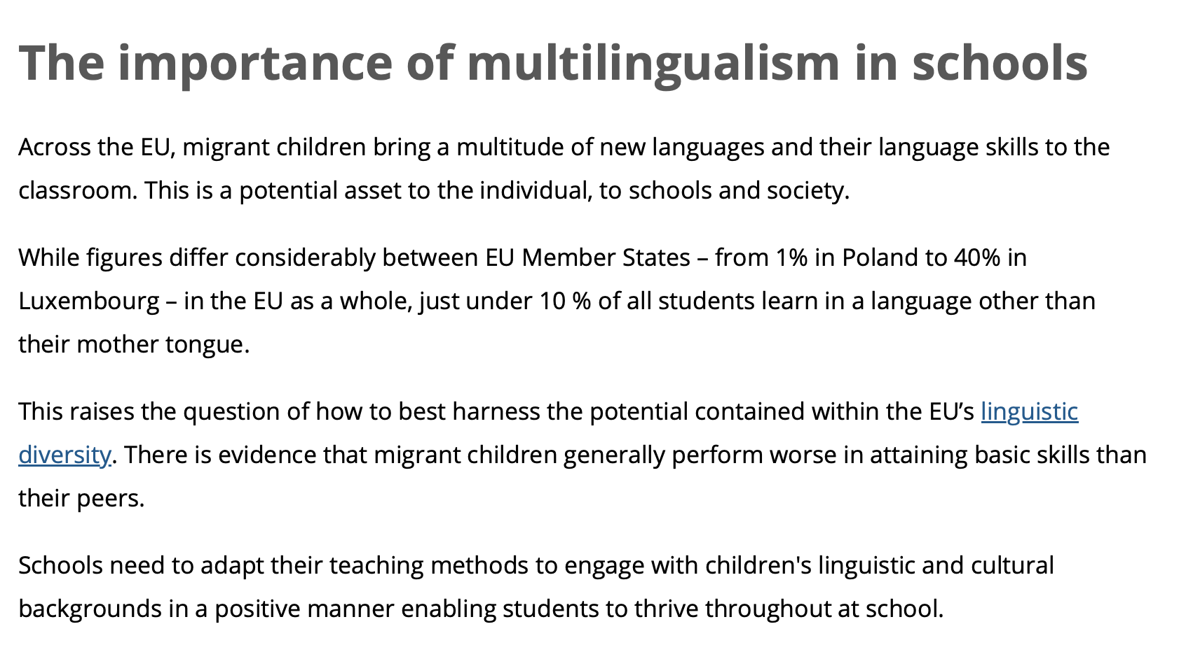
https://education.ec.europa.eu/education-levels/school-education/multilingual-classrooms

Young migrants
Supporting multilingual classrooms, ECML

https://www.ecml.at/TrainingConsultancy/Multilingualclassrooms/tabid/1816/language/en-GB/Default.aspx

European Commission, Directorate-General for Education, Youth, Sport and Culture, Language teaching and learning in multilingual classrooms, Publications Office, 2016,https://data.europa.eu/doi/10.2766/766802

