What is English for Academic Purposes (EAP)?

English for Academic Purposes, or EAP for short, is the English, which is needed to study or conduct research using that language. It is most commonly associated with preparation for undergraduate study, though many other EAP contexts exist, including courses to prepare students for post-graduate study, longer courses such as foundation year programmes, and courses, which take place at the same time as the study, called in-sessional courses.

English for Academic Purposes (EAP) vs. General English (GE)
Two fundamental areas of difference are the aims of the courses and reasons for study. The aims of an EAP course are to meet the needs of particular learners. This contrasts with GE, which has the aim of improving overall English ability in different areas (reading, speaking, vocabulary and so on). The reason why students study EAP is that they study or plan to study another subject in English or do research in English. GE, on the other hand, is studied because it is a compulsory course (e.g. at school), or because it interests them.
A third difference, shaped by the previous two, is the focus of the course. Unlike GE courses, which are level driven and focus on language, EAP courses are driven by needs, and focus on the learner and the situation.
Another difference is the timeframe. EAP courses tend to be very short courses. GE courses, in contrast, can be more flexible, and may cover many years of study. As a result of the short timeframe and reasons for study, EAP courses tend to be very intensive.
There is also a difference in terms of skills focus. EAP courses tend to devote more time to reading and writing, since these are the most important skills for academic study, and for learning and assessment at university. In contrast, GE courses tend to give more time to speaking and listening.
The text types and approach also differ. EAP generally uses authentic, academic texts, which are genre based and, because of their complexity, tend to be explored more fully. GE texts, on the other hand, are often chosen because the topic is interesting, and are usually not explored in great depth. They tend to be conversational or social in nature.
The form of expression is another area of difference. In EAP, clarity and objectivity are prized, in contrast to GE, for which self-expression and creativity are usually important.
Another difference is the role of the teacher. In EAP, the role of teacher and student are usually more equal. The teacher brings language expertise and knowledge of teaching to the classroom, while students may be more knowledgeable about their own specialist subject. This situation is different from a GE course, for which the teacher is seen as the language expert.
A final difference is the range of learning skills involved. In EAP, there will almost always be a strong emphasis on study skills, in particular learner autonomy and critical thinking. In a GE class, if learning skills are covered, they tend to be limited to language learning skills.
A summary of differences between EAP and GE.
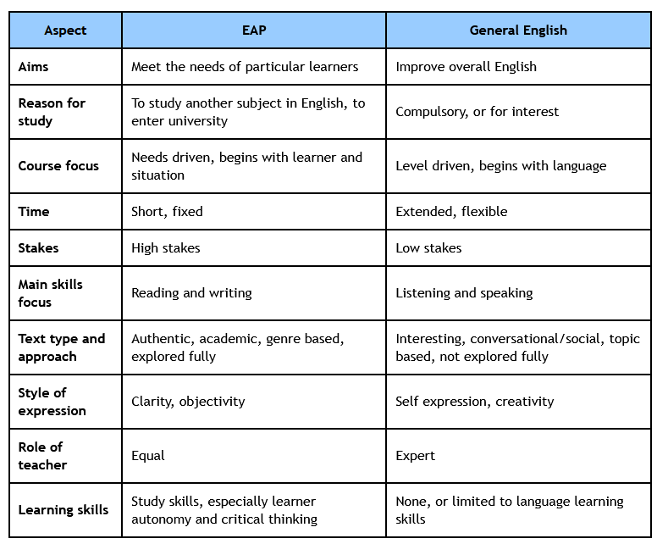
Some od the EAP skills you will develop include:
- listening and listening comprehension
- reading comprehension
- critical thinking
- note-taking skills
- academic speaking
- writing skills (including referencing skills)

