FROZEN – PRACTISE WORKSHEET
1. K sliki pripiši, kaj prikazuje. Pomagaj si z besedami v okvirju.
ICE SCARED MOUNTAIN WEAK

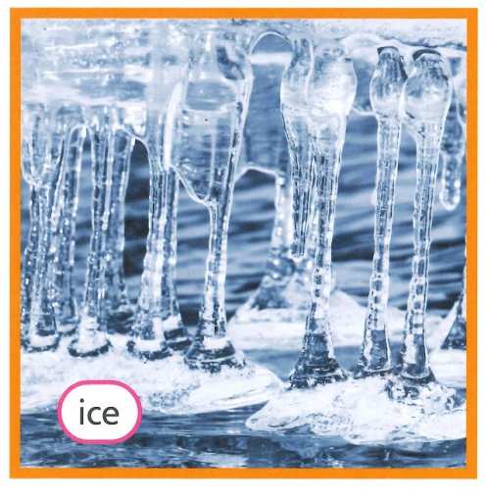
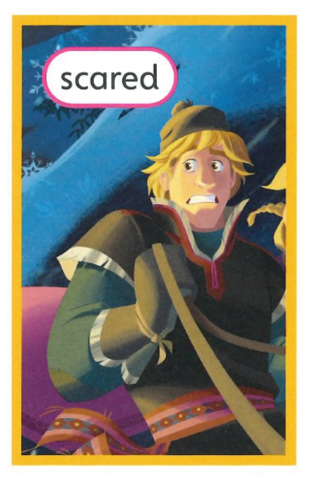
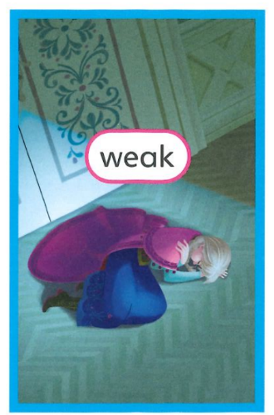
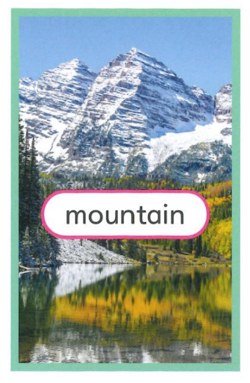

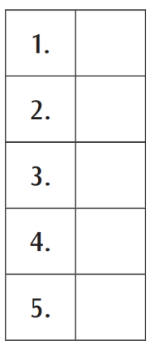
2. Poveži dele povedi. En del povedi je odveč.
- Elsa (A) asks Elsa to melt the ice.
- Anna (B) is a magic snowman.
- Olaf (C) is Queen of Arendelle.
- Kristoff (D) is a castle.
- Arendelle (E) helps Anna in the mountains.
(F) is frozen.

3. Dopolni povedi z ustreznimi besedami.
______________ (Olaf / Anna / Elsa) makes a blizzard of ice and snow.
Anna is a ______________ (young / old / magic) woman now and Elsa is Queen.
Elsa's magic snow and ice are ______________ (warm / dangerous / scared).

4. V kateri knjigi se pojavijo navedene osebe ali ključne besede?
 | Monsters University | Finding Dory | Frozen
Mike
Jenny
California
Anna
Oozma Kappa
whale
Arendelle
reef

5. K povedim zapiši ✓, če so pravilne, in Χ, če so napačne.
Monsters University
- Mike is a small green monster. _____
- Oozma Kappa are scary. _____
Finding Dory
- Marlin and Nemo want to help Dory. _____
- An octopus cathes Dory and puts her in a fish tank. _____
Frozen
- Elsa makes a small snowman in the mountains. _____
- Magic ice flies and hits Anna's heart. _____

