UTRJEVANJE 1
1. POSLUŠAJ IN ZAPIŠI ČRKE.
(dži, ejč, ai, džei, wai, ou, ar, dablju, kju, ej)

2. POSLUŠAJ IN ZAPIŠI ŠTEVILA.
(thirty-seven, forty-five, seventeen, twelve, twenty, fifty-four, one hundred, thirty-one, eight, ninety)

3. POVEŽI.
E. Who's Polly's brother? ___ She’s got one sister.
E. How do you spell your name? ___ It’s Jack.
N. How many cousins have you got? ___ He's seven.
L. Is it a lion? ___ Yes, it is.
D. What are these? ___ They are jumpers.
L. How old is your brother? ___ Her name is Alice.
O. What's your mum’s name? ___ I’ve got three cousins.
W. How many sisters has Polly got? ___ M-A-R-Y.

4. DOPOLNI MANJKAJOČE ČRKE, KI SE NANAŠAJO NA DRUŽINSKE ČLANE.
_ U_ _
S _ _ _ E_
G _ _ _ D _ _ _ _ _ _ S
C _ _ _ _
B _ _ _ H_ _
P _ _ _ _ _S
C _ _ _ _ N

5. ZAPIŠI ŠTEVILA Z BESEDO.
71 ________________ 23 ________________100 ________________
54 ________________ 13 ________________ 68 ________________

6. SMISELNO DOPOLNI POVEDI.
1. Have you got any ____________? 2. Jack ______ _____two sisters.
3. Greg hasn’t got _____ brothers. 4. This is _______ (njegova) bag.
5. I’m __________ than my friend. 6. She ____ swim but she ____ ski.

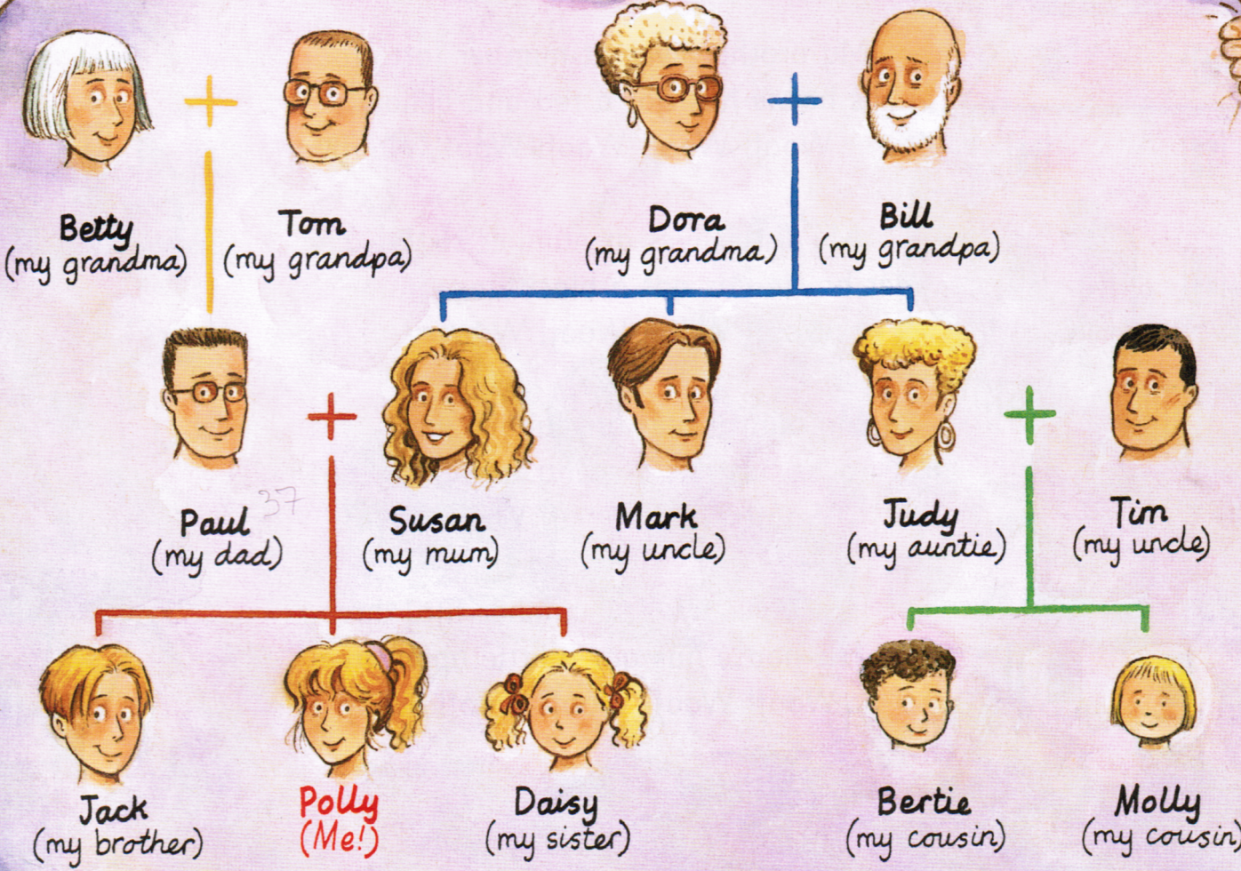
7. ODGOVORI V CELIH POVEDIH.
How many brothers has Jack got?
______________________________________
Who is Susan's brother?
______________________________________
Who is Bill married to?
______________________________________
Who is Bertie?
______________________________________
How many grandpas has Polly got?
______________________________________

8. PREDSTAVLJAJ SI, DA JE NA SLIKI TVOJ STRIC. OPIŠI GA.
______________________________________________________________________________________________________________________________________________________________________________________________________________________________________________________________________________________________________________________________________________________________________________________________________________________________________________________________________________________________________________________________________________________
IME: TIM
STAROST: 35
LASJE; KRATKI SKODRANI, BRADA
POSTAVA: VISOK, MOČNEJŠA
SESTRA: 3
BRAT: 0



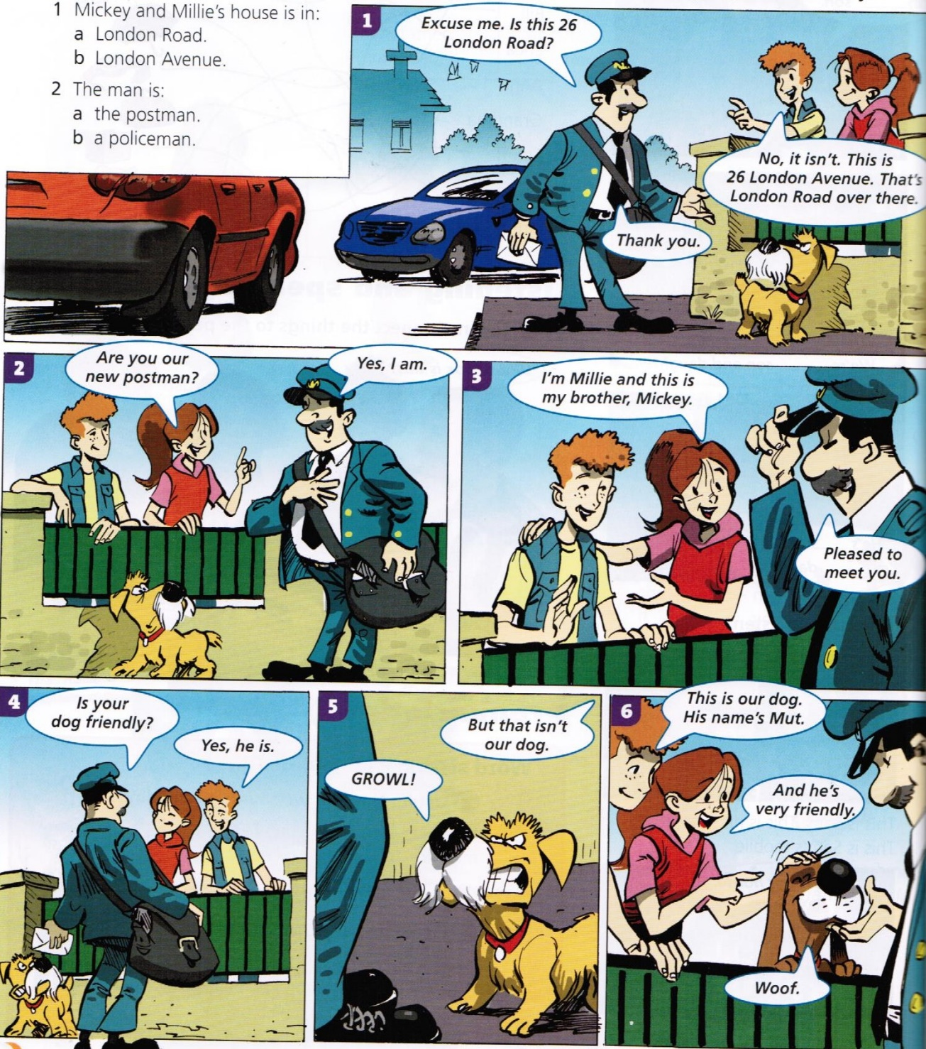
9. PREBERI IN ODGOVORI Z YES ALI NO.

The man is a postman. ______ Millie is Mickey's brother. ______
Mickey and Millie's house is in London Avenue. ______
Mut is their cat. ______ Mut is friendly. ______
REŠITVE:
- G H I J Y O R W Q A

- 37, 45, 17, 12, 20, 54, 100, 31, 80, 90

- WELL DONE

- GRANDPARENTS, SISTER, AUNT, CHILD, BROTHER, COUSIN, PARENTS

- SEVENTY-ONE, TWENTY-THREE, ONE/A HUNDRED, FIFTY-FOUR, THIRTEEN, SIXTY-EIGHT

- 1 brothers/sisters/uncles … 2 has got 3 any 4 his 5 older/younger 6 can, can’t

- Jack/He hasn’t got any brothers.
Susan’s brother is Mark. / It’s Mark. / He’s Mark.
He/Bill is married to Dora.
Bertie is Polly’s cousin/Molly’s brother.
She has got/She’s got 2 grandpas.
- This is my uncle.
His name is Tim.
He’s thirty-five years old.
He’s got short curly hair and a beard.
He’s tall and fat.
He’s got 3 sisters.
He hasn’t got any brothers.
He’s ALI He is
He’s got ALI He has got
9. The man is a postman. YES Millie is Mickey's brother. NO
Mickey and Millie's house is in London Avenue. YES
Mut is their cat. NO Mut is friendly. YES

UTRJEVANJE 2

1. Odgovori na vprašanja v celih povedih.

1. How many sisters have you got? _________________________________________________________
2. What are these? ________________________________________ 3. What does your friend look like? ______________________________ __________________________________________________________4. How many brothers has your friend got? __________________________________________________________

2. Smiselno napiši začetek povedi.
1. _______________________ any cousins.
2. _______________________ long red hair and blue eyes.
3. ________________________ younger than my sister.
4. ________________________ swim, ski and play football.

3. Oglej si Pollyino družinsko drevo in dopolni povedi.
Jack is my ___________.
Dora and Bill have got 3 _____________.
Judy is my ___________.
Paul and Susan are my ___________.
Tom is married to _______.
Betty is my ___________.
Mark is my __________.
Molly and Bertie are my _____________.

4. Preberi in nadaljuj.
ten, twenty, _________, ___________, ___________, __________, ___________
eighty-one, eighty-two, _______________________, ____________________, _________________________, __________________________

5. Napiši vprašanja.
_______________________________________? It's a dinosaur.
_______________________________________? I’m Tom.
_______________________________________? I’ve got 3 sisters.
_______________________________________? M-A-R-Y.
6. Dopolni povedi.
A bat has got big ___________ (krila) and long ___________ (ušesa).
Magic Mervin has got lots of _________________ (baloni).
In the magic box there is a long colourful _____________ (šal).
Madame Michel sees a ____________ (krožnik) in the sink.

7. S celimi povedmi opiši sebe (ime, starost, koliko bratov in sester imaš, v kaj si oblečen, kaj znaš, primerjaj starost z enim družinskim članom).

______________________________________________________________________________________________________________________________________________________________________________________________________________________________________________________________________________________________________________________________________________________________________________________________________________________________________________________________________________________________________________________________________

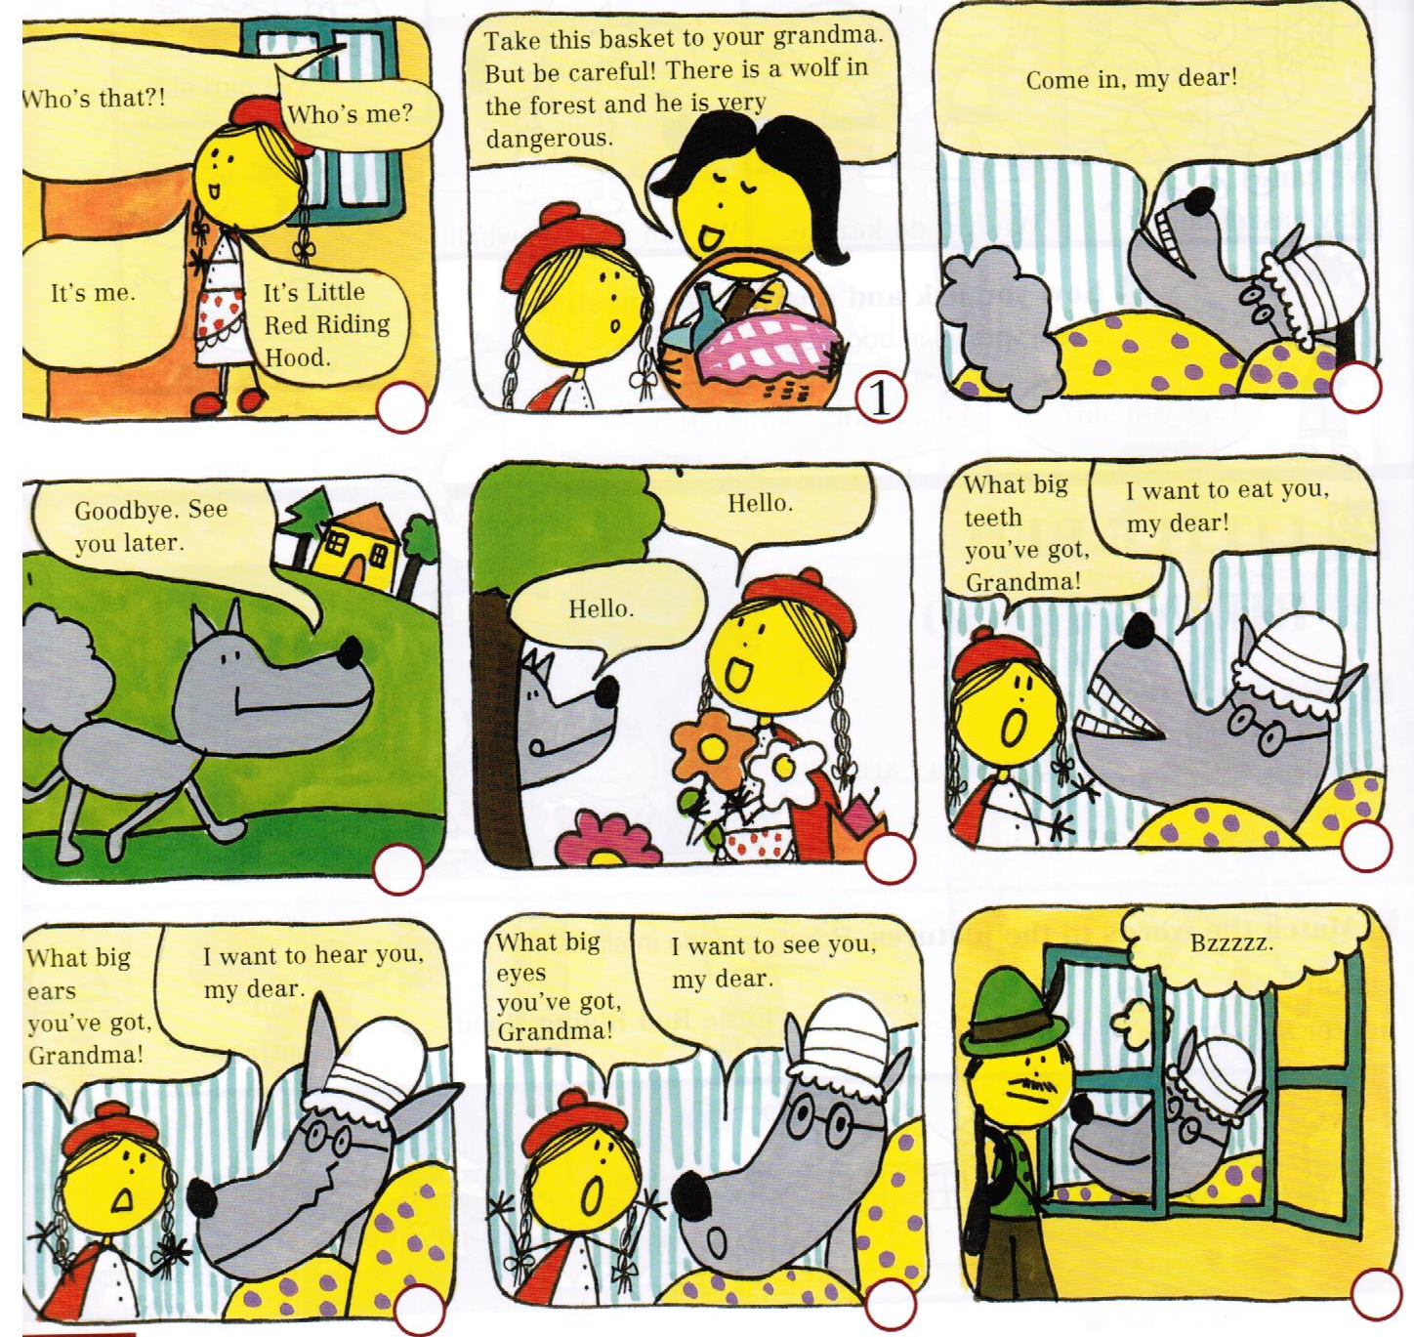
8. Preberi in oštevilči slike od 1 do 9.

9. Poveži tako, da števila zapišeš na črte.
1 The Little Red Riding Hood ___ the bad wolf here.
2 There are sandwiches and a cake ___ kills the wolf.
3 She walks and walks ___ eats grandma and Little Red Riding Hood.
4 She picks ___ goes to her grandma.
5 She meets ___ all happy together.
6 The wolf ___ through the forest.
7 The hunter ___ beautiful flowers.
8 At the end they are ___ in the basket.
REŠITVE
1.
1. I’ve got 1 sister/2 sisters. I haven’t got any sisters.
2. They are balls. / They’re balls.
3. npr. She/He’s got long brown hair and blue eyes. ALI He/She has got
4. She/He’s got 1 brother. She/He hasn’t got any brothers.
2.
I haven’t got / She/He hasn’t got
I’ve got / She’s got / He’s got
I’m / He’s / She’s
I can / I can’t
3. brother, children, aunt, parents, Betty, grandma, uncle, cousins
4. thirty, forty, fifty, sixty, seventy
eighty-three, eighty-four, eighty-five, eighty-six
5. What’s this?
What’s your name?
How many sisters have you got?
How do you spell Mary/your name?
6. wings, ears, balloons, scarf, plate
7. I’m/My name is I’m … years old. I’ve got/I haven’t got any …
I’m wearing … I can … Npr. I’m older/younger than my sister.
8.
4 1 5
3 2 8
6/7 6/7 9
9. 5, 7, 6, 1, 8, 3, 4, 2

UTRJEVANJE 3

1. Števila 47, 36, 100, 15, 18, 20, 63, 91, 54, 35, 12, 79 napiši z besedo.
__________________________________________________________________________________________________________________________________________________________________________________________________________________________________________________________________________________________________________________________________________________________________________________________________________________________________________________________________________________________________________________________________________________________________________________________________________________________________________________________________________________________________________________________________________________________________________________________________________________________________________________________________________________________________________________________________________________________________________________________________________________________________

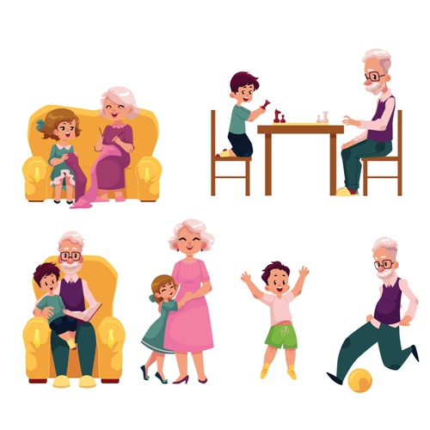
2. Besede postavi v pravilen vrstni red in napiši povedi.
grandma wavy my hair short has got
__________________________________________________ .

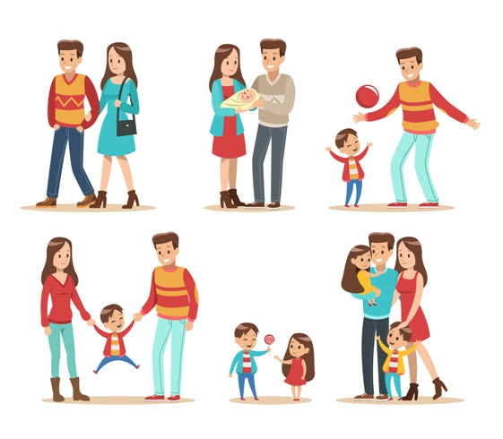
younger my I'm than parents
_______________________________________________ .

football my play grandpa I with
_______________________________________________ .

she two has got brothers
_______________________________________________ .

3. Obkroži pravilen začetek povedi.
1. I’ve got/I haven’t got any cousins. 4. I’m/I’ve got older than my sister.
2. I’m/I’ve got blue eyes. 5. I’m/I’ve got one brother.
3. I’m/I’ve got thin. 6. I’m/I haven’t got straight hair.
4. Popravi napake. V vsaki povedi je le ena napaka.

I has got three brothers. I’ve got ten years old.
She’s playing guitar. My mum have got long hair.
He’s got curli hair. I’m younger then my dad.

5. Dopolni opis z besedami iz okvirja.
glasses, sixty-three, older, green, blond, taking, old, grandma

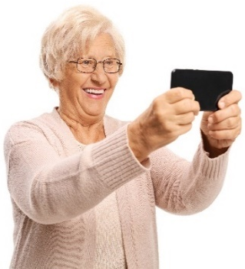
This is my _____________. She is _____________ years
old. She has got _____________. She has got short
_____________ hair and _____________ eyes.
She is _____________ and tall. She is _____________ than
me. She is _____________ a photo.


6. Poveži vprašanja z odgovori tako, da na črto napišeš črko.
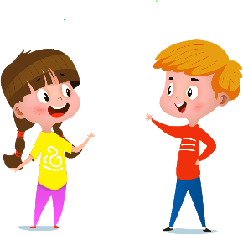
A) How many uncles have you got? __ M-I-A.
B) How do you spell your name? __ I’ve got long hair.
C) What are you doing? __ I’m ten years old.
D) What do you look like? __ I’ve got three uncles.
E) How old are you? __ I’m tidying up.

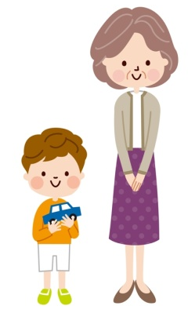
7. Primerjaj babico in brata. Uporabi older, younger.
_________________________________________________________________________________________________________________________________________________________________________________________________________________________________________________________________________________________________________________________________________________________________________________________________________________________________________________________________________________________________________________________________________________________________________________________________________________________________________________

8. Dopolni pogovor s povedmi v okvirju.
No, he hasn't. He's an excellent teacher. Yes and a beard, too.
Your uncle! That's great. He's got short black hair and glasses. No, he's short.

Matt Hi, Dora. Have you got a new English teacher?
Dora Hello, Matt. Yes. ______________________________________. His name is Dan.
Matt What does he look like?
Dora ____________________________________________________
Matt Has he got curly hair?
Dora ____________________________________________________
Matt Has he got a moustache?
Dora ____________________________________________________
Matt Is he tall?
Dora ____________________________________________________
Matt I know him. He's my uncle.
Dora ____________________________________________________
9. Preberi povedi o učitelju Danu in označi pravilne oziroma napačne trditve.

Dan teaches Slovene. true false
He is tall. true false
He has got glasses. true false
He hasn't got a beard. true false
He's got curly hair. true false
He hasn't got straight hair. true false
He isn't fat. true false
He is Matt's uncle. true false

REŠITVE
1. forty-seven, thirty-six, one hundred, fifteen, eighteen, twenty, sixty-three, ninety-one, fifty-four, thirty-five, twelve, seventy-nine

2. My grandma has got short wavy hair.
I'm younger than my parents.
I play football with my grandpa.
She has got two brothers.

3. 1. I haven't got, 2. I've got, 3. I'm, 4. I'm, 5. I've got, 6. I haven't got

4. I have got three brothers. ALI She/He has got three brothers. I'm ten years old. She's playing the/a guitar. My mum has got long hair ALI I have got long hair. He's got curly hair. I'm younger than my dad.

5. grandma, sixty-three, glasses, blond, green, old, older, taking

6. B, D, E, A, C

7. My grandma is older than my brother. My brother is younger than my grandma.

8.
he's an excellent teacher.
He's got short black hair and glasses.
No, he hasn't.
Yes and a beard, too.
No, he's short.
Your uncle! That's great.

FALSE, FALSE, TRUE, FALSE, FALSE, FALSE, TRUE, TRUE

