1. Dopolni besedilo o potresih!
Earthquake is a shaking of the ground. They can damage ______ (zgradbe), ______ (mostovi), _____ (jezovi) and other structures. Earthquakes can make ______________ (reke) change their ________________ (tok). They can trigger __________ (zemeljski plazovi) that cause great __________ (škoda) and loss of ____________ (izguba življenja). Huge ___________ (valovi) called ____________ (cunamiji) flood ______________ (obale) for many miles. During earthquakes, many people die because buildings, bridges, etc. fall or _____ (zrušiti se). Fires break out when electric ________ (žice) break and gas pipelines _______ (eksplodirati). The ____________ (plošče) move ______________ (počasi) all the time. The movement of these plates produces ____________ (prelomnice/razpoke). Most earthquakes ______________ (zgoditi se) along a fault. Most earthquakes usually begin _______________ (globoko) in the ground.The point in the earth where the rocks first break is called the ______________ (žarišče) or the hypocentre. The focus of most earthquakes lies less than 70 km _______ (pod) the __________ (površje). The point on the surface of the earth directly above the focus is called the ______________ (središče potresa). If you are indoors, you should stand under the ____________ (podboj vrat) or crouch under the table You should stay away from ____________ (okna) and _____________ (zidovi). Don’t try to leave the building until the shaking has stopped. If you are outdoors, you should move away from tall trees, ___________ ___________ (strma pobočja), buildings and ___________ ____________(električni vodi).
2. Poveži dele povedi.
1.1 1 | Earthquake is a | A | electric wires break and gas pipelines explode.
2. 2 | Landslides cause | B | waves that can flood the coast.
3. 3 | Fires can break out as | C | is also known as the hypocentre.
4. 4 | The outer shell of the Earth | D | are visible on the surface.
5. 5 | Some faults | E | shaking of the ground.
6. 6 | Tsunamis are huge | F | surface directly above the focus of the quake.
7. 7 | The focus of the earthquake | G | consists of a number of large plates.
8. 8 | Epicentre is the point on the | H | great damage and loss of life.

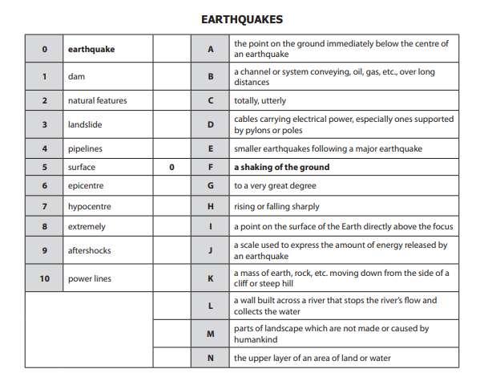
3. Poveži besede z ustrezno razlago.

