Delovni list: Weather (Vreme)

1. Izpolni prazna mesta (Fill in the blanks)
Dopolni stavke z ustrezno besedo: (sunny, rainy, cloudy, windy, snowy).
- Today it is __________. I need my umbrella.
- In winter, it is often __________. We can make a snowman!
- Look at the sky! It is so __________. I think it will rain.
- It is __________ outside. Let’s fly a kite!
- Wear your sunglasses! It is __________ today.

2. Obkroži pravilni odgovor (Choose the correct answer)
- What is the weather like when you see the sun?
a) Snowy
b) Sunny
c) Windy

- What is the weather like when it’s raining?
a) Cloudy
b) Rainy
c) Sunny

- What do you wear when it’s snowy?
a) Shorts
b) A coat
c) Sandals

- Which weather is best for flying a kite?
a) Windy
b) Rainy
c) Snowy

- Vremenska napoved (Weather forecast)

Poglej spodnjo sliko vremenske karte in napiši, kakšno je vreme v posameznem mestu.
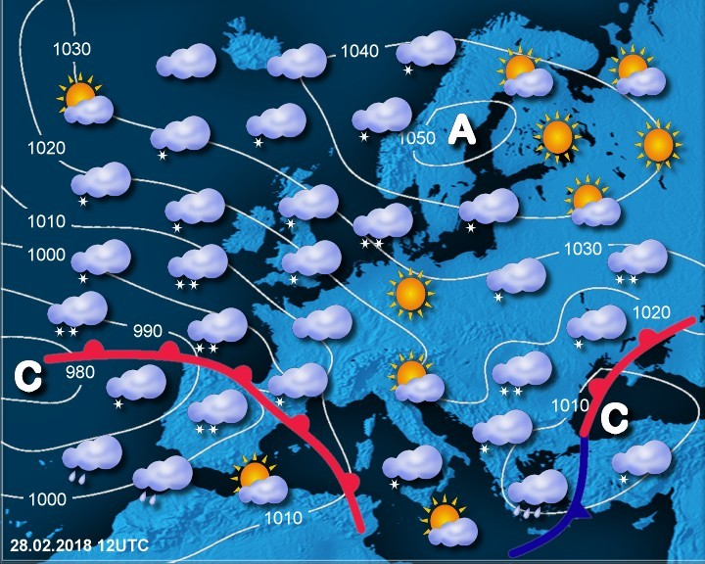
- In London, it is __________.
- In Paris, it is __________.
- In Berlin, it is __________.
- In Rome, it is __________.
- In Madrid, it is __________.

Navodilo za učence:
Ko končaš delovni list, ga oddaj učitelju ali naloži v spletno učilnico Moodle. 😊

