SIGHTS OF ENGLAND
- Stonehenge

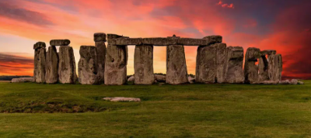
Stonehenge is one of the most famous landmarks in England and in the whole world. It is a circle of very large stones standing in a big open field in the south of England, near the city of Salisbury. The stones are huge and heavy, and nobody knows exactly how people moved them there thousands of years ago. Stonehenge is about 5,000 years old, and it was built long before modern machines or tools existed.
Many people believe Stonehenge was used for religious or ceremonial purposes. Some think it was a temple where ancient people worshipped the sun or the stars. Others think it was a kind of calendar, because the stones line up with the sunrise and sunset on special days like the summer and winter solstice. On those days, the sun rises and sets in a very special way, shining directly through some of the stones. Even today, many people visit Stonehenge to celebrate these moments.
Stonehenge is made of two main types of stone: larger ones called sarsen stones and smaller ones called bluestones. The sarsen stones come from nearby areas, but the bluestones came from mountains in Wales, which is very far away. This shows that the people who built Stonehenge were very clever and strong.
Today, Stonehenge is protected as a World Heritage Site. Thousands of tourists visit every year to walk around the stones and learn about ancient history. You can’t touch the stones anymore, but you can walk near them and feel the special atmosphere of the place. Stonehenge is quiet and mysterious, and it makes people think about life long ago.

- The Lake District

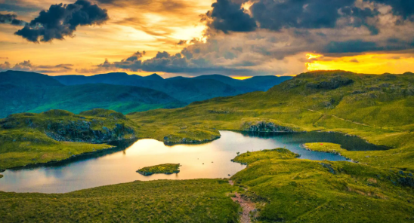
The Lake District is a beautiful area in the north-west of England. It is known for its stunning lakes, high hills, and green valleys. The area is a national park, which means it is protected so that nature and wildlife can stay safe. The Lake District is the largest national park in England and is also a UNESCO World Heritage Site.
There are sixteen main lakes in the Lake District, and the biggest one is called Windermere. People love visiting the lakes to go boating, swimming, or walking along the shores. The mountains, called “fells,” are also very popular for hiking. The tallest mountain in England, Scafell Pike, is found here. When people climb to the top, they can see amazing views of water, hills, and countryside all around.
The Lake District is also famous for its connection to English writers and poets. One of the most famous poets, William Wordsworth, lived there and wrote beautiful poems about nature. His home, Dove Cottage, is now a small museum where visitors can learn about his life and work.
In every season, the Lake District has something special to offer. In spring, the fields are full of flowers and lambs. In summer, the lakes sparkle under the sun. In autumn, the trees turn orange and gold, and in winter, the mountains are covered in snow. Many visitors come to relax, enjoy the quiet, and take photos of the amazing scenery.
The Lake District shows the natural beauty of England and helps people understand why it is so important to protect nature for the future.

- Big Ben and the Houses of Parliament

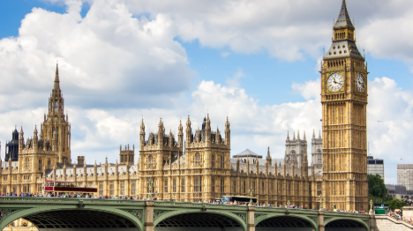
Big Ben is one of the best-known symbols of London and England. Many people think Big Ben is the name of the clock tower, but it is actually the name of the big bell inside the tower. The tower’s real name is the Elizabeth Tower. It stands next to the River Thames, attached to the Palace of Westminster, also called the Houses of Parliament.
The clock tower was completed in 1859 and has become a very important part of London’s skyline. The clock is famous for being very accurate, and its bells ring every hour. The sound of Big Ben is broadcast on radio and television, and it is especially important on New Year’s Eve when people across the country listen to it at midnight.
The Houses of Parliament next to Big Ben are where the government of the United Kingdom meets. It is a beautiful building with Gothic-style architecture and many tall spires. Visitors can take guided tours to see the rooms where laws are made and where members of Parliament debate important topics.
At night, Big Ben and the Houses of Parliament are lit up, making them look even more impressive. Tourists love to take photos from Westminster Bridge or the other side of the river. Big Ben is not just a clock; it is a national symbol of British history, democracy, and tradition.

- The White Cliffs of Dover
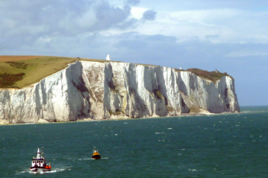
The White Cliffs of Dover are one of England’s most beautiful natural landmarks. They are found on the south coast, near the town of Dover, where England is closest to France. The cliffs are made of chalk, which gives them their bright white color. They rise high above the English Channel and can be seen from far away, even from the sea.
For hundreds of years, the White Cliffs have been a symbol of hope and safety for the English people. When sailors or soldiers came home by boat, the first thing they often saw was the shining white cliffs. During World War II, they became an important symbol of Britain’s strength and courage.
Visitors can walk along the top of the cliffs and enjoy wonderful views of the sea and the French coast on clear days. There are also paths that lead to quiet beaches below. The cliffs are home to many types of birds and plants, making them a great place for nature lovers.
The National Trust protects the area to keep it beautiful and safe. Standing on the cliffs, with the wind in your hair and the sea below, gives you a true feeling of freedom and peace. The White Cliffs of Dover are a reminder of England’s natural beauty and proud history.
- Windsor Castle

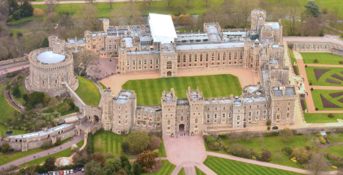
Windsor Castle is one of the most famous castles in England and one of the homes of the British royal family. It is located in the town of Windsor, not far from London, and it is the oldest and largest castle in the world that is still used by a royal family today. The castle was first built in the 11th century, more than 900 years ago, by William the Conqueror.
Windsor Castle has a very long and interesting history. Many kings and queens have lived there, and it has been changed and rebuilt many times. The castle is made of stone and sits on a hill, with thick walls and tall towers. It looks like something from a fairy tale. Inside, there are many beautiful rooms, old paintings, and fine furniture. The State Apartments are very grand, and visitors can walk through them and see where important guests are received.
One of the most famous parts of the castle is St George’s Chapel, a beautiful church built in the Gothic style. Many royal weddings and funerals have taken place there. Some kings and queens, including Queen Elizabeth II, are buried in the chapel.
Every year, thousands of tourists visit Windsor Castle. When the royal family is not staying there, the castle is open to the public. Visitors can watch the “Changing of the Guard,” where soldiers in red uniforms and tall black hats march and change places in a special ceremony.
Windsor Castle is not only a home but also a piece of living history. It shows how the monarchy and traditions of England have continued for centuries.

- Hadrian’s Wall

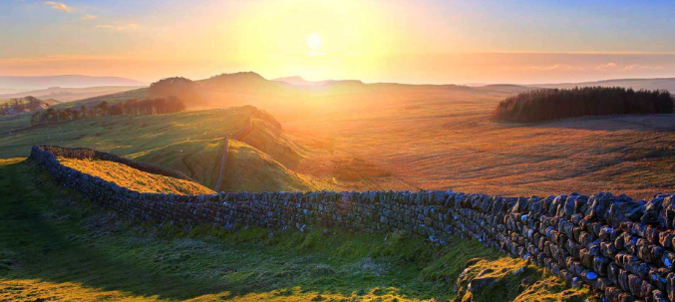
Hadrian’s Wall is an ancient Roman wall in the north of England. It was built almost 2,000 years ago, during the time of the Roman Empire, when Emperor Hadrian ruled Britain. The wall stretched for about 73 miles (117 kilometers) from the east coast to the west coast, near the border with Scotland.
The Romans built the wall to protect their land and to control who could enter and leave Roman Britain. It was made of stone and earth, and along the wall there were many forts, towers, and gates. Roman soldiers lived in these forts, watching for enemies and guarding the frontier.
Today, parts of Hadrian’s Wall are still standing, and you can walk along them. There is a famous walking path called the Hadrian’s Wall Path National Trail, which follows the wall’s route from coast to coast. Along the way, visitors can see beautiful countryside, old ruins, and museums that tell the story of Roman life in Britain.
Hadrian’s Wall is a UNESCO World Heritage Site, which means it is protected as a place of great historical importance. It reminds people of how powerful the Roman Empire once was and how it shaped the history of Britain.
For many visitors, walking along the wall feels like walking through history — a journey back to ancient times.

- The Cotswolds

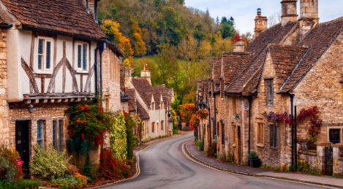
The Cotswolds is a beautiful region in the south and west of England, famous for its rolling green hills, stone villages, and peaceful countryside. It covers several counties, including Gloucestershire, Oxfordshire, and Wiltshire. The area is protected as an Area of Outstanding Natural Beauty, meaning it is special and must be preserved.
The villages in the Cotswolds are built with honey-colored limestone, which gives them a warm, golden glow. Streets are lined with small cottages, gardens full of flowers, and old churches. Some of the best-known villages are Bourton-on-the-Water, Bibury, and Stow-on-the-Wold. Each has its own charm and character.
Visitors love walking or cycling through the Cotswolds. There are many footpaths, such as the Cotswold Way, which goes for more than 100 miles through hills and fields. Along the way, travelers see sheep grazing, rivers, and woods — a picture of traditional English life.
The Cotswolds are also famous for local markets, tea rooms, and country pubs. People can try traditional English food, buy handmade crafts, or simply relax and enjoy the quiet atmosphere.
The Cotswolds show the gentle beauty of rural England and are often called “the heart of the English countryside.”

- The Jurassic Coast

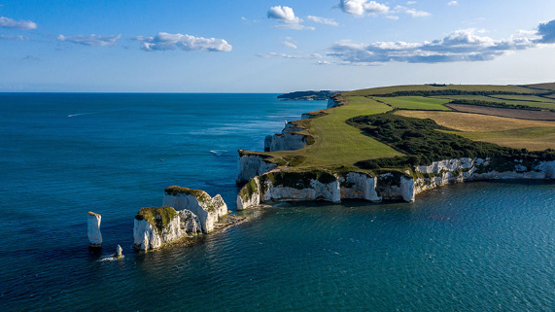
The Jurassic Coast is a stretch of coastline in the south of England, between the towns of Exmouth in Devon and Studland Bay in Dorset. It is about 95 miles (150 kilometers) long and is famous for its amazing cliffs, beaches, and rocks. The name “Jurassic Coast” comes from the many fossils found there, some from over 180 million years ago.
The cliffs along the coast show layers of rock from different times in Earth’s history — the Triassic, Jurassic, and Cretaceous periods. This makes the area very important for scientists who study geology and fossils. Visitors can even find small fossils on the beaches.
One of the most famous spots on the Jurassic Coast is Durdle Door, a natural stone arch that rises from the sea. Another popular place is Lulworth Cove, a beautiful round bay with clear blue water. These places are perfect for walking, swimming, or taking photographs.
The Jurassic Coast is a UNESCO World Heritage Site and a great example of England’s natural beauty. It teaches people about the history of our planet and reminds us how much the Earth has changed over millions of years.

- Durham Cathedral and Castle

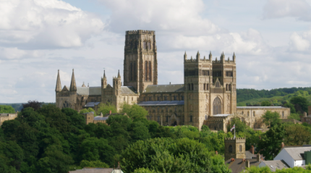
Durham Cathedral and Castle are in the city of Durham, in the north-east of England. They stand high above the River Wear and can be seen from far away. The cathedral and castle were built almost 1,000 years ago and are both UNESCO World Heritage Sites.
Durham Cathedral is one of the best examples of Norman architecture in England. It was built in the 11th century and is famous for its tall towers, stone arches, and beautiful stained-glass windows. Inside, the building is quiet and full of history. It is also the resting place of Saint Cuthbert, an important religious figure in English history.
Next to the cathedral is Durham Castle, which was built around the same time. It was once the home of powerful bishops and later became part of Durham University. Today, some students even live in the castle, which makes it a very unique place.
Visitors to Durham can walk along the old streets, visit the riverbanks, and enjoy the view of the cathedral and castle together. They look especially beautiful at sunset.
Durham Cathedral and Castle show the long religious and academic traditions of England and are a wonderful combination of history, architecture, and culture.

- Peak District National Park

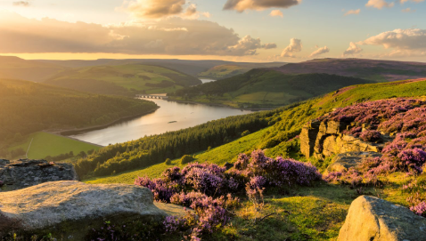
The Peak District is a national park in the center of England, between Manchester and Sheffield. It was the first national park in the United Kingdom, created in 1951. The area is known for its hills, caves, rivers, and small stone villages. It covers more than 500 square miles.
The Peak District has two main parts: the Dark Peak, with its high moorlands and rocky landscapes, and the White Peak, with softer hills and limestone valleys. The park is very popular for walking, cycling, and rock climbing. One of the most famous walks is up Mam Tor, also called the “Shivering Mountain,” which gives wonderful views of the countryside.
There are also many beautiful towns, such as Bakewell (famous for Bakewell pudding) and Castleton, known for its caves and old castle ruins. The area has lots of wildlife too, including birds, sheep, and deer.
The Peak District is loved by nature lovers and city people who come to relax and enjoy the fresh air. In every season, it offers something special — green fields in spring, wildflowers in summer, colorful leaves in autumn, and snow on the hills in winter.
It is a perfect example of England’s natural charm and peaceful beauty.

England’s Cultural and Natural Landmarks - exercises
- Besedišče

- Poveži besede z njihovimi pomeni.
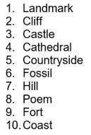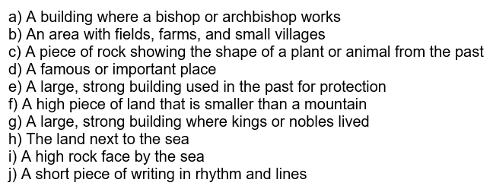

- Bralno razumevanje - Odgovori NA KRATKO.

1. Stonehenge
- How old is Stonehenge?
- What are the two main types of stones used?
- Why do some people think it was a calendar?

2. The Lake District
- What is the biggest lake called?
- Who was the famous poet who lived there?
- What can people do in the Lake District?

3. Big Ben and the Houses of Parliament
- What is Big Ben’s real name?
- What happens at midnight on New Year’s Eve?
- What kind of building is the Palace of Westminster?

4. The White Cliffs of Dover
- What are the cliffs made of?
- Why were they important during World War II?
- What can you see from the top on clear days?

5. Windsor Castle
- Who built the first part of the castle?
- What is St George’s Chapel used for?
- What special event can visitors watch outside the castle?

6. Hadrian’s Wall
- Who built Hadrian’s Wall?
- Why did they build it?
- What can visitors do there today?

7. The Cotswolds
- What are the villages made of?
- What is the Cotswold Way?
- Why do people love visiting the Cotswolds?

8. The Jurassic Coast
- How old are some of the fossils found there?
- What is Durdle Door?
- What does the Jurassic Coast teach us?

9. Durham Cathedral and Castle
- How old are these buildings?
- Who is buried in the cathedral?
- Who lives in the castle today?

10. The Peak District
- When was it made a national park?
- What are the two main parts called?
- What do people do in the park?

- Dopolni povedi z besedami iz nabora.
Big Ben, fossils, castle, lakes, cliffs, wall, countryside, coast, hills, cathedral
- The White ______ of Dover are bright and beautiful.
- Hadrian’s ______ was built by the Romans.
- Windsor ______ is one of the homes of the royal family.
- The Lake District has many beautiful ______ and mountains.
- Durham ______ is almost a thousand years old.
- The Jurassic ______ is famous for ancient ______.
- The Cotswolds have quiet ______ and green fields.
- People can hear the bells of ______ in London every hour.
- The Peak District has many walking paths in the ______.
- KVIZ: Preberi opise in napiši, o kateri znamenitosti govorijo.
- I am a circle of stones. I am very old. People don’t know why I was built. → __________
- I am full of lakes and mountains. A poet named Wordsworth loved me. → __________
- I am a big bell inside a clock tower. → __________
- I am white and high above the sea. → __________
- Kings and queens still live in me. → __________
- The Romans built me to protect their land. → __________
- My villages are golden and peaceful. → __________
- You can find fossils and rocks that are millions of years old on my beaches. → __________
- I have a great cathedral and a castle side by side. → __________
- I was the first national park in the country. → __________
- Razmisli:
- Which landmark would you most like to visit? Why?
- Do you prefer natural places (like mountains and lakes) or cultural ones (like castles and cathedrals)? Explain.
- Imagine you are a tour guide. Choose one landmark and give a short 1-minute talk about it.

- Pisno sporočanje
Write a short paragraph about one of the landmarks you read about (60–80 words).
Include:
- Where it is
- Why it is special
- What people can do there

- Videos: YT:

(UK) https://www.youtube.com/watch?v=5fyagkd97LQ

(England) https://www.youtube.com/watch?v=UCtNyXfECiE https://www.youtube.com/watch?v=9iDRj4Wp7pY

