- Postavi aktivne povedi v trpnik:

- The cleaning lady cleans these windows every month.

- The workers gave the boss some flowers.

- The police followed the thieves into a building.

- The mechanic didn’t fix my car.

- The neighbour told us the news.

- The students painted the walls last year.

- The old woman feeds the pigeons every day.

- She showed the visitors the new house.

9. The teacher asked the students a very difficult question at the

- Postavi aktivne stavke v trpnik in obratno!

AKTIVNI STAVEK ( TVORNI) | PASIVNI STAVEK (TRPNIK)
Parents earn money at work. | ________________________________________
_____________________________________ | The house was built by my friends.
____________________________________ | Are children looked after by parents?
Shop assistant help customers. | _______________________________________
_____________________________________ | Were your friends invited by Maša?
She doesn’t usually do her homework. | ________________________________________
Did they make this toy in China? | ________________________________________

- Preberi besedilo in ga dopolni z ustreznimi besedami!

My grandma Veronica is in her early seventies, however she is quite F__________ because she leads a H _________________ life.
In the morning she L______________ out of bed, has a simple breakfast and then she runs errands. She has a great sense of humour and she makes everybody laugh with her funny remarks. She likes laughing L_______________.
She eats small meals R_________________ and slowly. She says eating T______ quickly is a fast track to an early grave. She tries to A___________ too much sugar, fat and salt in her diet. She only eats W____________________ bread and she uses fresh olive oil instead of animal fats.
But she doesn’t D_____ any sports. She says working out is useless nut she prefers gardening or long walks in the forest with a big mushroom basket. She always takes the S____________ instead of the lift. In the evening she never stays U______ late. She goes to bed at S_________________ time.

- Dopolni besedilo z kuhinjskimi pripomočki ali besedami povezanimi s kuhanjem!
SERVE - FRYING PAN – SPREAD - FLOUR - ROLL - MIXTURE - POUR - BLENDER - BOWL - ADD -TURN - HEAT -

__________ some milk into a ____________. ___________ an egg and some _________.
Mix everything together with a _______________. Now ______________ a bit of oil in a_____________________. When the oils is hot, pour some _______________ into a frying pan. When the pancake is brown on one side, ___________________ it into the other side. ______________ some jam or chocolate cream on the pancakes and then R________________ them up. ____________ them warm

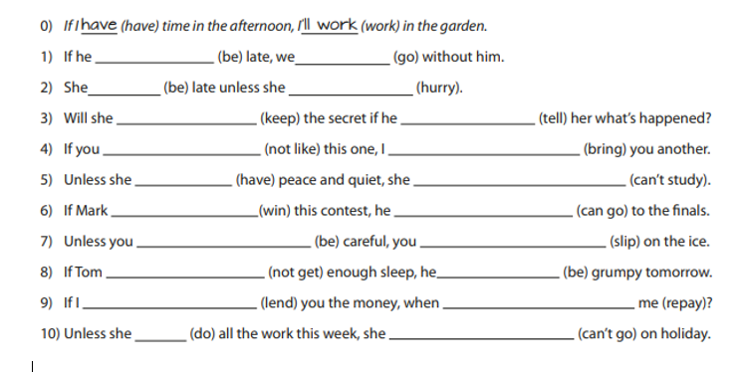
5.Dopolni spodnje povedi z ustrezno obliko glagola!

6.Poveži besedišče z ustrezno razlago!
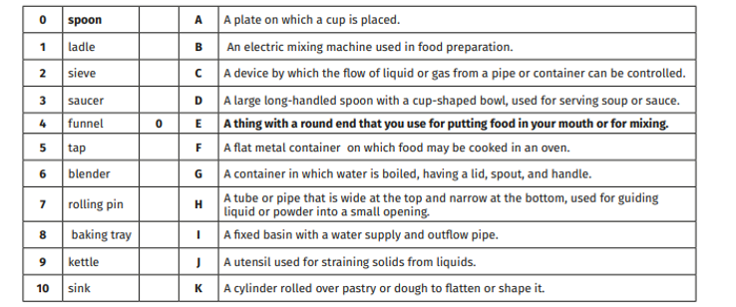

7.Besede iz okvirja razvrsti v tabele. Vsako besedo uporabi le enkrat. Ena beseda je odveč.

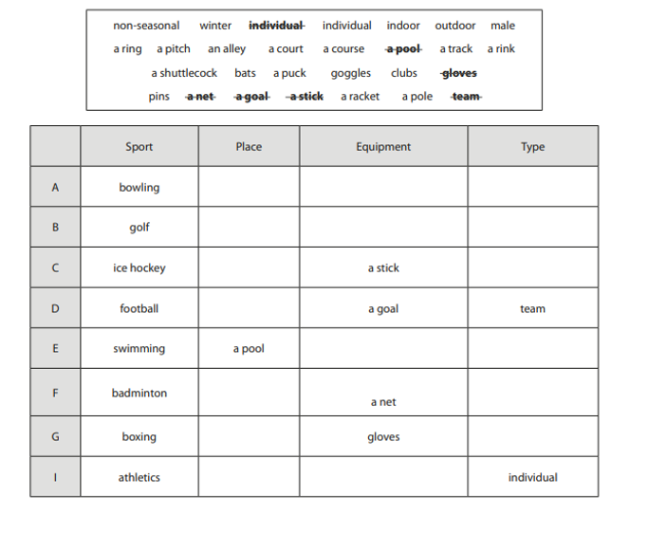
8. Preberi spodnje definicije in jih dopolni z izrazi iz besedila o eskimih!
- Make something suitable for a new purpose or use: ADOPT
- The regions around the North Pole: _______________________
- A vast flat, treeless Artic region of Europe, Asia and North America in which the subsoil is permanently frozen :_______________________________
- Keep safe from injury or harm:_________________
- A large fat animal which lives in the sea. It has two long teeth, called tusks that point downwards :________________________
- A large group of animals of one kind that live together:____________
- Extremely useful or important:________________
- A vehicle on runners for conveying loads or passengers over snow or ice, often pulled by animals:_____________

9. Povedi dopolni z glagolnikom ali z predlogom!

  - Are you interested ______ learning about history?
  - They love ________________ to parties.
  - They are good ______ running but bad ______ playing tennis.
  - Everyone is afraid _______ something.
  - She complains _______________________bullying.
- They are afraid ______________________losing the match.
- We are looking forward _________________________going out at the weekend.
- Laura dreams ________________________________living on a small island.
- Andrew apologized __________________________being late.
- Do you agree _____________________________staying in a foreign country?

