1. Dopolni spodnje pogojne stavke!
If she _____ (be) late, we _____________ (go) without her.
Will she ______________ (keep) the secret if he _____________ (tell) her what's happened?
If you _______________ (not like) this one, I __________________(bring) you another.
If Mark ________________(win) this contest, he __________________(go) to the finals.
Unless you ___________(be) careful, you _____________(slip) on ice.
If Tom ______________(not get) enough sleep, he ____________(be) grumpy tomorrow.
I ____________(not tell) her the secret unless she ___________(promise) not to tell anyone.
If Jack ___________(eat) all that chocolate, he _____________(be) ill.
Unless he ______________(wash) the car, I _______________(not give) him any pocket money.
If I _____________(be) too tired in the evening, I _____________(not go) to the party.

2.Ponovno napiši spodnje povedi tako, da uporabiš UNLESS!
Don't call me if you don't need help.___________________________________________________
You will have an accident if you aren't more careful._______________________________________
If he doesn't earn more, he won't be able to buy a house.___________________________________
We can't go in if we don't buy a ticket.___________________________________________________
If you don't lock the car, someone will steal it.____________________________________________
He doesn't have topay if he doesn't have enough money.___________________________________
If I'm not in a hurry ,I'll walk you home._________________________________________________
I'll call the police if he doesn't go away.__________________________________________________

3. Poveži izraze z definicijami!
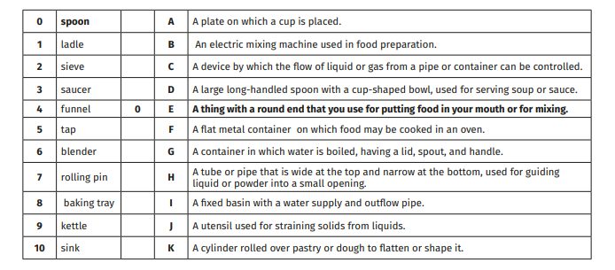

4. Dopolni besedilo z manjkajočimi besedami!