UTRJEVANJE 1
1. DOPOLNI BESEDILO.
In the morning I get _______ at 7.30. Then I ________ my hair and ________ my face. After that I _______ breakfast. I always have toast and jam for breakfast. Next I ______ to school at eight o’clock. I often walk to school. After school I __________ home. First I always _____ my homework and then I_________ for the next day. In the afternoon I _________ TV, ___________ a bike, _______ books and _______ computer games. After that I ______ dinner and finally I _____ to bed at 8.45.
- OBKROŽI PRAVILNO NAPISANO POVED.
My mum is a doctor. / My mum is a docter.
His dad works at a school. / His dad work at a school.
A shop assistant sells things. / A shop assistant sell things.
My aunt is an office worker. / My aunt is a office worker.
A teacher teaches children. / A teacher teache children.
The elephant is biger than the tiger. / The elephant is bigger than the tiger.
The lion has got sharp teeth. / The lion have got sharp teeth.
The monkey is funny and clever. / The monkey is funy and clever.
A giraffe has got a long neck. / A giraffe has got a long nek.
The crocodile is smaller than a whale. / The crocodile is smaller then a whale.
I get up at seven o’clock. / I gets up at seven o’clock.
She brushes her teeth every morning. / She brushes her teth every morning.
He goes to bed at nine o’clock. / He goes to bed at nine oclock.
I do my homework after school. / I do my homewrok after school.
It is half past three. / It is half past tree.
It is quarter to eight. / It is guarter to eight.
- SMISELNO DOPOLNI POVEDI.
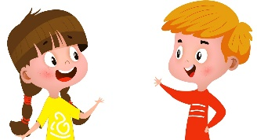
Ben: Hi, Mia. What is your mum's job?
Mia: Hello, Ben. ______ is a _____________.
Ben: What is your dad's _______?
Mia: He _______ an _____________.
Ben: Where do they work? What do they do?
Mia: My dad works in an _____________. He ________ _________. My mum works at a _____________. She _____________ _____________ .
Ben: And you? What do you want to be when you grow up?
Mia: I want to be a _____________. I like selling things.
Ben: That’s great! Where does a shop assistant work?
Mia: A shop assistant works in a _____________. She _____________ things.
4. POIŠČI NAPAKE IN JIH POPRAVI.
She like animals. There are a bed and a chair.
She likes read books. I can see computer and books.
It’s quater past nine. I have got lunch at one o’clock.
I work my homework. I go in bed.
I can football. She’s name is Amy.
5. ZAPIŠI PO 4 PRIMERE.
WEATHER | BODY PARTS | ADJECTIVES | LAND ANIMALS

6. PREBERI IN DOPOLNI TABELO Z TRUE, FALSE, NOT GIVEN.

Hi, I’m Randy. Usually I get up at a quarter to seven, but on Sundays I get up at nine o’clock. Then I have breakfast with my family. I usually have a traditional breakfast with eggs, bacon and tomatoes. After breakfast I go jogging with my father. At midday we sometimes go to my grandmother’s. She cooks very well. After lunch we often read a book.
At four o’clock in the afternoon we always go to the supermarket. At seven o’clock we have dinner. I never watch TV in the evening.
I usually play a board game with my family. I always go to bed at a quarter past ten.
1 The boy’s name’s Randy.
2 On Sundays he gets up at a quarter to seven.
3 He has a shower before breakfast.
4 In the morning he goes jogging with his father.
5 He always has lunch at his grandmother’s house.
6 In the afternoon he goes to the supermarket.
7 He doesn’t like shopping.
8 After dinner he watches TV.
9 He always goes to bed at 10:15.
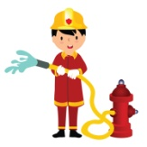
7. POIMENUJ POKLICA IN JU OPIŠI.
__________________________________________________________________________________________________________________________________________________________________________________________________________________________________________________________________________________________________________________________________________________________________________________________________________________________________________________________________________________________________________________________________________________________________________________________________________________________________________________________________________________________________________________________________________________________________________________________________________________________________________________________________________________________________________________________________________________________________________________________________________________________________

___________________________________________________________________________________________________________________________________________________
_______________________________________________________________________________________________________________________________________________________________________________________________________________________________________________________________________________________________________________________________________________________________________________________________________________________________________________________________________________________________________________________________________________________________________________________________________________________________________________________________________________________________________________________________________________________________________________________________________________________________________________________________________________



UTRJEVANJE 1 / REŠITVE
1. up, brush/comb, wash, have, go, go, do, study, watch, ride, read, play, have, go
2.
My mum is a doctor. / My mum is a docter.
His dad works at a school. / His dad work at a school.
A shop assistant sells things. / A shop assistant sell things.
My aunt is an office worker. / My aunt is a office worker.
A teacher teaches children. / A teacher teache children.
The elephant is biger than the tiger. / The elephant is bigger than the tiger.
The lion has got sharp teeth. / The lion have got sharp teeth.
The monkey is funny and clever. / The monkey is funy and clever.
A giraffe has got a long neck. / A giraffe has got a long nek.
The crocodile is smaller than a whale. / The crocodile is smaller then a whale.
I get up at seven o’clock. / I gets up at seven o’clock.
She brushes her teeth every morning. / She brushes her teth every morning.
He goes to bed at nine o’clock. / He goes to bed at nine oclock.
I do my homework after school. / I do my homewrok after school.
It is half past three. / It is half past tree.
It is quarter to eight. / It is guarter to eight.
3. She, teacher, job, is, office worker, office, writes emails, school, teaches children, shop assistant, shop, sells
4. She likes, There is, reading, a computer, quarter, have lunch, do my homework, go to bed, play football, Her name
5. Zapis besed preveri s pomočjo zvezka

6. T, F, NG, T, F, T, NG, F, T

7. He is a firefighter. He works at a fire station. He puts out fire and helps people. He is a cook/chef. He works in a kitchen. He cooks meals.

UTRJEVANJE 2
- Odgovori v celih povedih.
1. What time do you get up?
2. What are whales like?
3. What do you do in the afternoon?
4. What's his job?
5. What does a zebra look like?

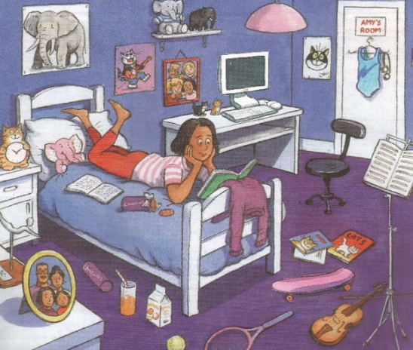
- Opiši sliko. Uporabi She is, She can, She has got, She is wearing, She likes, There is, There are.
________________________________________________________________________________________________________________________________________________________________________________________________________________________________________________________________________________________________________________________________________________________________________________________________________________________________________________________________________________________________________________________

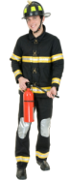
3. Ugotovi, katere poklice prikazujejo sličice.





D_____________ S______ A________ B_________ P___________ F___________
4. Ugotovi poklic.
I bring people food and drink. ……………………………….
I mend cars. ………………………………..
I help sick people. ……………………
I cut hair and do beautiful hairstyles. …………………………..
I help animals. ……………………………
I teach children. ……………………………

5. Kaj počne Annie v prostem času? Z danimi glagoli dopolni povedi.
DO, READ, COLLECT, PLAY, WATCH, USE

………………………… ……………………………. ……………………………… ……………………… /4

''I _________ postcards. Sometimes I ___________ books or _________ TV. I __________ the guitar every day, but I never ____________ the Internet. I also _________ sports – I swim in the local pool.''

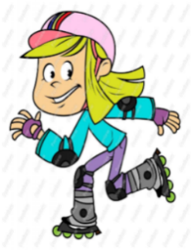



6. What do you do on Wednesdays? Zapiši.

___________________________________________________________________________
___________________________________________________________________________

7. Dopolni.
Monday - ………………………….. – Wednesday - ……………………… – Friday - ……………………………. - Sunday

8. Kateri dan v tednu je tvoj najljubši? Opiši svojo dnevno rutino. Napiši vsaj 10 povedi.

9. Dopolni besedilo z besedami;

flowers, animals, lucky, honey, see, insects.
/3

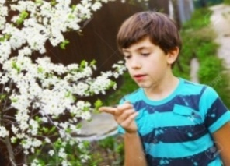
Hi everyone! My name is Paul and I'm English. My favourite pets are insects. Many people don't like them, but I do. In my opinion ____________ are great! I like bees and ladybirds best. Many people don't know them, but these insects are very useful! Ladybirds, for example, eat pests and help garden plants and bees, for example, make ___________.
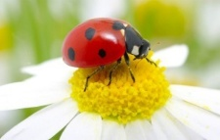
In my garden I planted ____________ that attract insects so I can observe them closely! In summer, when I see a ladybird, I immediately pick up my magnifying glass, so I can _________ it better. There is also a legend about ladybirds; it says that if you see them you will be ____________. I believe it! In fact, every time I see a ladybird, I get a good mark at school. They are really interesting ___________!
10. Opiši živali. Uporabi It lives, It has got, It eats, It's, It's.
__________________________________________________________________________________________________________________________________________________________________________________________________________________________________________________________________________________________________________________________________________________________________________________________________________________________________________________________________________________________________________________________________________________________________________________________________________________________________________________________________________________________________________________________________________________________________________________________________________________________________________________________________________________________________________________________________________________________________________________________________________________________________

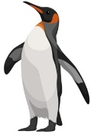


__________________________________________________________________________________________________________________________________________________________________________________________________________________________________________________________________________________________________________________________________________________________________________________________________________________________________________________________________________________________________________________________________________________________________________________________________________________________________________________________________________________________________________________________________________________________________________________________________________________________________________________________________________________________________________________________________________________________________________________________________________________________________

UTRJEVANJE 2 / REŠITVE
1. PRIMERI:
I GET UP AT SEVEN O’CLOCK.
WHALES ARE BIG AND INTELLIGENT.
I DO MY HOMEWORK AND PLAY FOOTBALL.
HE IS A DOCTOR.
A ZEBRA HAS BLACK AND WHITE STRIPES.
2. glej v zvezek BG
3. DOCTOR, SHOP ASSISTANT, BAKER, POSTMAN, FIREFIGHTER
4. WAITER, MECHANIC, DOCTOR, HAIRDRESSER, VET, TEACHER
5. COLLECT, READ, WATCH, PLAY, USE, DO
6. ON WEDNESDAYS I GO SHOPPING, GO ROLLERBLADING, HAVE A PIANO LESSON/PLAY THE PIANO AND DO MY HOMEWORK.
7. TUESDAY, THURSDAY, SATURDAY
8. NPR. My favourite day is Monday. I get up at 7 o'clock. Then I have breakfast and get dressed. After that I brush my teeth and comb my hair. Then I go to school. After school I do my homework and have lunch. After lunch I play football and play with my friends...
9. INSECTS, HONEY, FLOWERS, SEE, LUCKY, ANIMALS
10. a penguin: It lives in cold places. It is black and white. It has got a beak, feathers, a tail and wings. It eats fish. It is friendly and small.
It is smaller than a seal.
A polar bear: It lives in cold places. It is white. It has thick fur and big paws. It eats seals and fish. It is strong and beautiful.
It is bigger than a brown bear.

UTRJEVANJE 3
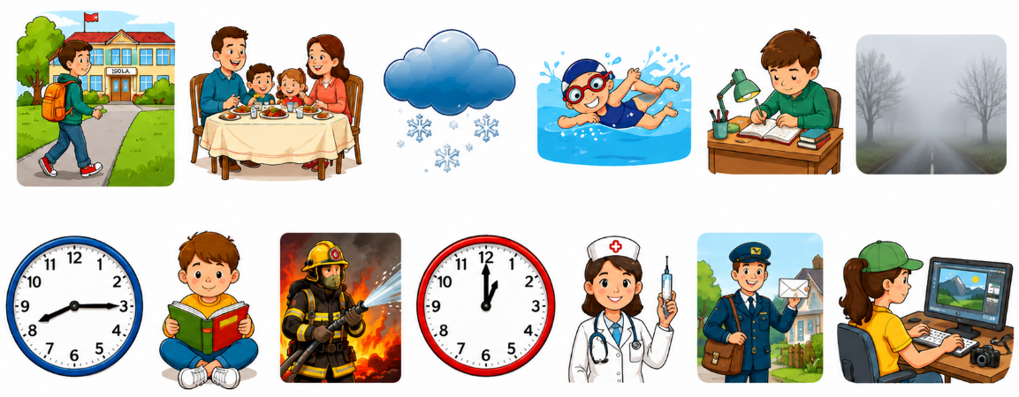
1. POIMENUJ SLIKE.

2. ODGOVORI V CELIH POVEDIH.
What’s the weather like today?
What are pigs like?
What time do you go to bed?
What do you do on Tuesdays?
3. NAPIŠI PO 5 USTREZNIH BESED.
DAYS OD THE WEEK JOBS CLOTHES WEATHER

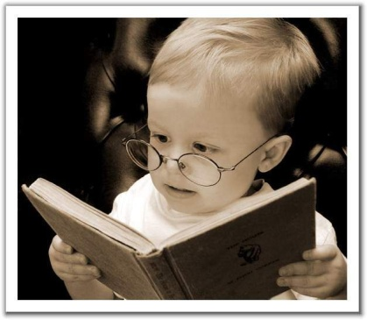
4. PREVEDI.
In the afternoon I (PRIDEM DOMOV) ________________ at (14.15) ___________________. Then I (SE UČIM) _________________ and (NAREDIM DOMAČO NALOGO) _________________________. After that I (JEM KOSILO) _____________________ and (GLEDAM TELEVIZIJO) ____________________. I sometimes (IGRAM IGRICE) _____________________ or (BEREM KNJIGO) __________________. Finally I (SE STUŠIRAM) __________________ at (20.30) _____________________ and (GREM SPAT) ________________________.
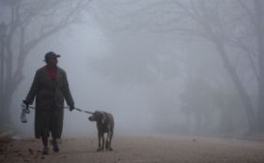
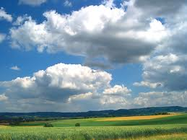
5. POVEŽI TAKO, DA V KVADRAT POLEG ČRKE NAPIŠEŠ ŠTEVILKO.
1 It's raining here in Paris. We need an umbrella.

B
A
2 It's cold and sunny. We like running in winter.



3 The weather here is often cloudy.

D
C
4 It's winter. The roads are icy.You must be careful or you can fall easily.
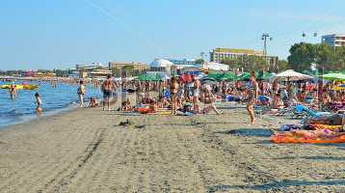
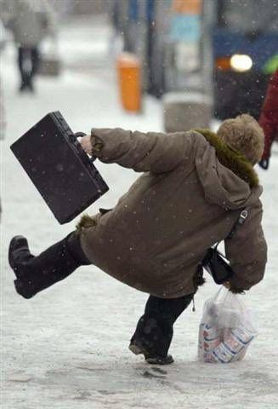
E
F
6 It's hot and sunny here on the beach.

5 She is taking a dog for a walk in a cold foggy weather.

6. DOPOLNI BESEDILO O AMY.
She is Amy. ______________ long black hair. ______________thirteen years old. ______________the violin. ______________with her mum, dad and her little sister. ______________rollerblading, playing tennis and dancing. In her room ______________a desk, a bed and a chair. ______________two cupboards. ______________a t-shirt and trousers.
7. SESTAVI POVEDI IN JIH NAPIŠI.
a garage cars in mends

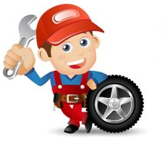


bread at bakes a bakery


works a supermarket at

8. PREBERI BESEDILO, NATO POVEDI UREDI V PRAVILEN VRSTNI RED.
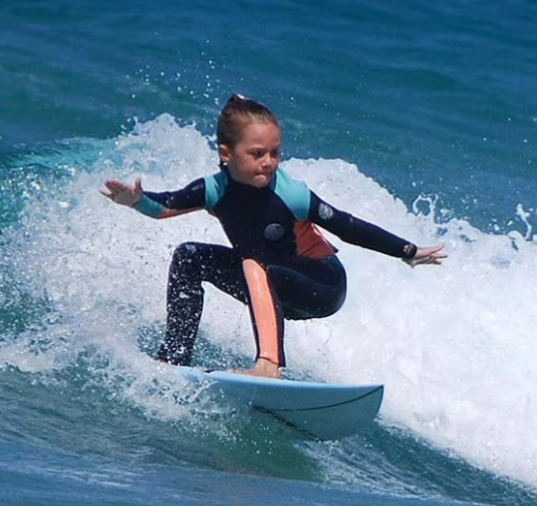
I’m Felicity. I live in Ljubljana, but every summer I go to Greece. My grandmother is Greek and she lives in Crete.
I love the sea and I do lots of water sports. In the morning, I get up at seven o’clock and I ride my bike to the beach. Then I meet my friend Tony and we have breakfast together. We have a cappuccino and a piece of cake. His father is Italian and he’s got a coffee bar on the beach.
Then we go by motorboat to Dia. It’s a small island and a protected area. It’s a fantastic place with rare animals. The keeper is a nice man. Every day he teaches Tony and me many things about fish.
In the afternoon, we usually go for a horse ride on the beach. Then we swim and have a surfing lesson. I love my summer holidays!
___ Her grandmother is from Greece.
___ She meets her friend Tony on the beach.
___ She learns to surf.
___ She comes from Ljubljana.
___ She travels by motorboat to a small island.
___ She goes to the beach by bike.

UTRJEVANJE 3 / REŠITVE
1. go to school, have lunch, snowy, swim/go swimming, do my homework, foggy, quarter past eight, read a book, firefighter, one o'clock, doctor/nurse, postman, play computer games
2. NPR.
It's sunny, cloudy...
They are fat, friendly, beautiful …
I go to bed at 10 o'clock.
On Tuesdays I go to school/do my homework, study...

3. glej v zvezek
4. get home/come home, quarter past two, study, do my homework, have lunch, watch tv, play computer games, read a book, have a shower, half past eight, go to bed/go to sleep

5. 1C, 2D, 3A, 4F, 5B, 6E

6. HAS GOT, SHE IS, SHE PLAYS, SHE LIVES, SHE LIKES, THERE IS, THERE ARE, SHE'S WEARING

7. A mechanic mends cars in a garage.
A baker bakes bread at a bakery.
A shop assistant works at a supermarket.

8.
2, 4, 6, 1, 5, 3

