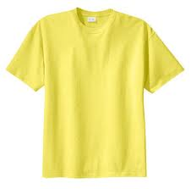
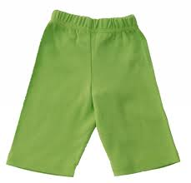
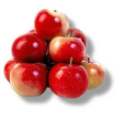
UTRJEVANJE 1
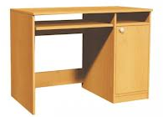
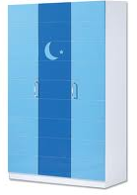
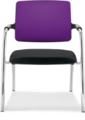
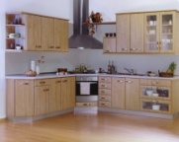
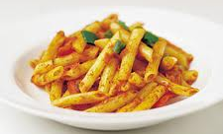
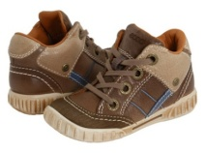
1. POIMENUJ SLIKE.

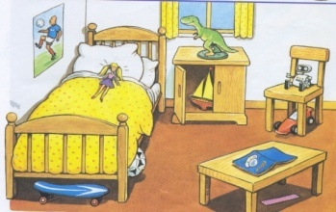
2. SMISELNO DOPOLNI POVEDI.
- There is a __________ on the chair.
- There is a __________ in the cupboard.
- __________is a doll on the ____________.
- There is a book __________the _____________.
- There _____ a car___________ the chair.

3. POVEŽI DELE POVEDI.
Where are ... ... a small purple boat.
There is … ... you from?
I have ... ... three chairs in my bedroom.
I haven’t got ... ... got a car.
There are ... ... a vase in the sitting room.
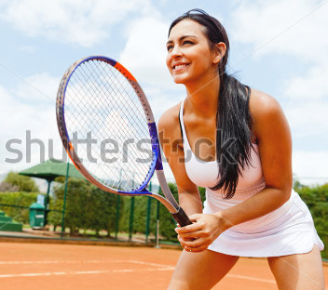
4. NAPIŠI ŠTEVILA OD 15 DO 20.

5. PREBERI BESEDILO IN ODGOVORI NA VPRAŠANJA V CELIH POVEDIH.
I'm Polly. I'm from England. I live in a big house. I've got one brother, Jack and one sister, Daisy. Daisy is five and I'm ten years old. In my bedroom there's a small cupboard. On the cupboard there's a new radio. The radio is black and red.

1. Where are you from, Polly? 2. How old are you, Polly?
3. Where's the radio? 4. What colour is the radio?

6. DOPOLNI Z BESEDAMI IZ OKVIRJA. TRI BESEDE SO PREVEČ.
twelve balls kitchen toy
in on favourite lamp

- My _______________ place is my bedroom.
- There’s a car _______________ the floor.
- There are ________________ books in the bookcase and three red _______________ on the table.
- My favourite _____________ is my skateboard.
7. VSTAVI ČLEN a ALI an.
_____ eye _____ book _____ pen _____ arm
_____ vase _____ lamp _____ biscuit _____ ice cream

8. NAPIŠI MANJKAJOČE VPRAŠALNICE.
1. __ __ __ __ ’s your favourite colour? 6. __ __ __ __ __ are you from?
2. __ __ __ are you? 7. __ __ __ __ you got a pen?
3. __ __ __ __ ’s your favourite number? 8. __ __ __ __ you got a book?
4. __ __ __ old are you? 9. __ __ __ ‘s your teacher?

5. __ __ __ __ can you do? 10. __ __ __ __ have you got?

REŠITVE UTRJEVANJA 1
- a desk, a wardrobe, a chair, a kitchen
- robot, boat, There, bed, on, table, is, under
- Where are you from?
There is a vase in the sitting room.
I have got a car.
I haven't got a small purple boat.
There are three chairs in my bedroom.
- fifteen, sixteen, seventeen, eighteen, nineteen, twenty
- I'm from England.
I'm 10 years old.
The radio is on the cupboard.
The radio is black and red.
- favourite, on, twelve, balls, toy
- an eye, a book, a pen, an arm
a vase, a lamp, a biscuit, an ice cream

1. What 2. How/Who 3. What 4. How 5. What
6. Where 7. Have 8. Have 9. Who 10. What

UTRJEVANJE 2
- POLJUBNO DOPOLNI TABELO.
FURNITURE | ROOMS IN A HOUSE | MONTHS | NUMBERS TO 20

2. POIMENUJ PROSTORE V HIŠI IN NAPIŠI, KAJ LAHKO V NJIH POČNEŠ. UPORABI There is / There are / I can.
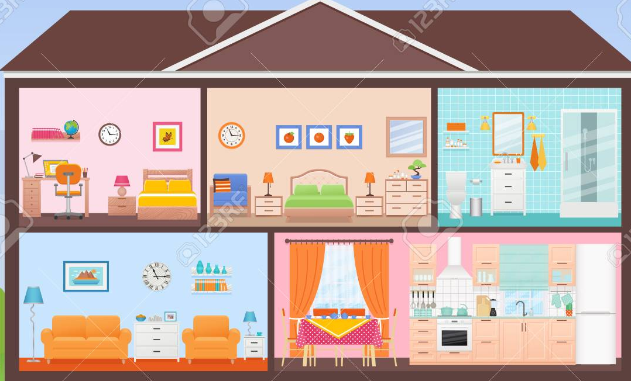
__________________________________________________________________________________________________________________________________________________________________________________________________________________________________________________________________________________________________________________________________________
3. NAPIŠI, KAJ IMAŠ / NIMAŠ.
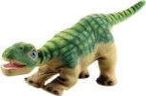
_____________________________________________________________________________________________________________________________________________________________________________________________________________________________________________________________

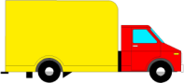

4. SMISELNO DOPOLNI POVEDI.
I’ve got a ______________. My favourite colour is a _______________.
I’m_________________. Twenty minus seven is________________.
I’m __________________. There is a __________________________.
I can _________________. Fifteen plus three is__________________.

5. PREBERI POVEDI IN NAPIŠI yes ALI no.
There are two bedrooms. _____
I can cook here. _____
There is a bathroom. _____
I can have breakfast here. _____
There are two sitting rooms. _____
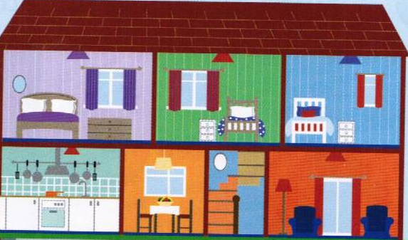

6. ODGOVORI V CELIH POVEDIH.
Who's this? __________________________________________
Have you got a ruler? _________________________________
Can I borrow your book, please? _____________________________

Where are you from? ______________________________________
Is it a kite? ____________________________________________

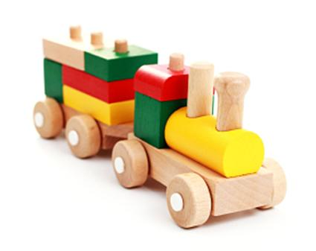
7. OPIŠI IGRAČO. UPORABI It's.
________________________________________________________________________________________________________________________________________________________________________________________________________________________________________________________________________________________

REŠITVE UTRJEVANJA 2
- Pravilnost zapisanih besed preveri s pomočjo zvezka.

- There are two bedrooms. There is a bathroom, a sitting room, a dining room and a kitchen. I can sleep, have a shower, watch tv, eat my lunch and cook here.

- I've got a lorry. I haven't got a dinosaur.

- Možne so različne rešitve, npr.;

I've got a plane. My favourite colour is blue.
I'm Mija. Twenty minus seven is thirteen.
I'm fine, thanks//10 years old. There is a bedroom/a cupboard. …
I can cook here. Fifteen plus three is eighteen.

- no, yes, no, yes, no

- It's/This is my friend.

Yes, I have./No, I haven't.

Yes. Here you are.

I'm from Slovenia.

Yes, it is.

- It's a train. It's new and small. It's brown, yellow, red and green. It's made of wood.

UTRJEVANJE 3
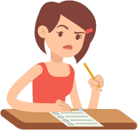
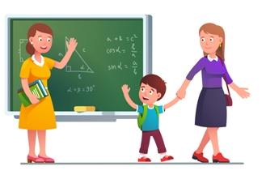

1. NAPIŠI VLJUDNOSTNE IZRAZE.


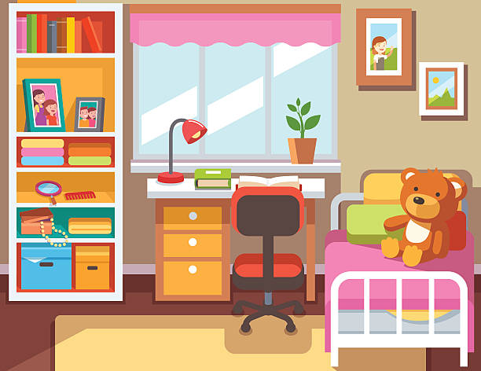
2. Z MANJKAJOČO BESEDO SMISELNO DOPOLNI POVEDI.
There are books and a _______ on the desk. There is a __________________ on the bed. There are ________________ on the wall. _______________ a bookcase next to the desk. There is a chair _________ the rug.

3. IZ OKVIRJA IZBERI BESEDE IN DOPOLNI POVEDI.
winters England bed Miss Davis flat red

I'm Polly. I'm not from Slovenia I'm from ______________. I live in a small _____________. My teacher is _____________. I like summers but I don't like _________________. In my bedroom there's a new rug. On the rug there is a __________________. It is black and __________.
4. VSTAVI ČLEN a ALI an.
___ rubber ___ doll ___ olive
___ eye ___ car ___ orange

5. KAJ JE V SOBI? UPORABI There is / There are. NAPIŠI 3 POVEDI.
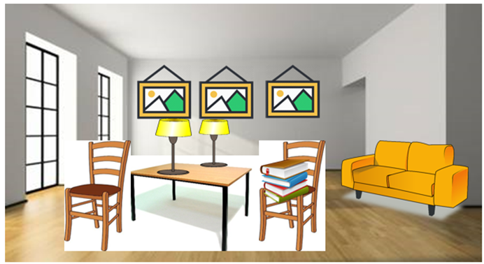
1 . _______________________________________________________________
2. ________________________________________________________________
3. ________________________________________________________________
6. GLEDE NA SLIKI TVORI SMISELNI POVEDI.
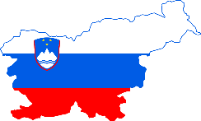

___________________________________________________________

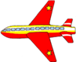
7. NAPIŠI, KAJ IMAŠ IN ČESA NIMAŠ.
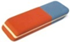
_________
________________________________________________________
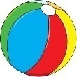 ____________________________________________________
REŠITVE UTRJEVANJA 3
- Enjoy your meal. See you soon/tomorrow. Good luck! Happy birthday!
- lamp, teddy bear, pictures, There is, on
- England, flat, Miss Davis, winters, bed, red
- a rubber, a doll, an olive, an eye, a car, an orange
- npr. There are two chairs. There is a sofa next to the wall. There are books on the chair. There are three paintings on the wall. There is a table. There are two lamps on the table.
- I'm from Slovenia. I'm in class 4.
- I've got a plane and a rubber. I haven't got a ball.

UTRJEVANJE
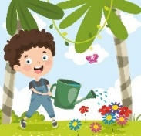
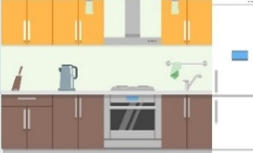
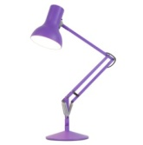
1. DOPOLNI MANJKAJOČE ČRKE IN POVEŽI BESEDE S SLIKAMI.
L _ _ _
J _ _ _ S
J _ _ _ _ R
P _ _ _ _ _ E
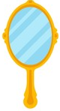

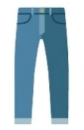
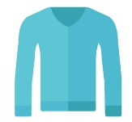
S _ _ _ _ G
T _ _ _ _ _ _ S
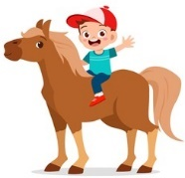
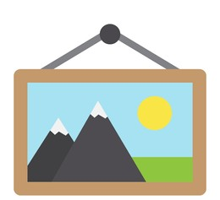
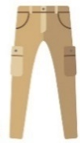
M _ _ _ _ R T
R _ _ _ A H _ _ _ _ S
K _ _ _ _ _ N
W _ _ _ H T

2. NAPIŠI, KATERI PROSTORI SE NAHAJAJO V HIŠI.
UPORABI There is, There are.
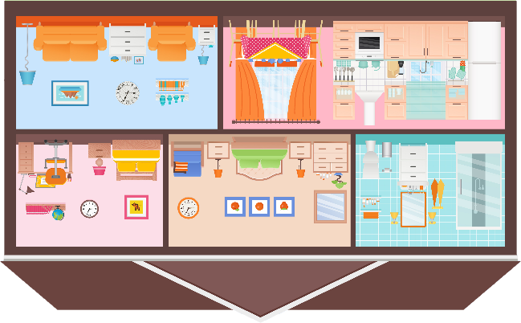
______________________________________________________________________________________________________________________________________________________________________________________________________________________________________________________________________

3. ODGOVORI V CELIH POVEDIH.
What have you got? __________________________________________
Have you got a ball? _________________________________________
Who’s your teacher? ________________________________________
What can you do? ___________________________________________
What are you wearing today? __________________________________________________________
4. SMISELNO DOPOLNI POVEDI.
1. I’m wearing _______________. 4. I’m from ______________.
2. I can _______________. 5. ______________ great.
3. My birthday is in ______________. 6. I speak ______________.
5. IZ OKVIRJA IZBERI BESEDE IN DOPOLNI POVEDI.
under, wardrobe, favourite, there, chair

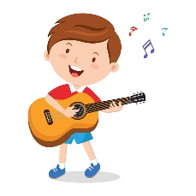
My ____________ place is my bedroom. There is a blue bed, a blue desk, a blue wardrobe and a blue ____________. I have got lots of things in my room. There is a skateboard ____________ the bed and there is a guitar next to the chair. I can play the guitar very well. There are t-shirts and jumpers in the _____________ and ___________ is a picture on the wall.

6. NAPIŠI 7 POVEDI O SEBI.
ME
_________________________________________________________________________________________________________________________________________________________________________________________________________________________________________________________
7. VSTAVI ČLEN a, an.
_____ arm _____ ruler _____ elephant _____ school
_____ pencil _____ igloo _____ olive _____ desk

8. NAPIŠI MANJKAJOČE VPRAŠALNICE.
__ __ __ __ ’s your favourite colour? __ __ __ __ __ are you from?
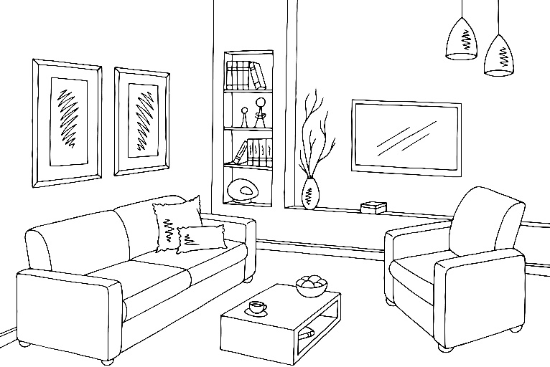
__ __ __ are you? __ __ __ __ you got a camera?
9. PREBERI IN NARIŠI.
The red rug is under the table. The green pencil is on the table. The yellow book is in the bookcase. The blue school bag is on the sofa.

- a rug under the cat
- an ice-cream on the table
- a book in the table

10. DOPOLNI TABELO.
MONTHS | THINGS | NUMBERS FROM 11 TO 20 | CLOTHES

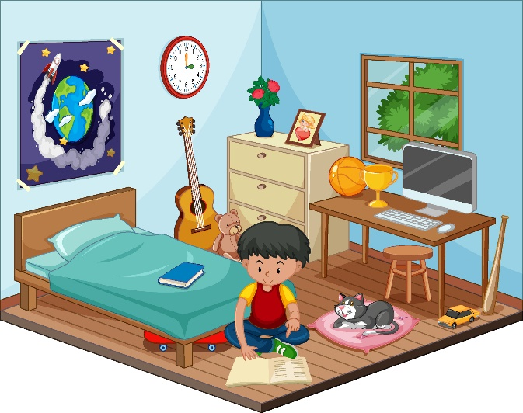
11. Z MANJKAJOČO BESEDO SMISELNO DOPOLNI POVEDI.
There is a _______________ on the wall.
There is a book ______________ the bed.
_____________ is a car next to the desk.
There ___________ toys in the bedroom.
There is a boy next to the ___________.

12. PREVEDI.

Oblečena je v kratke hlače. _________________________________
Imam medvedka. _________________________________________
13. POVEŽI DELE POVEDI TAKO, DA NA ČRTE NAPIŠEŠ ŠTEVILKE.
1. What language ___ camera?
2. There are ___ do you speak?
3. What’s ___ a purple plane?
4. Have you got ___ soft and short.
5. It is ___ desks and chairs in my classroom.
6. Is it a ___ your favourite season?

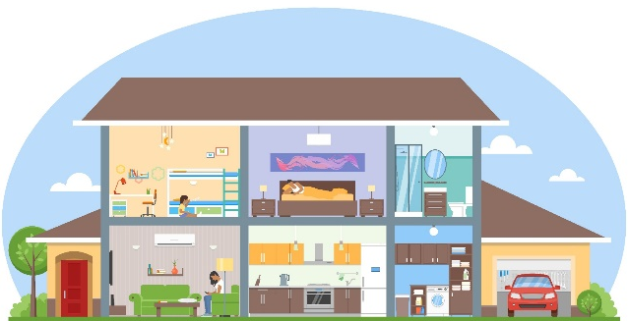
14. ČE JE TRDITEV PRAVILNA, NAREDI KLJUKICO, ČE JE NAPAČNA, PA KRIŽEC.
There is a living room. _____
There are four bedrooms. _____
I can have a shower here. _____
I can eat my lunch here. _____
I can park my car. _____

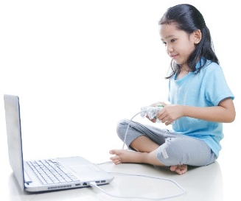
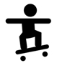
15. NAPIŠI. UPORABI She can, She can't, She's wearing.

______________________________________________________________________________________________________________________________________________________________________________

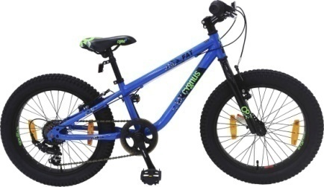
UPORABI It's, It's made of.
______________________________________________________________________________________________________________________________________________________________________________

UTRJEVANJE
1. lamp, jumper, trousers, mirror, watch, jeans, picture, spring, ride a horse, kitchen
2. There are two bedrooms. There is a bathroom. There is a kitchen. There is a dining room. There is a living room.
3. npr. I've got a ball. Yes, I have. My teacher is Tina. I can dance. I'm wearing jeans and a jumper.
4. npr. a jumper, swim, May, Slovenia, I'm, Slovene
5. favourite, chair, under, wardrobe, there
6. npr. My name is Vita. I'm 10 years old. I'm wearing jeans and a t-shirt. I can swim and play basketball. My favourite season is summer.
7. an arm, a pencil, a ruler, an igloo, an elephant, an olive, a school, a desk
8. What, Who/How, Where, Have
9. rdeča preproga pod mizo, zelen svinčnik na mizi, rumena knjiga v knjižni omari, modra šolska torba na sedežni
10. Npr. MONTHS: January, May, December …
THINGS: a rubber, a book, a torch ...
FROM 11 TO 20: thirteen, seventeen, eighteen ...
CLOTHES: socks, a t-shirt, a jumper ...
11. clock/picture/poster, on, There, are, bed/cat
12. She's wearing shorts. I've got a teddy bear.
13. 6 1 4 5 2 3
14. yes, no, yes, no, yes
15. She's wearing a t-shirt and trousers. She can play computer games. She can't skateboard.
It's a bike. It's big and new. It's blue. It's made of metal, plastic and rubber.

