GB VERSUS CANADA
- Where does Mrs Globetrotter come from?
- What does she like doing?
- How many km has she travelled so far?
- What is she talking about on a TV show?
- What do you notice first in GB?
- What are the British like?
- Why is it easier to travel in Britain?
- How high is the highest mountain in Britain?
- What`s it called?
- What is British countryside like?
- What kinds of landscape has Canada got?
- What about the British weather?
- Is Canadian food worse than British?
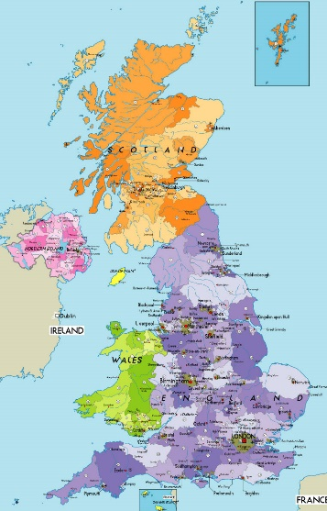
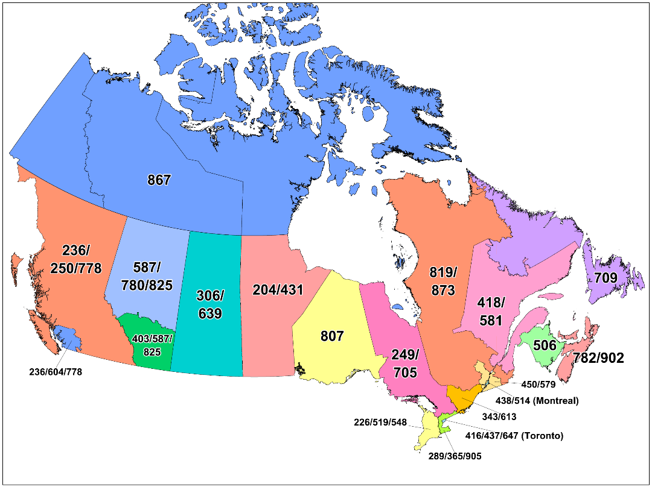
Britain

Canada

