1. Pasta – al dente or not al dente?
Entire chapters can be written about pasta! After having eaten overcooked pasta over and over again, especially abroad, I would say that the biggest sin about pasta is probably overcooking it. Not only doesn’t it taste well, overcooked pasta is also harder to digest.
Even Barilla, being the biggest exporting brand of pasta ‘encourages’ (e.g. the packages sold in the US) indirectly to overcook it by stating a time frame as cooking time, instead of one exact time.
Have you ever seen or heard about the trick as to how to check if the pasta is ready to be eaten, by throwing one spaghetti against the wall? I wonder who invented that :)) And if it sticks on it, apparently it’s done! Ok, so now I would dare to add a little side note: When the pasta truly sticks on the wall like glue, it is not ready. But it is way overcooked. ;) Ok, seriously, set the timer, with the correct cooking time (if a time frame is given on the package, make sure to consider the shortest cooking time), and the pasta will be fine.
And, last advice: It’s very important that the water boils first, before throwing the pasta inside!

Do pasta shapes really matter?
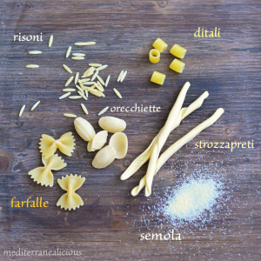I could see a big astonishment on people’s faces, including my husband’s, when I told them how ‘important’ it is not to combine the ‘wrong’ pasta shape with the ‘wrong’ sauce! :)) Didn’t I already mention how picky we can be about food? ;) Although all shapes consist of the main ingredients and they do taste the same (ok, sort of), it really does make a big difference! For instance you don’t wanna eat spaghetti with beans, or the tiny little shaped ones (e.g. risoni) with a tomato sauce. So, why not? Well, it just doesn’t match! :)
5. Is pasta a starter, a main or a side dish?
Oh, I haven’t seen more confusion and debates than this one! Actually it’s very simple to remember: There are two main dishes in Italy: pasta and risotto. They are not a starter, and not a side, either. I don’t blame anyone for getting confused if even some Italian restaurants abroad display it wrongly on their menus, pretending to serve authentic Italian cuisine.
Who is Alfredo?
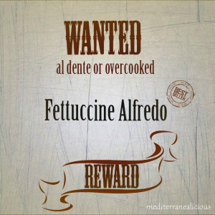Well, I got introduced to Alfredo during my visits in the US. It was impossible to overlook ‘him’. I learned that Alfredo comes in all kind of versions: chicken Alfredo, Alfredo sauce, Fettuccine Alfredo, etc. And I kept wondering: Who is Alfredo?!
When my husband’s nephew asked me whether I could make some chicken Alfredo for him, I told him that I had no idea what that was.
Considering its popularity and the fact that it is being promoted as something Italian, that surprisingly in Italy probably no one has ever heard of, I was intrigued to find out more about this phenomenon. It turns out that Alfredo was a restaurant owner in Rome (http://www.alfredo-roma.it) about one century ago. Later on American celebrities were among the guests of that restaurant. So, in the 70s they introduced Alfredo’s recipes in a new restaurant opening in New York City. And that was the beginning of its success. Now that’s interesting! But should you go to Italy – outside of Rome – I do not recommend ordering anything under this name. As long as they haven’t been to the US, they won’t understand what you mean.
Espresso, Latte & Co.
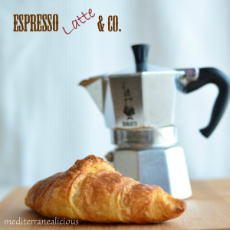Espresso – as the name says, it can be defined as an express coffee. They drink it for breakfast, after lunch, at home or quickly at the bar, at the counter. There are different versions of espresso coffee. Just to name a few: cappuccino, ristretto (concentrated coffee), lungo (a longer-style), corretto (with a little shot of liquor).
You won’t find shots of vanilla, nor any other kind of extras added to your coffee. Nor will you find any ‘latte’. Latte means milk. And the one that corresponds to the ‘latte’ in the US is the caffellatte or latte macchiato. Ordering a ‘latte’ in Italy might get you a glass of milk ;)
One thing you will probably never see in Italy is someone drinking a cappuccino with a meal, or right after a meal. The locals drink it most of the time for breakfast, only. Maybe matched with a cornetto (croissant).
And talking about breakfast…this will take us to the last point.
10. The Italian breakfast – not really a big deal at all (besides the coffee)
No eggs, no bacon, no cheese nor ham. A coffee and a cornetto on the go, or maybe a cup of milk with some cookies at home. As you can see, breakfast is not the main meal in a typical Italian day. It’s quick and simple. And sweet. Which could be the reason why lunch is such a big deal instead.
Having only an espresso or a croissant in our stomach for several hours, by the time we reach lunch time we need more than a simple sandwich ;)

