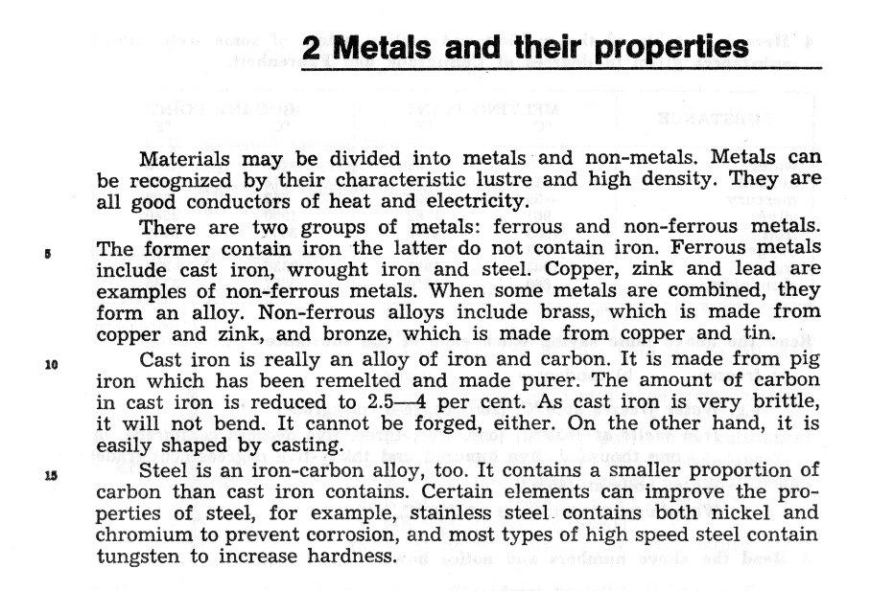
COMMON WORDS AND EXPRESSIONS:
recognize – brittle-
heat – bend -
the former – forge -
the latter – shape-
contain – improve-
pure – increase-
amount – hardness-

TECHNICAL TERMS AND EXPRESSIONS:
lustre – cast iron - pig iron -
high density- wrought –iron - remelt -
conductor – steel - by casting -
ferrous – brass - stainless steel-
non-ferrous - carbon - copper –
tin - lead - alloy –
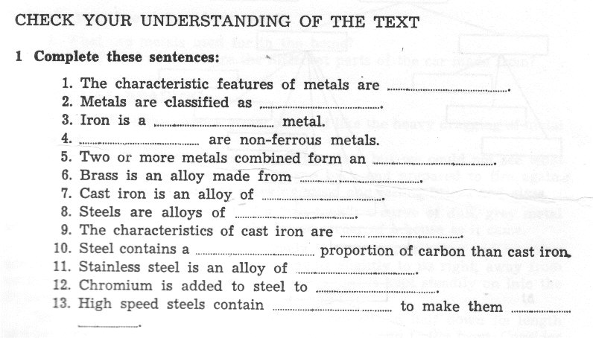
high speed steel - tungsten –

