HELENIZEM – delovni list
- Pojasni, kakšna je bila dediščina Aleksandra Makedonskega.
___________________________________________________________________________________________________________________________________________________________________________________________________________________________

- Pojasni, kaj je helenizem.
__________________________________________________________________________________________________________________________________________________

- Najpomembnejše mesto helenizma je bila _____________________.

- Naštej znamenitosti tega mesta.
_________________________________________________________________________

- Pojasni, kakšen je bil pomen Aleksandrijske knjižnice. Kakšna je bila njena usoda?
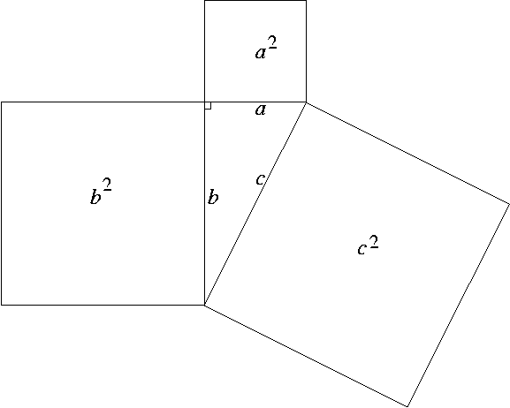
____________________________________________________________________________________________________________________________________________________________________________________________________________________________________________________________________________________________________

- Naštej dosežke helenističnih znanstvenikov.
  - Aristarh________________________________________________________________________________________________________________________________
  - Ptolomej_______________________________________________________________________________________________________________________________
  - Eratosten______________________________________________________________________________________________________________________________
  - Arhimed_______________________________________________________________________________________________________________________________
  - Evklid_________________________________________________________________________________________________________________________________
  - Pitagora_______________________________________________________________________________________________________________________________
- Naštej dve filozofski smeri, ki sta se pojavili v 3. stoletju.
_________________________________________________________________________
- Pojasni kakšna je razlika med obema filozofijama.
____________________________________________________________________________________________________________________________________________________________________________________________________________________________________________________________________________________________________
- Pojasni, kakšna je bila razlika med klasičnim grškim kiparstvom in helenističnim kiparstvom.
____________________________________________________________________________________________________________________________________________________________________________________________________________________________________________________________________________________________________

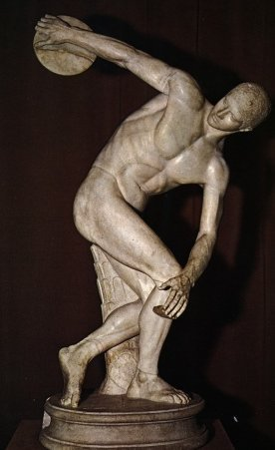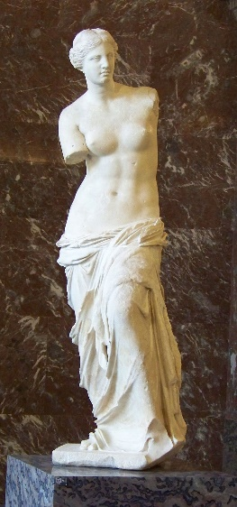
Metalec diska (Miron) – klasična grška umetnost Miloška Venera (Aleksander iz Antiohije

- Pojasni pojme:
  - Pharos________________________________________________________________________________________________________________________________
  - Kolos__________________________________________________________________________________________________________________________________
  - Muzeon________________________________________________________________________________________________________________________________
  - Muze__________________________________________________________________________________________________________________________________

