- Click on the link below. Listen to the song.
Klikni na spodnjo povezavo. Poslušaj pesem.

https://www.youtube.com/watch?v=kuycjD-xXOQ
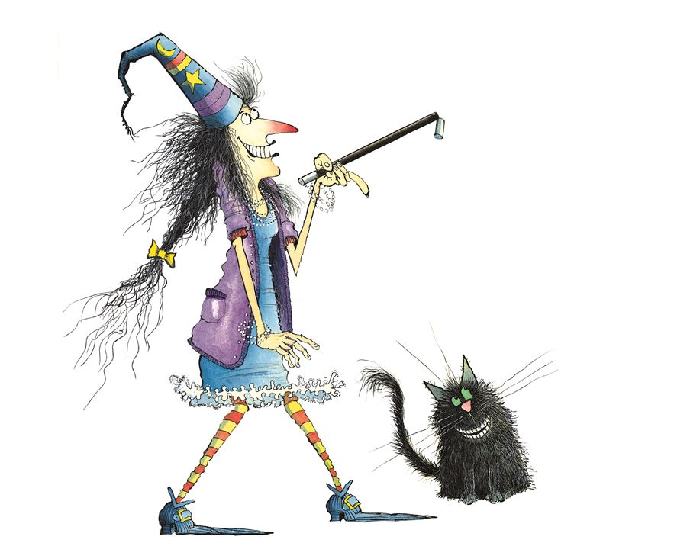
Kdo sta glavna junaka zgodbe?
(Odgovor: čarovnica Winnie in maček Wilbur)

Vir slike: https://www.google.com/search?q=winnie+and+wilbur&client=firefox-b-e&source=lnms&tbm=isch&sa=X&ved=2ahUKEwjx7e-0xpzoAhXExIsKHVnjDZcQ_AUoAXoECBkQAw#imgrc=7oZG_O27JfFhMM

- Click on the link again . Now listen to the song and read.
Ponovno klikni na povezavo. Sedaj poslušaj pesem in hkrati beri.
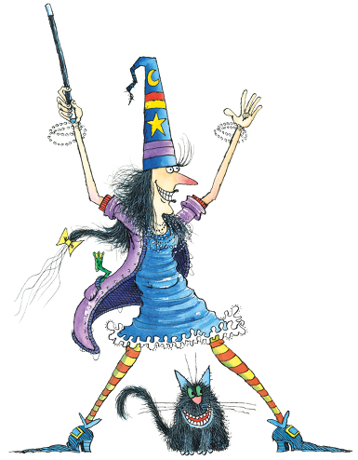
Winnie's Song
https://www.youtube.com/watch?v=kuycjD-xXOQ

A big tall hat,
Ten long toes,
A black magic wand,
A long red nose.
She's Winnie,
Winnie the witch.

A long black tail,
Big green eyes,
He goes with Winnie
When she flies.
He's Wilbur,
Wilbur the cat.

- Click on the link again . Now listen to the song, read and sing.
Ponovno klikni na povezavo. Sedaj poslušaj pesem in hkrati beri ter poj.

- Print the song (page 2) and glue it in your notebook.
Natisni pesem (stran 2) in jo prilepi v zvezek. List bo potrebno malo obrezati.

Če pesmi ne moreš natisniti, boš natisnjeno obliko dobil(a), ko se vrnemo v šolo. Tisti, ki ste v petek bili v šoli, ste ta učni list že dobili.

- In your notebook write the title: WINNIE'S SONG. Copy the English words. Add the Slovene meaning.

V zvezek napiši naslov: WINNIE'S SONG. V prepiši angleške besede. Dodaj jim še slovenski pomen.

English | Slovene
a hat |  | 
ten toes |  |   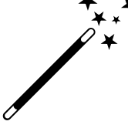
magic wand
a nose |  | 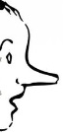
a witch |  | 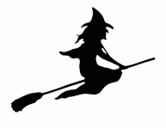
a tail |  | 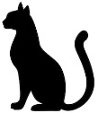
eyes |  | 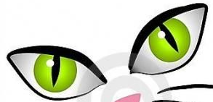
a cat |  | 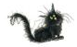
(Rešitve: klobuk, deset nožnih prstov, čarobna palica, nos. čarovnica, rep, oči, maček)

- Print the song (page 6) and glue it in your notebook. Complete the song with the words from the box.
Natisni pesem (stran 6) in jo prilepi v zvezek. List bo potrebno malo obrezati. Dopolni pesem z besedami iz ovirčka.

Če pesmi ne moreš natisniti, boš natisnjeno obliko dobil(a), ko se vrnemo v šolo. Potem dopolni računalniško obliko.
Tisti, ki ste v petek bili v šoli, ste ta učni list že dobili.

Winnie's Song

A big tall _______,
Ten long _________,
A black magic ________,
A long red ________.
She's Winnie,
Winnie the __________.

A long black _________,
Big green ________,
He goes with Winnie
When she flies.
He's Wilbur,
Wilbur the ________.
CAT TAIL WAND HAT NOSE TOES WITCH EYES

