SPROŠČANJE S PLESOM - JUST DANCE
Med štirimi stenami vašega doma se lahko s plesom na prijeten način razgibate in razvedrite. V GOOGLE ali YOUTUBE vtipkajte JUST DANCE in si ples izberite sami ali pa izberete katero od ponujenih možnosti.
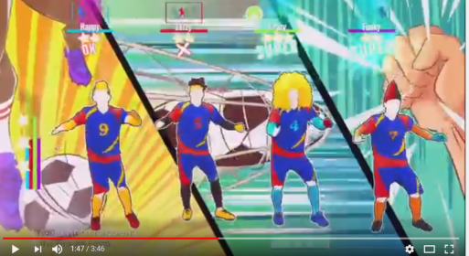
- https://www.youtube.com/watch?v=gCzgc_RelBA

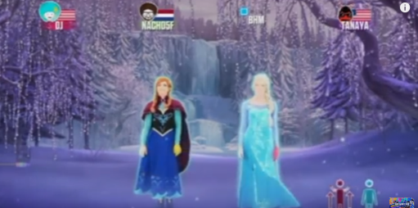
- https://www.youtube.com/watch?v=ERbdjlvg6dg

- https://www.youtube.com/watch?v=Wcr4ZB_4Iqo
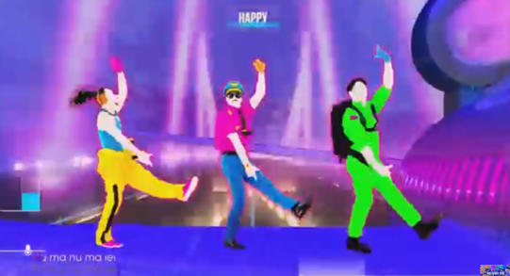

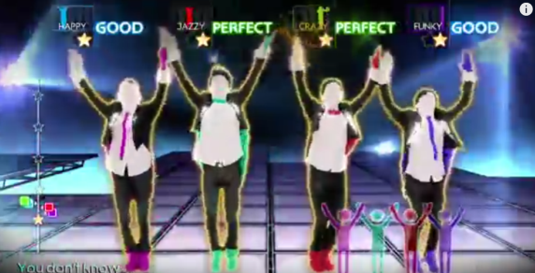
- https://www.youtube.com/watch?v=dpY4ZTV7Fm0

- https://www.youtube.com/watch?v=v_U7ERmMGzU
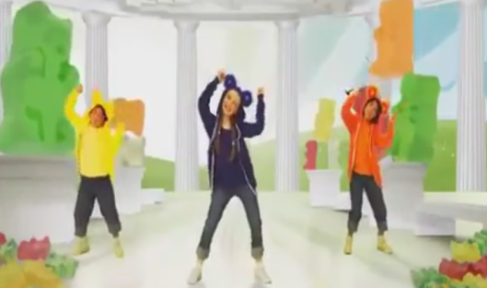

- https://www.youtube.com/watch?v=7eIwxX_cPZU
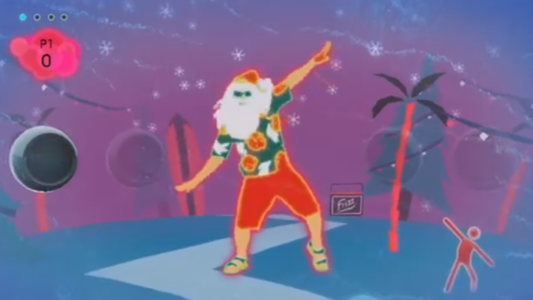

- https://www.youtube.com/watch?v=y2joDOunHBo
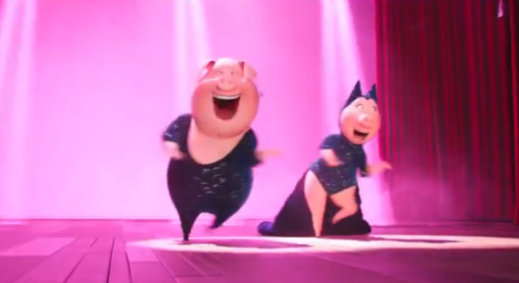

- https://www.youtube.com/watch?v=SWHS4HsgnUk
