Monday, 23rd March, 9r / group 1
Instructions for work in English class

Hello, my dearest 9th graders!

JOKE OF THE DAY JUST FOR YOU!!!

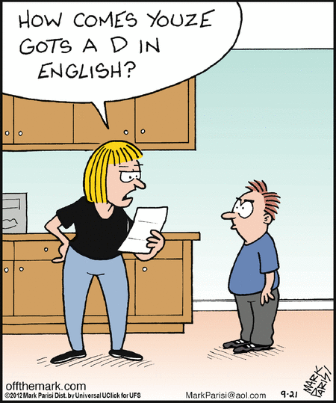

Instructions for today are as follows:

- The instructions for today are how to write MAIN CHARACTERS DESCRIPTION. I am sure you are already familiar with that but still. The instructions one more time in order not to make too many mistakes.

- Besides that please write YOUR OPINION ABOUT THE BOOK, so the next lesson will be only for ACTIVITIES and then we will move on to LEARNING FROM STUDENT BOOKS AND WORKBOOKS.

- So, the next two steps in the BOOK PROJECT are MAIN CHARACTERS DESCRIPTION AND MY OPINION ABOUT THE BOOK.

- As I already explained how it should be done in school , let's just quickly go through the basic instructions.

- MAIN CHARACTERS

Choose the main characters in the book. Describe them in 8-10 sentences. Write how they look like, what are they like, how are they important for the story, why are they important fort he development of the story …

- MY OPINION ABOUT THE BOOK

Write at least 12-15 sentences what you liked or disliked the book. Write as many arguments as possible to present your opinion, write why you would recommend the book for others to read…

PLEASE SEND ANY QUESTIONS YOU HAVE TO THE FORUM OR MY EMAIL ADDRESS.

HAVE A GREAT DAY AND TAKE CARE OF YOURSLEVES.
YOUR TEACHER SAŠA

PS. Navodila vam pišem v angleščini. Če česarkoli ne razumete, prosim, pišite mi.

