- Answer the question: What did you last time?
Ustno odgovori na vprašanje: Kaj si v prejšnjič delal(a) pri angleščini?
Preveri, če si naredil(a) vse:
- ponovil(a) in pel(a) pesem Winnie's song,
- poslušal(a) zgodbo Winnie Flies Again
- se učil(a) novega besedišča s pomočjo sličic in besed .

Če ti je še kaj ostalo, naredi zdaj.

- Click on the link below. Sing the song.
Klikni na spodnjo povezavo. Zapoj pesem. Pomagaj si z besedilom (v zvezku).

https://www.youtube.com/watch?v=kuycjD-xXOQ

- Click on the link below. Listen to and read the story WINNIE FLIES AGAIN.
Klikni na spodnjo povezavo. Poslušaj in beri zgodbo WINNIE FLIES AGAIN.
https://www.youtube.com/watch?v=2bv0fAgpjAs

- Let's repeat the words.
Ponovi besedišče.

! NOTE: SPECTACLES = GLASSES

- Read the words.
Preberi besede.

WAND BROOMSTICK HANG GLIDER HOLE BUILDING GLASSES = SPECTACLES POND CUP OF TEA BICYCLE BALLOON TREE SKATEBOARD AIRPLANE HAT

- Point to the picture and say the word.
Poimenuj spodnje sličice. Zgornje besede so ti lahko v pomoč.

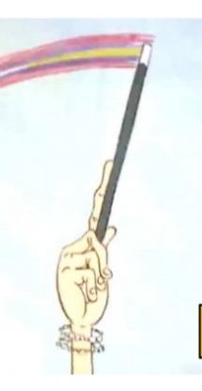
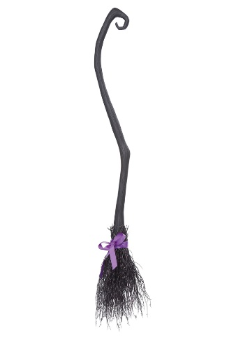
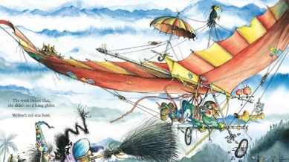

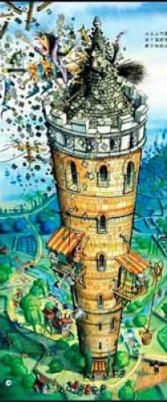




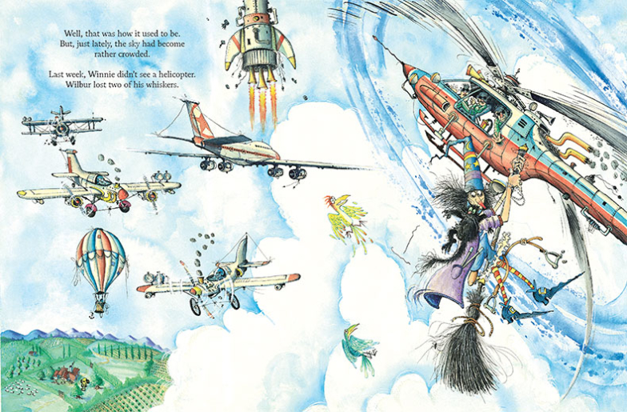


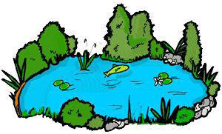

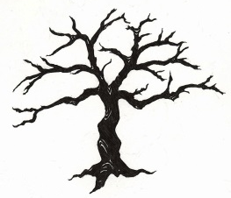
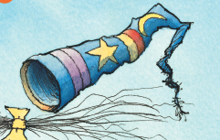
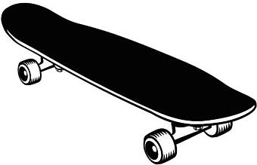

- Find the words in the text and colour / highlight them.
Besede v okvirčku poišči v besedilu in jih pobarvaj ali označi.
WAND BROOMSTICK HANG GLIDER HOLE BUILDING GLASSES CUP OF TEA BICYCLE TREE SKATEBOARD HELICOPTER HAT HORSE

WINNIE COULD FLY AGAIN
Summary

Winnie and her cat Wilbur loved flying on the broomstick.
One day the sky was very busy and Winnie crashed into a helicopter, a hang glider and a building. So Winnie used her black magic wand and made a change. Her broom was a bicycle but it was not easy to ride. Winnie turned the bicycle into a skateboard which was too fast. Winnie now decided to change the skateboard into a horse. But she crashed into a tree, so Winnie and Wilbur decided to walk. Then she fell into a hole. Winnie wanted a cup of tea and some milk but a lady at the shop had only glasses.
Winnie and Wilbur flew on their broomstick again because Winnie had new glasses and could see better.

- Try and answer the questions in Slovene.
Poskusi ustno odgovoriti na vprašanja v slovenščini.
(Če na kakšno vprašanje še na znaš odgovoriti, ga samo označi. Naslednjo uro angleščine boš poskusil(a) še enkrat.)

- Kdo je Winnie?
- Kdo leti z Winnie na metli?
- Kam se je Winnie zaletela?
__________ _____________ ____________
- V kaj je spremenila svojo metlo?
____________ ____________ ____________
- Kam je Winnie padla?
- Zakaj je Winnie spet lahko letela na svoji metli?

Če imate možnost tiskanja, prosim, če to stran natisnete in jo učenec /-ka obreže in prilepi v zvezek. Hvala.

