Osnovna šola Ivana Skvarče Zagorje

2. PISNO PREVERJANJE, Units 2 and 3

Name and surname: ___________________ Points: 81/_____
Class: 6.______________ Mark: _________
Date: ______________
1. Poslušaj Tyrona, ki se pogovarja po telefonu in označi povedi kot resnične oziroma napačne.

Free time 8/___
There are four different age groups that play water polo. T F

Tyrone wants to join the under 14s club. T F

The under 16s water polo team train three times a week. T F

The under 16s train on Monday and Thursday evenings. T F

Water polo matches are played on Saturdays. T F

You have to pay to join the water polo classes for under 18s. T F

You need to bring a photo to register at the swimming pool. T F

Training for the water polo team starts this week. T F

- Prevedi v angleščino. 10/___

hladilnik | kuhinja
omara | ogledalo
umivalnik | rastlina
obesek za ključe | stol
znamka | tuš

3. Napiši naslednja števila s številko ali z besedo. 6/___
167 |  | fifty-six
83 |  | twelve
92 |  | forty-three

4. Napiši, čigavi so predmeti. 4/___
the wizard –books the cowboy – horse Thomas – tent girls - shoes

Primer: Whose book is this? It’s Jenna’s book.
a) Whose books are these? __________________________________________________
b) Whose horse is this? ________________________________________________
c) Whose tent is this? ______________________________________________________
d) Whose shoes are these? _________________________________________________

5. Napiši manjkajoče oblike (trdilne, vprašalne ali nikalne). 12/__

Affrimative + | Question ? | - Negative
Sarah lives in Ireland.
 | Do Jack and Jill collect stickers?
 |  | Mark hasn’t got a cousin.
 | Are they happy?
 |  | Nicolette doesn’t hate rainy weather.
You speak German.

6. Odgovori. 8/__ a) Are there any windows in your classroom? Yes, _______
b) Does your friend like joking around? No, ______________
c) Do Andy and Robert like lazy people? No, _________________
d) Is there a toy tiger in your room? No, ____________________
e) What’s the time? ____________________________________
f) What’s your favourite school subject?______________________________
g) What do you have on Wednesdays? _______________________________
h) When do you go to school? ______________________________________
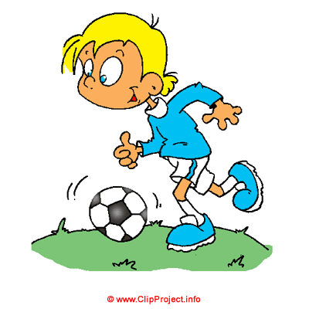
7. Oglej si sličice in napiši, kaj imaš rad in česa ne maraš.
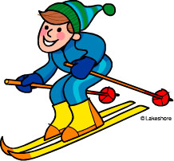
Uporabi dejanja iz sličic. 4/___
Example: I like going to the cinema.
I don't like dancing.
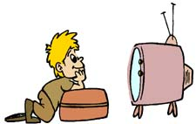
a) _______________________________________________
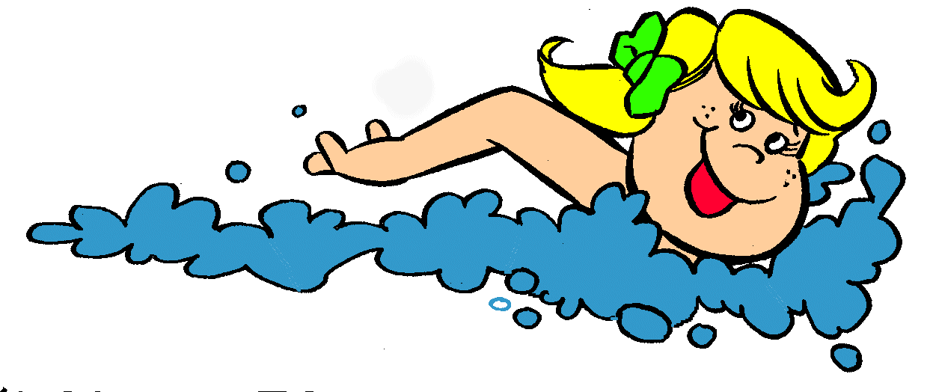
b)________________________________________________
c) _______________________________________________
d) _______________________________________________
8. Oglej si sliki in reši nalogi.
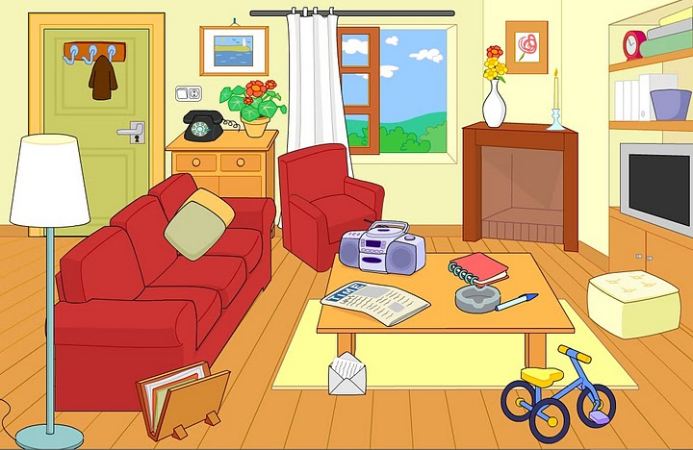
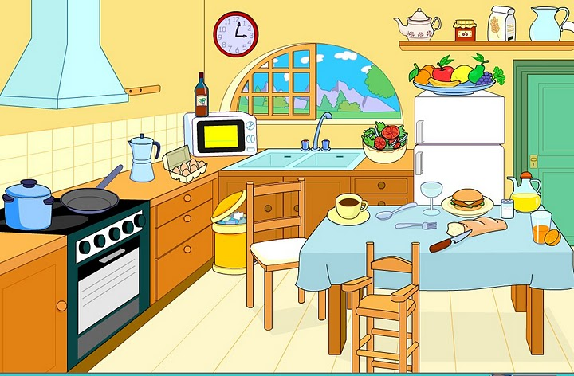

A Opiši prvo sliko in uporabi there is/are, there isn't/aren't. Napiši vsaj 6 stavkov. 6/___
_______________________________________________________________________________________________________________________________________________________________________________________________________________________________________________________________________________________________________________________________________________________________________________________
B Oglej si drugo sliko. Povej, kje so stvari in pri tem uporabi predloge. 6/__
1. Coffee is ……………….the table. | 2. The eggs are…………………. the box.
3.The window is ……………the microwave. | 4. The hamburger is ………………….. the glass and the juice.
5. The clock is ……………….. the wall. | 6. The chairs are …………….. the table.

9. Oglej si sličice in napiši, koliko je ura. 5/__
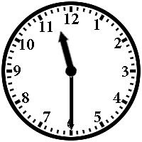
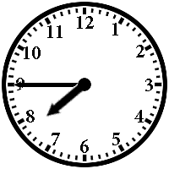
1. 2. 3. 4. 5. 
1.___________________________________________________2.___________________________________________________3.___________________________________________________4.___________________________________________________5.___________________________________________________
10. Prevedi v angleščino. 6/___
Zbiram posterje. ________________________________________________________
Ob ponedeljkih imam plavanje. ______________________________________________
Kdaj imaš na urniku zgodovino? ________________________________________________
Anna ima balet od petih do sedmih. ___________________________________________
Danes je sreda.____________________________________________________________
Kdaj imaš rojstni dan? _____________________________________________________

11. Glede na sličice napiši imena šestih šolskih predmetov po izbiri. 6/__
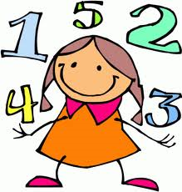  -------------------------- |   --------------------- |   ---------------------- |   -------------------------- |   ---------------------
  -------------------------- |   ---------------------- | ----------- |   ------------------------
KRITERIJ: 100% - 90% = odl (5) 81T- 73T
89% - 80% = pdb (4) 72T – 65T
79% - 65% = db (3) 64T – 53T
64% - 45% = zd (2) 52T – 36T
44% - 0% = nzd(1) 35T - 0T
LINK ZA SLUŠNO RAZUMEVANJE

https://learnenglishteens.britishcouncil.org/skills/listening/elementary-a2-listening/free-time

Osnovna šola Ivana Skvarče Zagorje

2. PISNO PREVERJANJE, Units 2 and 3

Name and surname: ___________________ Points: 81/_____
Class: 6.______________ Mark: _________
Date: ______________
1. Slušno razumevanje
1. True 2. False 3. False 4. False 5. True 6. False 7. True 8. False

- Prevedi v angleščino. 10/___

hladilnik a fridge | kuhinja a kitchen
omara a wardrobe | ogledalo a mirror
umivalnik a washbasin | rastlina a plant
obesek za ključe a key ring | stol a chair
znamka a stamp | tuš a shower

3. Napiši naslednja števila s številko ali z besedo. 6/___
167 | one hundred and sixty-seven | fifty-six | 56
83 | eighty-three | twelve | 12
92 | ninety-two | forty-three | 43

4. Napiši, čigavi so predmeti. 4/___
the wizard –books the cowboy – horse Thomas – tent girls - shoes

Primer: Whose book is this? It’s Jenna’s book.
a) Whose books are these? They’re the wizard’s books.
b) Whose horse is this? It’s the cowboy’s horse.
c) Whose tent is this? It’s Thomas’ tent.
d) Whose shoes are these? They’re girls’ shoes.
5. Napiši manjkajoče oblike (trdilne, vprašalne ali nikalne). 12/__
Affrimative + | Question ? | - Negative
Sarah lives in Ireland. | Sarah doesn’t live in Ireland. | Does Sarah live in Ireland?
Jack and Jill collect stickers. | Do Jack and Jill collect stickers? | Jack and Jill don’t collect stickers.
Mark has got a cousin. | Has Mark got a cousin? | Mark hasn’t got a cousin.
They are happy. | Are they happy? | They aren’t happy.
Nicoletta hates rainy weather. | Does Nicoletta hate rainy weather? | Nicolette doesn’t hate rainy weather.
You speak German. | You don’t speak German. | Do you speak German?

6. Odgovori. 8/___ a) Are there any windows in your classroom? Yes, there are.
b) Does your friend like joking around? No, he/she doesn’t.
c) Do Andy and Robert like lazy people? No, they don’t.
d) Is there a toy tiger in your room? No, there isn’t.
e) What’s the time? ______
f) What’s your favourite school subject?______________________________
g) What do you have on Wednesdays? On Wednesdays I have…
h) When do you go to school? I go to school at ….

7. Oglej si sličice in napiši, kaj imaš rad in česa ne maraš.
Uporabi dejanja iz sličic.
Example: I like going to the cinema. I don't like dancing.

a) I like/ I don't like playing football.
b) I like / I don't like watching TV.
c) I like / I don't like skiing.
d) I like / I don't like swimming
8. Oglej si sliki in reši nalogi.
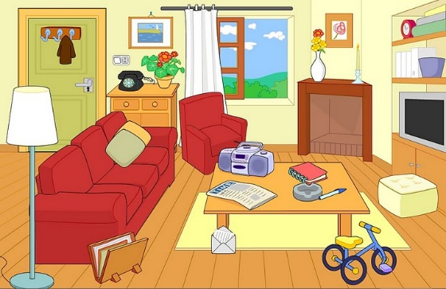
A Opiši prvo sliko in uporabi there is/are, there isn't/aren't. Napiši vsaj 6 stavkov. 6/___
There is a sofa in the living room. There's a lamp next to the sofa. There is a table in front of the sofa.
There are two pictures on the wall. There aren't any keys on the chest of drawers. There isn't a fridge in the living room.
B Oglej si drugo sliko. Povej, kje so stvari in pri tem uporabi predloge. 6/___
1. Coffee is ……on…….. the table. | 2. The eggs are………in……. the box.
3. The window is behind…. the microwave. | 4. The hamburger is between….. the glass and the juice.
5. The clock is ……on….. the wall. | 6. The chairs are next to….. the table.

9. Oglej si sličice in napiši, koliko je ura. /5
1. 2. 3. 4. 5.
1. It's quarter to eight.
2. It's half past eleven.
3. It's ten past ten.
4. It's twenty-five to eleven.
5. It's seven o'clock.

10. Prevedi v angleščino. 6/__
Zbiram posterje. I collect posters.
Ob ponedeljkih imam plavanje. I have swimming on Mondays.
Kdaj imaš na urniku zgodovino? When do you have history on the timetable?
Anna ima balet od petih do sedmih. Anna has ballet from 5pm to seven pm.
Danes je sreda. Today is Wednesday.
Kdaj imaš rojstni dan? When’s your birthday?

11. Glede na sličice napiši imena šestih šolskih predmetov po izbiri. 6/__
maths | computng | geography | art | P.E.
English | science | biology | music

