OŠ Ivana Skvarče Zagorje

PREVERJANJE ZNANJA IZ ANGLEŠKEGA JEZIKA

Name & Surname: ________________ POINTS: 79/_____
Class: 8. __
Date: ____________ GOOD LUCK! ____%

Kriterij: 100% - 90% =odlično 89% - 80% = prav dobro 79% - 65% = dobro 64% - 45% = zadostno 44%-0% = nezadostno

1. Fill in the gaps with the missing forms of the verbs. Izpolni z manjkajočimi oblikami glagolov. 12/_______

Infinitive (nedoločnik) Past Tense Past Participle Translation (prevod)
piti
pometati
teči
srečati, spoznati
narediti
zmagati
izgubiti
zlomiti

2. Complete with verbs in the Present Perfect Tense. Dopolni z glagoli v predsedanjiku.

Jim _____________ (put) the book back in its place.
They _____________________(buy) a new car. 7/___
We ____________________ (work) here for a very long time.
She ___________________ (write) three letters this afternoon.
Where _________________ (he/be)? He ________________(be) in London.
I _________________________(not finish) my work yet.
Peter ___________________ (open) a new store recently.

3. Write two things you have done and two things you haven't done yet. (Napiši dve stvari, ki si jih že počel/a in dve, ki jih še nisi. Uporabi Present Perfect!) 8/___

____________________________________________________________________________________________________________________________________________________________________________________________________________________________________________________________________________________________________________
4. Fill in a suitable adverb. Vstavi: just, never, already, ever, yet 5/____
Have you _____________ jumped from speeding cars? – Not yet.
Jack hasn’t cleaned his shoes ___________ .
I have _____________ tried snails.
Is Rose at home? – No, she has _________ left.
We have _______________ done our homework.

5. Name some endangered animals (at least 3) and write down why they are in danger. Naštej nekaj ogroženih živali (najmanj 3) in napiši, zakaj so v nevarnosti. 6/_____
_______________________________________________________________________________________________________________________________________________________________________________________________________________________________________________________________________________________________________________________________________________________________________________________

6. Name the following activities and daily chores. Poimenuj aktivnosti in vsakodnevna opravila na sličicah. 8/____

  LOKOSTRELSTVO  __________________ |   LIKATI  ___________________ | 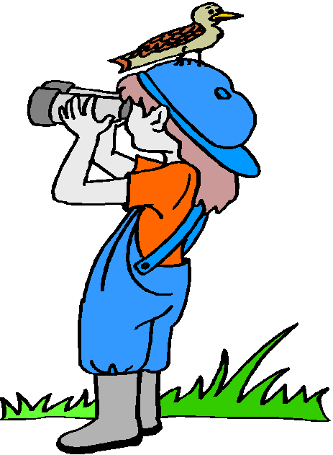  OPAZOVANJE PTIC  __________________ |   BORILNE VEŠČINE  ___________________
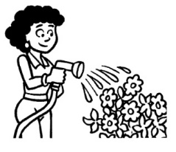  ZALIVATI ROŽE  __________________ |   POGRABITI LISTJE  _________________ |   KIPARJENJE  ___________________ |   DESKANJE  ____________________

7. Fill in the table. Izpolni tabelo s pravilnimi oblikami glagolov. 12/_____

Affirmative (+) | Negative (-) | Interrogative (?)
She will go out tomorrow.

 |  | Does he like dogs?
 | We didn't cook lunch.
 |  | Was it raining last night?
 | You aren't speaking now.
He has made a parachute jump.

8. Translate the sentencesinto Slovene. Prevedi naslednje stavke v slovenščino! 5/_____
Do you have to do any chores? _________________________________________________
Who does the ironing in your family? ____________________________________________
Pollution is one of the main global issues today.
__________________________________________________________
Tom has gone to Berlin. __________________________________________________
Alice has been to Great Britain. _________________________________________________

9. How often do people do the following things? Ask and answer questions. Napiši vprašanji, kako pogosto to delajo (A) in odgovori V CELIH POVEDIH (B). 4/____

 | WHO? | WHAT? | HOW OFTEN?
1. | NICOLETTA | PREPARE BREAKFAST | EVERY MORNING
2. | JIM AND JOE | FORGET THEIR HOMEWORK | OFTEN

- A:_______________________________________________________________________________
B:_______________________________________________________________________________
- A:_______________________________________________________________________________
B:_______________________________________________________________________________
10. Complete the text with the appropriate words. Dopolni z ustreznimi besedami.
Začetne črke bedes so že napisane.
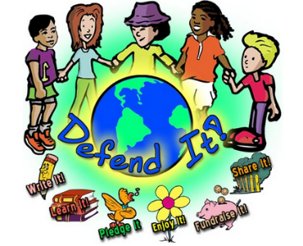
Seven ways to protect the environment 12/___
We all want to p______________ our planet, but we're mostly too busy or too lazy to put up big change that would improve our lifestyle and s________________ the environment.
These are 7 simple habits to implement in your everyday life which will make a difference. There is nothing new here but if you follow at least some of these tips, you can be proud of yourself participating in the protection of the e_____________________ .
- Use compact fluorescent light bulbs:
It is true that these bulbs are more expensive, but they last much longer and they can save e________________ and in the long term your electricity bill would be reduced.
- Donate:
You have tons of clothes or things you want to get rid of. If they are still usable, give them to someone who needs them. You may also choose to give them to associations. These associations may sell them and collect a little m_____________. Not only will you protect the environment, but you will also contribute to a good cause.
- Turn off your devices:
When you do not use a house device, turn it off. For example, if you don't watch TV, turn it off. T_______ o_______ the light when you leave a room (even if you intend to return.) It's an easy habit to take up which will help you save a lot of money.
- Walk or cycle:
Driving is one of the biggest causes of p________________. If you want to use your car, ask yourself the following question: do I really need my car? Walk or use your bike if the journey is a short one.
- Detergent:
Follow the recommended dose of detergent to wash your clothes or dishes.
- Leaky taps:
Watch leaky taps, which can cause a significant increase in the the water bill. An average of 120 liters of water can be wasted due to a dripping t____________.
- Rainwater:
Think of recovering rainwater. This water can be used for different p _____________.
(Adapted from: http://www.myenglishpages.com)

Read and circle the correct answer. Preberi trditve in obkroži pravilen odgovor:
- Fluorescent light bulbs waste more energy. TRUE / FALSE
- Donate means: GIVE / TAKE
- The 7 tips suggested: TO SAVE MONEY / TO PROTECT THE ENVIRONMENT / TO SAVE MONEY AND PROTECT THE ENVIRONMENT

