
Name & surname: ________________
Class: 7. ______
Date: ___________ UTRJEVANJE SNOVI UNITS 2&3

- What are the things in the picture? Kaj so stvari na slikah? Napiši izraze!

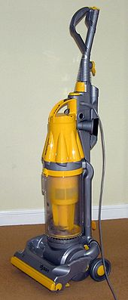 | 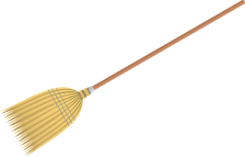 | 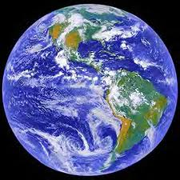 | 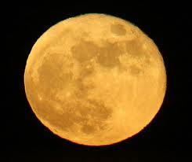 | 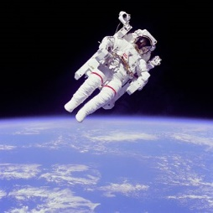

- Write the numbers as years. Napiši letnice.
- _______________________________________________________
1903 _______________________________________________________
2012 ________________________________________________________
1805_________________________________________________________

3. Put the verbs into PAST SIMPLE TENSE. Glagole postavi v navadni preteklik.
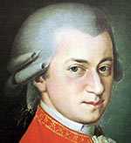 Mozart _____________ (be) born in Salzburg on 27 January 1756. He __________ (be) only four when he ______________ (start) to play the piano. By the age of five he _____________ (can) read and write music. Aged six, he ______________ (travel) with his father through Europe, giving many concerts. Mozart ______________(like) Italy the best.
In 1781, he ____________(move) permanently to Vienna, where he ____________(become) well known as a composer and performer. In 1782, he ______________(marry) against the wishes of his family. He _______________(have) six children but only two survived infancy.
Mozart _____________ (write) wonderful operas, symphonies and sonatas.
He _______________ (die) at the age of thirty-five in Vienna.

4. Match the questions with the right answers.
1. Did you have a music lesson last Friday? _____ Of course I could.
2. Were you at school yesterday? _____ No, she wasn’t. She was at home.
3. Did Betty wash her hair last night? ______Yes, I did.
4. Was she at the cinema last Sunday? _____ No, I wasn’t. I had a temperature.
5. Could you swim when you were 6? _____ No, she didn’t.
6. Who wrote Romeo and Juliet? _____ Shakespeare did.

5. Complete the table with irregular verbs. Dopolni tabelo z nepravilnimi glagoli.
1. OBLIKA 2. OBLIKA PREVOD
drink
speak
fly
drive
begin
come
meet
see

6. Complete with the appropriate modal verbs. Dopolni z ustreznimi naklonskimi glagoli.

- sem moral/a Yesterday I _____________________ clean my room.
- ni mi bilo dovoljeno I _________________________ to go out last Saturday.
- mora Mary _______________________cook lunch every day.
- ni znal Ted __________________________ ski when he was 5.
- morala bi You’ve got a fever. You ______________ see a doctor.
- ni jim bilo treba The children ____________________ wash up after diner.
- ne smeš You ______________ cross the street when the light is red.
- ni ji treba She _________________ go shopping every day.
- znamo We _____________________ sing very well.
- ne znam I ______________________ speak Spanish.

7. Make the sentences negative. Zanikaj povedi.

- The alien understood Vasja. ______________________________________________
- The flying saucer stopped in mid-air. _______________________________________
- It had three eyes. ______________________________________________________
- Gina and Claudio were frightened. _________________________________________
- Maddy could rollerblade when she was 8. ___________________________________
8. Make WH-questions using the Past Tense. Tvori WH.vprašanja v pretekliku.

1. 70 years ago people washed their clothes by hand. How__________________________
2. Chaplin had 8 children. How many ___________________________________________
3. They went to the zoo last Saturday. Where______________________________________
4. Eliot took E.T. home. Who _________________________________________________
5. They were born in 2005. When _______________________________________________
6. Chaplin died in Switzerland. Where ___________________________________________
7. Oscar Levi Strauss created the first pair of jeans in 1850.
What ______________________________________________________

9. Complete the text with the appropriate words. Dopolni tekst z ustreznimi besedami.
Prve črke besed so že napisane.
UFOs are Unidentified F_______________ Objects. They come from outer s___________.
People usually see UFOs at n______________. UFOs are round and flat like s____________.
Sometimes they l_______________ and sometimes they don’t. They can f_______________
very fast. They usually have many bright l_______________.
Aliens are f_______________ and don’t have any guns. They are usually smaller than us, but they have bigger h ____________. They w_____________silver, shiny suits and h__________. . 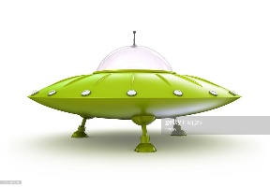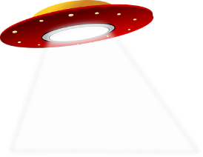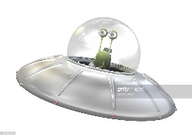
10. Translate into English. Prevedi v angleščino.
- Tom je znal plavati, ko je bil star 7 let. _______________________________________
- Zemlja se vrti okrog sonca. _______________________________________________
- Carlie Chaplin je bil komik. _______________________________________________
- V preteklosti ljudje niso imeli računalnikov. __________________________________
- Kje si bil/a včeraj? ______________________________________________________
- Samo bogati ljudje so imeli hladilnike. ______________________________________

11. Translate into Slovene. Prevedi v slovenščino.
- Mr Slade ni imel pralnega stroja. _______________________________________
- Maddy was often awake. _________________________________________
- I was never lonely and miserable. ______________________________________
- Maria Callas was a Greek opera singer. _________________________________
12. Describe your yesterday. Opiši včerajšnji dan. Napiši najmanj 10 povedi. What did you do:
● in the morning,
● in the afternoon
● in the evening.

_______________________________________________________________________________________________________________________________________________________________________________________________________________________________________________________________________________________________________________________________________________________________________________________________________________________________________________________________________________________________________________________
________________________________________________________________________________________________________________________________________________________________________________________________________________________
________________________________________________________________________
_______________________________________________________________________

Name & surname: ________________
Class: 7. ______
Date: ______________ UTRJEVANJE SNOVI UNITS 2&3

- What are the things in the picture? Kaj so stvari na slikah? Napiši izraze!

a vacuum cleaner | a broom | the Earth | the full moon | an astronaut

- Write the numbers as years. Napiši letnice.

- fourteen sixty-eight
1903 nineteen – oh -three
2012 twenty twelve
1805 eighteen – oh - five

3. Put the verbs into PAST SIMPLE TENSE. Glagole postavi v navadni preteklik.
Mozart _____was____ (be) born in Salzburg on 27 January 1756. He _____was__ (be) only four when he ____started____ (start) to play the piano. By the age of five he _____could____ (can) read and write music. Aged six, he _travelled_____ (travel) with his father through Europe, giving many concerts. Mozart ___liked____(like) Italy the best.
In 1781, he _____moved__(move) permanently to Vienna, where he ___became___(become) well known as a composer and performer. In 1782, he ____married____(marry) against the wishes of his family. He _______had_____(have) six children but only two survived infancy.
Mozart ____wrote____ (write) wonderful operas, symphonies and sonatas.
He _______died____ (die) at the age of thirty-five in Vienna.

4. Match the questions with the right answers.
1. Did you have a music lesson last Friday? ___5__ Of course I could.
2. Were you at school yesterday? ___4__ No, she wasn’t. She was at home.
3. Did Betty wash her hair last night? ___1___Yes, I did.
4. Was she at the cinema last Sunday? ___2__ No, I wasn’t. I had a temperature.
5. Could you swim when you were 6? ___3__ No, she didn’t.
6. Who wrote Romeo and Juliet? ___6_ Shakespeare did.

5. Complete the table with irregular verbs. Dopolni tabelo z nepravilnimi glagoli.
1. OBLIKA 2. OBLIKA PREVOD
drink | drank | piti
speak | spoke | govoriti
fly | flew | leteti
drive | drove | voziti (se), peljati (se)
begin | began | začeti
come | came | priti
meet | met | srečati; spoznati
see | saw | videti

6. Complete with the appropriate modal verbs. Dopolni z ustreznimi naklonskimi glagoli.
- sem moral/a Yesterday I ______had to_________ clean my room.
- ni mi bilo dovoljeno I _____wasn’t allowed to____ to go out last Saturday.
- mora Mary _______must___________cook lunch every day.
- ni znal Ted _______couldn’t__________ ski when he was 5.
- morala bi You’ve got a fever. You ___should____ see a doctor.
- ni jim bilo treba The children __didn’t have to____ wash up after dinner.
- ne smeš You __mustn’t__ cross the street when the light is red.
- ni ji treba She _doesn’t have to____ go shopping every day.
- znamo We _________can________ sing very well.
- ne znam I ______can’t_______ speak Spanish.

7. Make the sentences negative. Zanikaj povedi.

- The alien understood Vasja. The alien didn’t understand Vasja.
- The flying saucer stopped in mid-air. The flying saucer didn’t stop in mid-air.
- It had three eyes. It didn’t have three eyes.
- Gina and Claudio were frightened. Gina and Claudio weren’t frightened.
- Maddy could rollerblade when she was 8. Maddy couldn’t rollerblade when she was 8.
8. Make WH-questions using the Past Tense. Tvori WH.vprašanja v pretekliku.
1. 70 years ago people washed their clothes by hand. How did people wash their clothes 70 years ago?
2. Chaplin had 8 children. How many children did Chaplin have?
3. They went to the zoo last Saturday. Where did they go last Sunday?
4. Eliot took E.T. home. Who did Elliott take home?
5. They were born in 2005. When were they born?
6. Chaplin died in Switzerland. Where did Chaplin die?
7. Oscar Levi Strauss created the first pair of jeans in 1850.
What did Oscar Levi Strauss create in 1850?

9. Complete the text with the appropriate words. Dopolni tekst z ustreznimi besedami.
Prve črke besed so že napisane.
UFOs are Unidentified Flying__________ Objects. They come from outer space_____.
People usually see UFOs at night__________. UFOs are round and flat like saucers______.
Sometimes they land__________ and sometimes they don’t. They can fly____________
very fast. They usually have many bright lights____________.
Aliens are friendly________ and don’t have any guns. They are usually smaller than us, but they have bigger heads_______. They wear_________silver, shiny suits and helmets____.
10. Translate into English. Prevedi v angleščino.
- Tom je znal plavati, ko je bil star 7 let. Tom could swim when he was seven.
- Zemlja se vrti okrog sonca. The Earth orbits/circles the Sun.
- Carlie Chaplin je bil komik. Charlie Chaplin was a comedian.
- V preteklosti ljudje niso imeli računalnikov. In the past people didn’t have computers.
- Kje si bil/a včeraj? Where were you yesterday?
- Samo bogati ljudje so imeli hladilnike. Only the rich people had fridges.
11. Translate into Slovene. Prevedi v slovenščino.
- Mr Slade didn’t have a washing machine. Mr Slade ni imel pralnega stroja.
- Maddy was often awake. Maddy je bila pogosto budna.
- I was never lonely and miserable. Nikoli nisem bila osamljena ali nesrečna.
- Maria Callas was a Greek opera singer. Maria Calla je bila grška operna pevka.
12. Describe your yesterday. Opiši včerajšnji dan. Napiši najmanj 10 povedi. What did you do:
● in the morning,
● in the afternoon
● in the evening.

_______________________________________________________________________________________________________________________________________________________________________________________________________________________________________________________________________________________________________________________________________________________________________________________________________________________________________________________________________________________________________________________
________________________________________________________________________________________________________________________________________________________________________________________________________________________
________________________________________________________________________
________________________________________________________________________

