My favourite pet
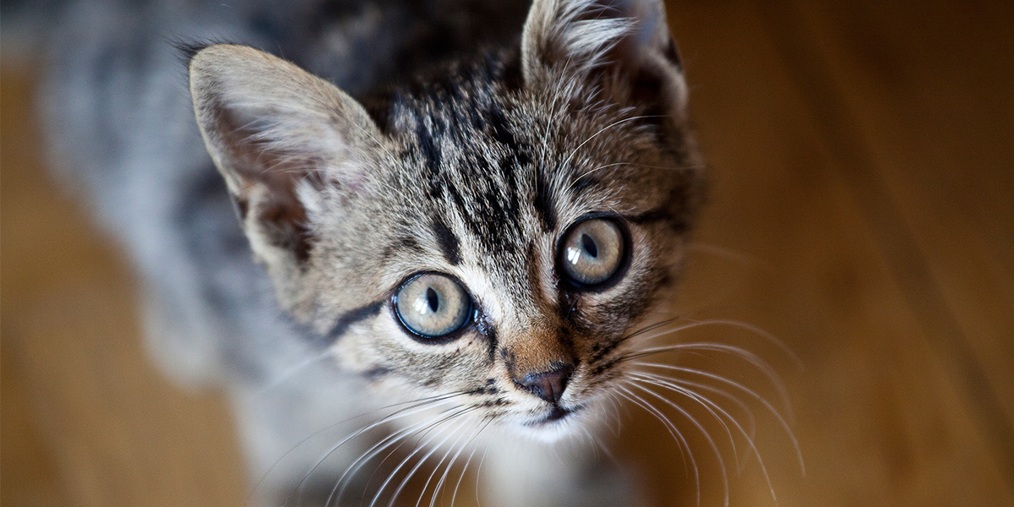
THIS IS MY CAT PIKICA.
SHE IS TWO YEARS OLD.
SHE IS BIG.
SHE IS BLACK, BROWN AND WHITE.

