Primeri vaših izdelkov z mojimi komentarji 30th March
Primer vzorno zapisanega današnjega dela. Le drobna poprava.
!! PAZITE a football ball, an orange clock, an aeroplane/ a plane

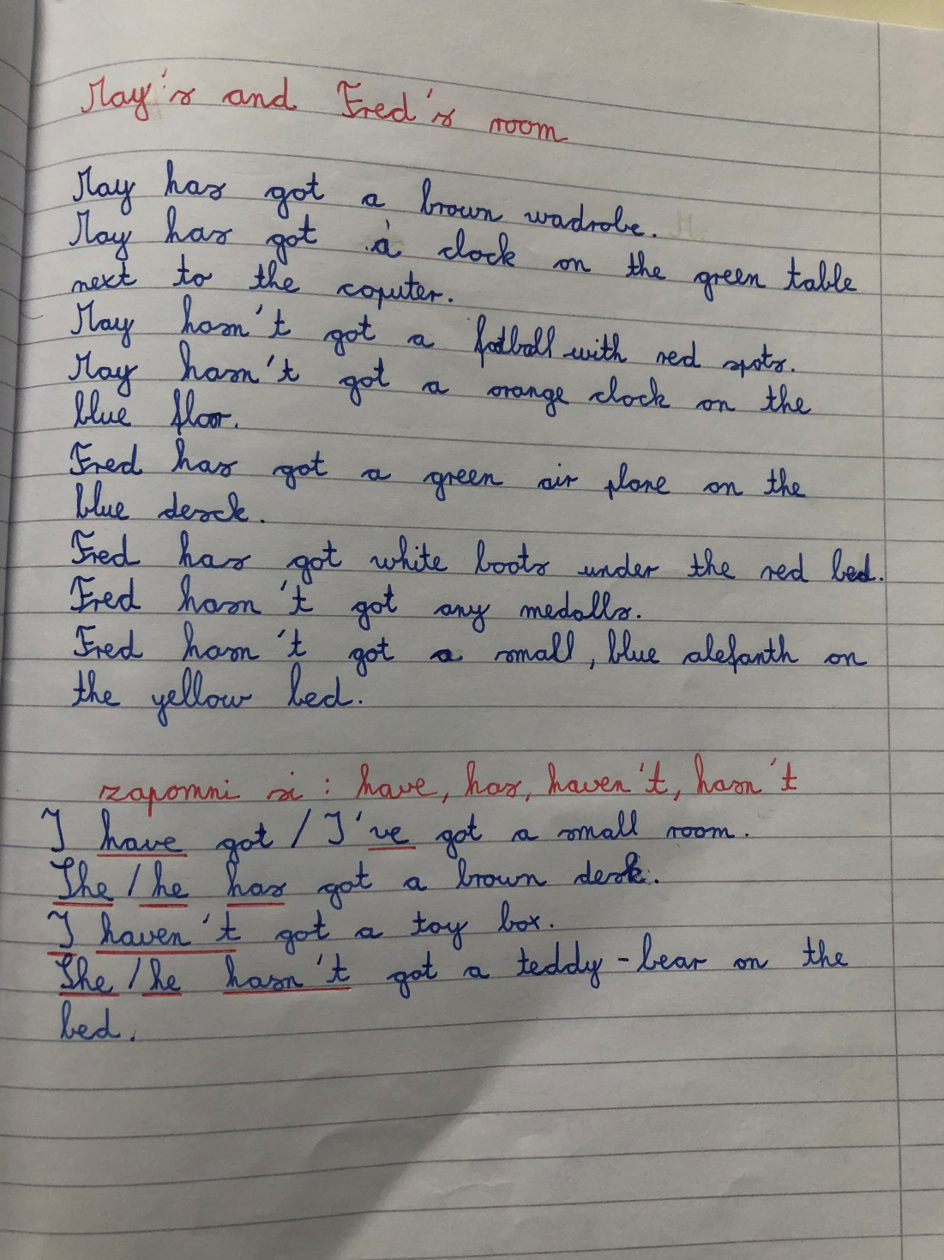

Primeri opisa sobe:

My bedroom

I have my own room. In my bedroom there is a beautiful white bed. There are also two wardrobes and one big radio with two speakers. In my room there are walls in two diferent colours. There is a small desk under the roof window. On the wall there are four diferent boxes in diferent colours. There I have books and small toys. In my room I don t have a mirror and a mat. I have a black lamp on the desk. Behind the desk there are green flowers. In my room I sleep, read, play, listen music and do my/the homework. I like my bedroom.
Odlično zapisano. Pazi le na uporabo THERE IS/ARE/ISN’T/ AREN’T Pazi na pravilen zapis besede: different

MY BEDROOM

I have my own room. There is a the bed on the ride side. It is big. There is a the big wardrobe. It is pink and brown colour. There is a the big green flower on the cupboard. Walls in my room is pink corour. !! The celling is white colour. There is a the desk on the left side. It is brown colour. There is the pencilcase, notebooks, studensbooks, workbooks on my desk. I sleep in my room, play with my sister,… I do anythink in my room. I like my room.

Poglej, najprej sem nastavila jezik v angleščino in dobila to. Tam kjer je podčrtano rdeče, so besede zapisane narobe. Tam kjer zelen, poved ni dobro oblikovana . Popravljam: In my room the walls are pink colour./ The walls are light pink.
There is a purple pencil case. There are many notebooks, student books and workbooks on my brown desk. I sleep, play with my sister, read books and dance in my room. I do everything in my room.
Linda , punca draga. Ti znaš odlično, zdaj pa si bila malo površna.
My bedroom
I have my own bedroom. It is very big. In my bedroom i have a big bed and a big closet. Furniture is white and brown.
I have a desk in my room. It is under the window. On the desk are my books. The walls are blue and black. The floor is gray. I have pictures on the walls. The ceiling is white. I like my room becouse I have very nice room. It is very beautiful. I play in my room. I do homework and study in my room.
Tom Taylor Dear Tom, thank you very much. I'm very happy for your description. Well done.
Only one comment: be careful with THE FURNITURE IS... and BECAUSE AND i DO MY HOMEWORK..

MY BEDROOM

This is my bedroom. I share my room with my brother. It's very big. My room has a big bunk bed. It one small and two big wardrobrs. Room has two white desks.The desk on the left is mine, and on the right is my brother 's.My bedroom has one window. My room hasn 't got flowers. Walls are white. To the left of my desk is a big sticker on the wall. Ceiling is white colour. In my room I play ,study,sleepp,… I can't wait to get my room.

Ne končamo povedi z……
Najprej sem spremenila jezik v angleščino in vidiš, kaj se je zgodilo. Popravljam in komentiram.
There is one small and one big wardrobe in our room. There are two white desks. The walls are white. There is a big sticker on the left wall. The ceiling is… I sleep, study and play in my room.
Pazi na presledke, da ti ne podčrta rdeče.

