RECYCLING
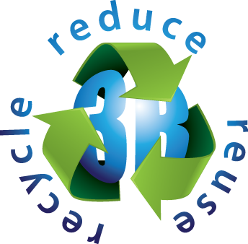 3 Rs 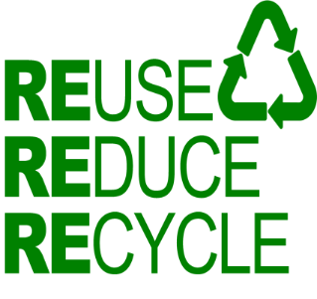
TO REUSE | ponovno uporabiti
TO REDUCE | zmanjšati
TO RECYCLE | reciklirati
(WATER, AIR, LAND) POLLUTION | onesnaževanje, onesnaženost
TO POLLUTE | onesnaževati
POLLUTED | onesnažen
(DOMESTIC / HOUSEHOLD) WASTE | (gospodinjski) odpadki
BIODEGRADABLE WASTE | biološko razgradljivi odpadki
ORGANIC WASTE | organski odpadki
COMPOST | kompost
HAZARDOUS WASTE | nevarni odpadki
SPECIAL WASTE | posebni odpadki
TOXIC WASTE | strupeni odpadki
LANDFILL | odlagališče smeti
LITTER | smeti, odpadki
TRASH | smeti, odpadki
GARBAGE | smeti
NATURAL RESOURCES | naravni viri
RENEWABLE RESOURCES | obnovljivi viri
NON-RENEWABLE RESOURCES | neobnovljivi viri
CONTAMINATION | onesnaženje, okužba

3Rs refers to three terms often used when talking about waste:
Reduce, Reuse, and Recycle.
Reducing is cutting back on the amount of trash we make, reusing is finding a new way to use trash so that we don't have to throw it out, and recycling is using trash to remake new goods that can be sold again.
Using the 3Rs will help us cut back the amount of trash we throw away.

REDUCING is simply creating less waste. By making less waste in the first place, there's less mess to clean up.
Here are a few ways you can help reduce the amount of waste you make:
Pack your lunch in a lunchbox instead of a disposable bag. Also, pack your lunch items in reusable containers instead of disposable ones.
Bring your own bags when shopping. Many grocery stores now sell canvas bags that can be brought and reused over and over when shopping.
Turn off lights when you're not using them. Even though you might not be able to see the waste made from leaving on the lights, it wastes electricity and energy. Cutting back on the amount of electricity you use will not only help the environment, but it will save your parents money too.
Make sure your faucets aren't dripping. After you wash your hands, brush your teeth, or get out of the bath, make sure there's no water dripping from your faucets. Fresh water is a very precious resource, and dripping faucets waste water.

REUSING is taking old items that you might consider throwing away and finding a new use for them.
Here are ways you can reuse items to prevent trash from being created:
Donate clothes that no longer fit you.
You can also donate toys you no longer want.
Use plastic groceries bags as trash bags.
Have your parents use worn clothing as cleaning rags.
RECYCLING is changing old products into new ones so they can be resold.

For example, when you set out bottles and cans to be recycled, they are taken to a plant where they can be reprocessed into many new things. They may be changed in to new bottles or cans, or they could be changed into things like bicycles or asphalt.

The most well-known recycled materials are glass, paper, plastic, and aluminum. Other recyclable materials include batteries, biodegradable waste (plants, kitchen waste), concrete, electronics, ferrous metals (steel, iron), textiles (cotton) and timber.
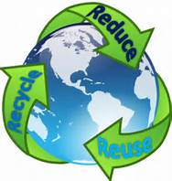
The RECYCLING LOOP describes the entire recycling process.
First, recycling starts when you drop materials to be recycled, like bottles and cans, on the curb.
Secondly, collectors come to pick up the materials and take them to a processing plant where they are sorted and processed into raw materials (or materials that can be used to make new items.)
Next, the materials from the plant are sold to manufacturers, or people who make the things you buy. These manufacturers make new items from them.
Finally, you buy items made from recycled materials, so the process can start all over again.

