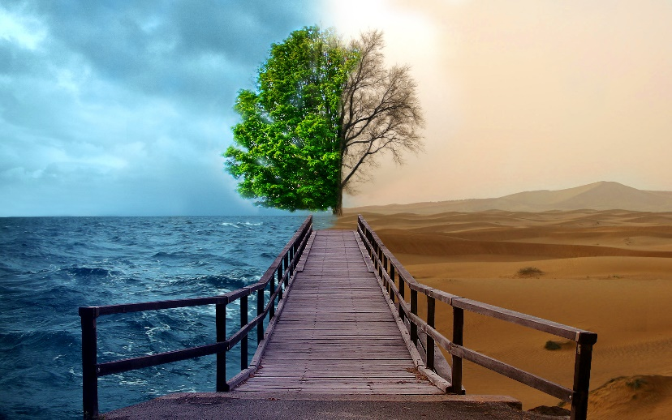
ENVIRONMENT & POLLUTION
Your environment is where you live. When we refer to the environment we mean the entire Earth; each and every city, field, forest, river, and ocean is part of our environment.

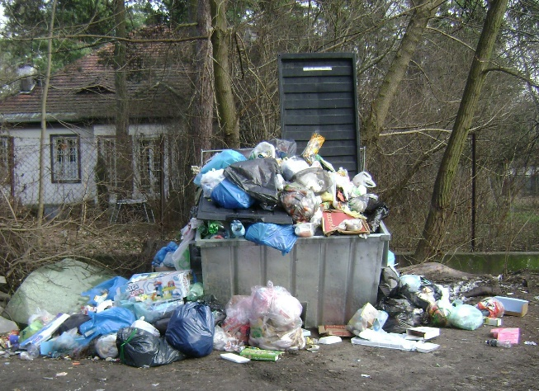
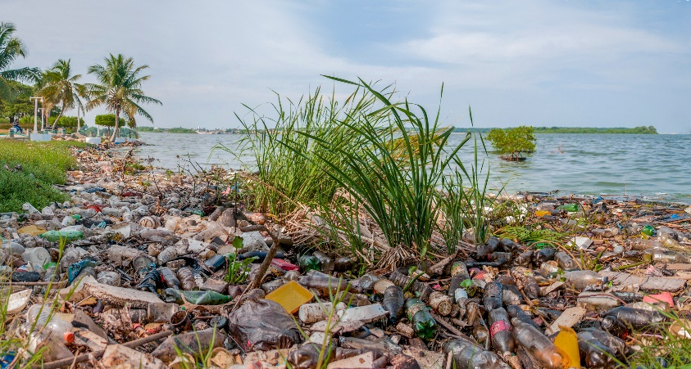
Pollution is contamination that harms the environment or the people or animals living in the environment. If you live in or have ever visited a large city, you might have noticed that the air is filled with smoke. That smoke is air pollution. Water and soil can be polluted too. Litter can attract rats and vermin and cause health problems. It can also harm animals and wildlife, and ruin the quality of water when thrown into rivers or lakes. Polluted water isn’t safe to drink, and polluted soil can’t grow plants and food to eat.
Litter is trash that has not been disposed of properly. Trash that has been thrown on the side of the road or in a lake instead of in a trash can is litter.
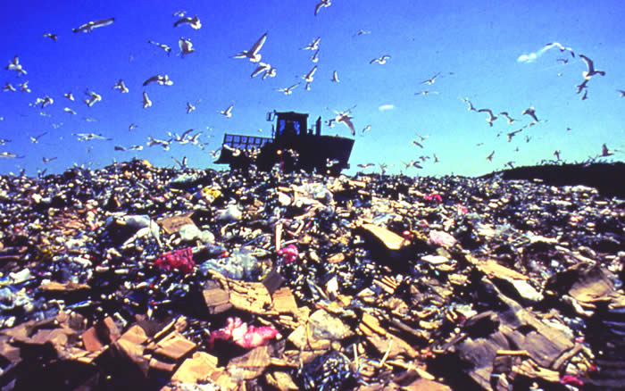
Trash is anything we don't want. Food, paper plates, broken toys, old clothes, empty shampoo bottles --once you throw it away, it's called garbage, waste, or trash.
Once ther trash is picked up, it's taken to a landfill. A landfill is a designated place for trash to be discarded.

TYPES OF POLLUTION
