HOLIDAYS

This year we went to... /we stayed at home.
It was..
We travelled there for.../by...
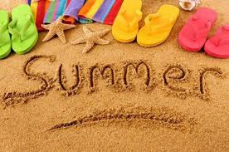
We stayed there for...
The day started with...
We had lunch at ...
In the afternoon we...
In the evening we....
The weather was...
I saw...
I met...
The worst thing was
The best thing was...

ASK ABOUT YOUR FRIEND`S HOLIDAYS!

Where did you spend this summer holidays?

