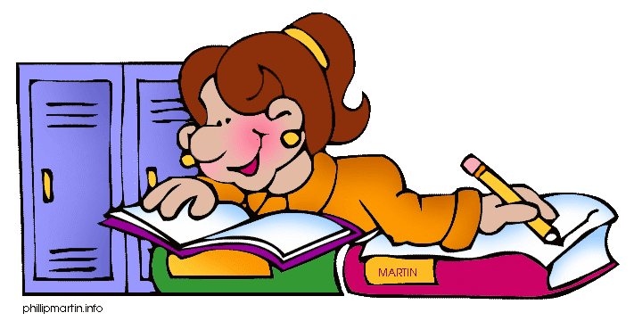

- It’s been ages since we last ………………….. to the cinema.(go)
- -Where is Robert ?
-He is in the garden
-What ………… he ……………..? (do)
-He ………………………. the lawn.(mow)
- I …………….the newspaper every day.( read)
- ……………….. you ever ………………. to Japan? (be)
- He ……………………… a girl(not kiss) since he ……………………..(break up) with Mary.
- ……………….. you ……………. any photos during your stay in London? (take)
- I ………………… always ……………. to be a vet.(want)
- Dan …………………. a new car last month.(buy) Where………….. he ………….. (buy) it?
- She ……………………. her boss tonight.(meet)
- It ………………. (be) a long time since we last ………………………… Ron.(see)
- I …………………………. from Paul for two weeks.(not / hear)
- Look! It ………………..(snow)
- ………………. you …………… any good books lately? (read)
- Tom …………………….. at school this morning.(be)
- It was the first time they ………………….. alcohol.(drink)
- It’s our anniversary next week. We ………………………………. a party. (have)
- I don’t think he …………………..(come).
- Sarah ………………………… to the supermarket, the fridge is full now.(go)
- Bog and Fiona ………………………………. cards since the beginning of the afternoon.(play)
- They ……………………….. there since they were children.(live)
- Look at these grey clouds, it ………………………………..(rain).
- How long has it been since it last ………………………? (rain)
- It usually ……………………….. a lot in March.(rain)
- - I am so hungry.
-I ……………………………….. a sandwich.(get)
- She …………………………………… me last night.(not / phone)
- Paul ………………………………….. at the moment.(not / work)
- ………………. Sarah …………….. in London? Yes, she does. (live)
- –There is no orange juice left
-I ………………………… and get some.(go)
- Shakespeare ………………… “Romeo & Juliet”, ……………………. he? (write)
- This is the best book I ………………………………….(ever / read)
- How long …………………. she …………………… in Paris? (live)
She`s lived here for a couple of years.
- -What ……………… you …………….. of Paul? (think)
-Well, I ……………….. he is a nice person. (think)
- ………………. the police …………………. the burglars yet? (arrest)
- -The grass need cutting
-Yes, I know; I ………………………………… the lawn tomorrow.(mow)
- Who ……………… you …………….at the meeting yesterday? (see)
- Robert and Tricia ……………………………… each other for over 25 years.(know)
- Stop talking! I ……………………………. my lessons.(learn)
- I …………………………………… my homework.(already / finish)
- I am sure you ……………………………. this book, it’s really interesting.(enjoy)
- ……………. Mr. Dawson in Detroit yesterday? (be)
- I …………. Jim a couple of days ago.(meet)
- He is the most stupid man I ……………………………(ever / meet)
- How long ago ……………… they ……………? (leave)
- I ………………………….. to the theater tonight (go); I ……………….the ticket yesterday (buy).
- They ………………………… their summer holidays in Italy when they were children.(spend)
- I ……………………………….. when he rang me last night.(sleep)
- I …………………………………. a tyre before.(never / change)
- She ……………………………… her homework at 5 o’clock.(finish)
- While I ……………………………. to work I met an old friend of mine.(go)
- Jill …………………….. a car for a week.(have)
- How long …………… they …………………… English? (learn)
- They …………………………… to our party. (probably / come)
- When I got home, they ………………just………………. dinner.(have)
- I am sweating because I ……………………………………. the whole house.(clean)
- -Is the house clean?
-Yes, I ………………………….. it.(clean)
- He ………………………………… with matches when he burnt himself. (play)
- The plane …………………………. (just / land)
- Bob ………………………….. dancing.(not / like)
- Bob …………………………………….. dancing.(never / like)
- John F. Kennedy ………………….. in 1963.(die)
- That was the worst film I …………………………………. (ever / see)
- My family ……………………………….. the castle for over two centuries. (own)
- I ……………………………………………. for you for three hours.(wait)
- Henry ………………………………. to Sam two hours this afternoon. (talk)
- Yesterday I met Dan; I ……………………………….. him for ages.(not / see)
- We ………………………………….. on a school trip next Tuesday.(go)
- I promise I ……………………………….. lies anymore. (not / tell)



