THE PASSIVE VOICE Grade 9 part 1

In active voice sentences the subject does the action.
Example: Liz played the piano. = subject + verb

In passive voice sentences the subject receives the action.
Example: The piano was played by Liz. = subject + verb be + past participle

1“Did you know….?”

1. Casper the Friendly Ghost ___________ ___________ Gaspar in Brazil? (call)

2. The internet _________ ___________ by an Englishman called Tim Berners Lee? (invent)

3. During the Second World War, the Oscars __________ _________ of wood? (make)

4. Fish and chips __________ ___________ over to England by the Polish? (bring)
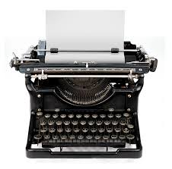
5. In Britain a car _________ __________ every twenty seconds? (manufacture)

6. Typewriters ___________ ____________ to help blind people to write?(design)

7. 1.3 billion Cokes ___________ ____________ every day? (drink)

8. The yoyo ____________ originally ___________ as a weapon in the jungles of the Philippines? (use)
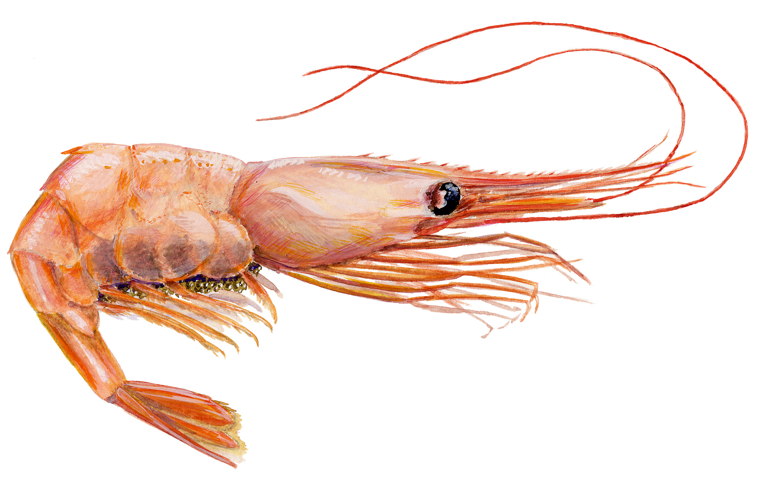
9. About 900 million Big Macs __________ ___________ each year? (eat)

10. The heart of a shrimp __________ ____________ in its head? (find)

11. Approximately 100 people ___________ ___________ by choking on a pen every year? (kill)
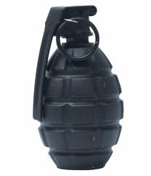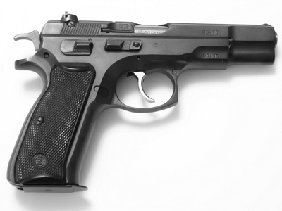
12. The electric chair __________ _____________by a dentist? (invent)

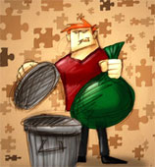
- BMW cars …..arent`t produced….. in Italy.
- A lot of newspapers …………………………………(send) all over the world.
- We should take care of our environment nowadays. Rubbish …………………………………. (throw) everywhere.
- Who ………………………………….... (the electric light/invent) by?
- Ball point pen ……………………………….(invent) by Laszlo Biro.
- My car ………………………………..(park) in the wrong area so they took it away.
- How do we get the bread?
When bread …………………………………..(take) out of the oven it is placed
on racks to cool. Then it is loaded onto lorries and in the shops it ………………………
(sell) to us.

The police haven’t found the missing dog. The missing dog ………………………………………
The captain chooses the basketball team. The basketball team …………………………………………….
We’ll sell most tickets on the day of the match. Most tickets ..................................................
They took the injured people to hospital. The injured people ……………………………………………….
People drink millions of cans of soft drinks. Millions of soft drinks……………………………………..
Somebody is cleaning the room at the moment. The room …………………………………………………..
You should see a specialist. A specialist .............................................................................
John was driving his car. John’s car ...............................................................................

Claude won THE QUIZZ COMPETITION. The quiz competition was won by Claude.
We have bought A HOUSE. ___________________________________________
My aunt took SOME PHOTOS. _________________________________________
The alarm will wake ME. ___________________________________________
Someone can carry THIS BOX. __________________________________________
The fog holds THE TRAFFIC. _________________________________________
The managers sign THE CHEQUES. ______________________________________

Millions of pounds’ worth of damage (1) has caused / has been cused by a storm which (2) swept / was swept across the north of England last night. The River Ribble (3) burst / was burst its banks after heavy rain. Many people (4) rescued /
were rescued from the floods by fire-fighters, who (5) received / were received hundreds of calls for help. Wind speeds (6) reached / were reached ninety miles an hour in some places. Roads (7) blocked / were blocked by fallen trees, and electricity lines (8) brought / were brought down, leaving thousands of homes without electricity. ˝Everything possible (9) is doing / is being done to get things back to normal,˝ a spokesman (10) said / was said.

