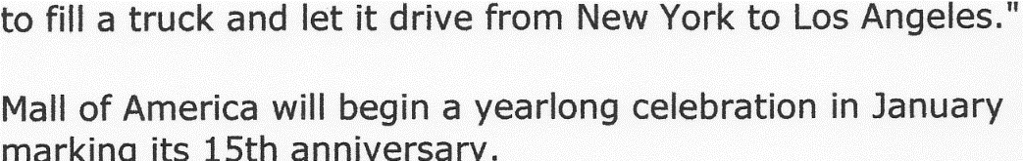
America´s Largest Mall Offers more than Shopping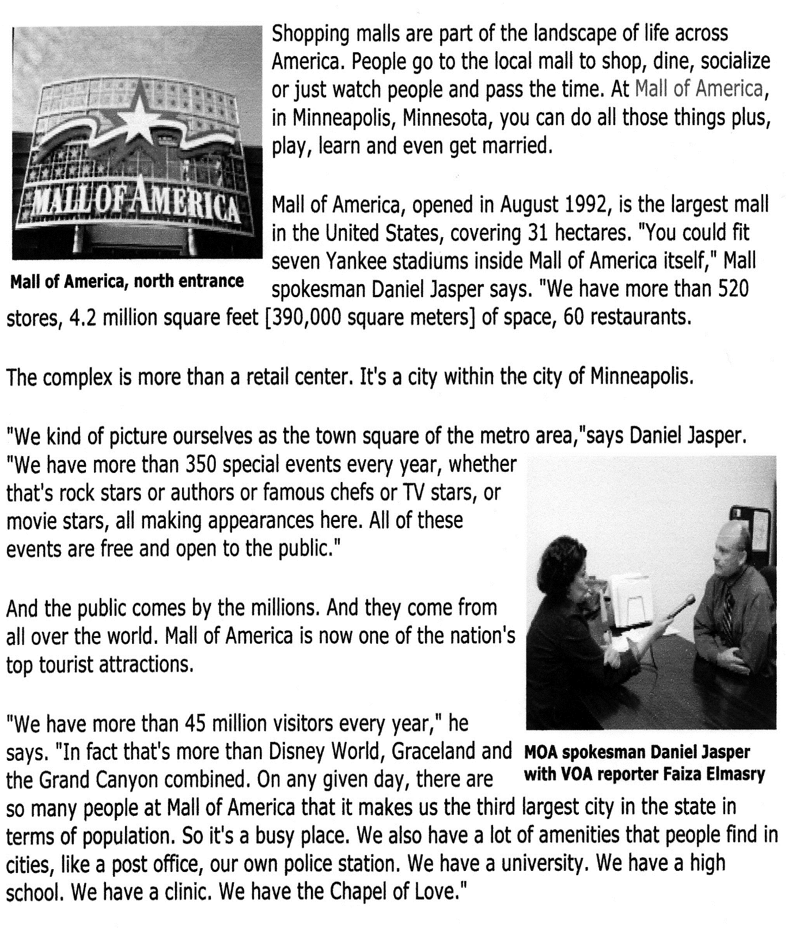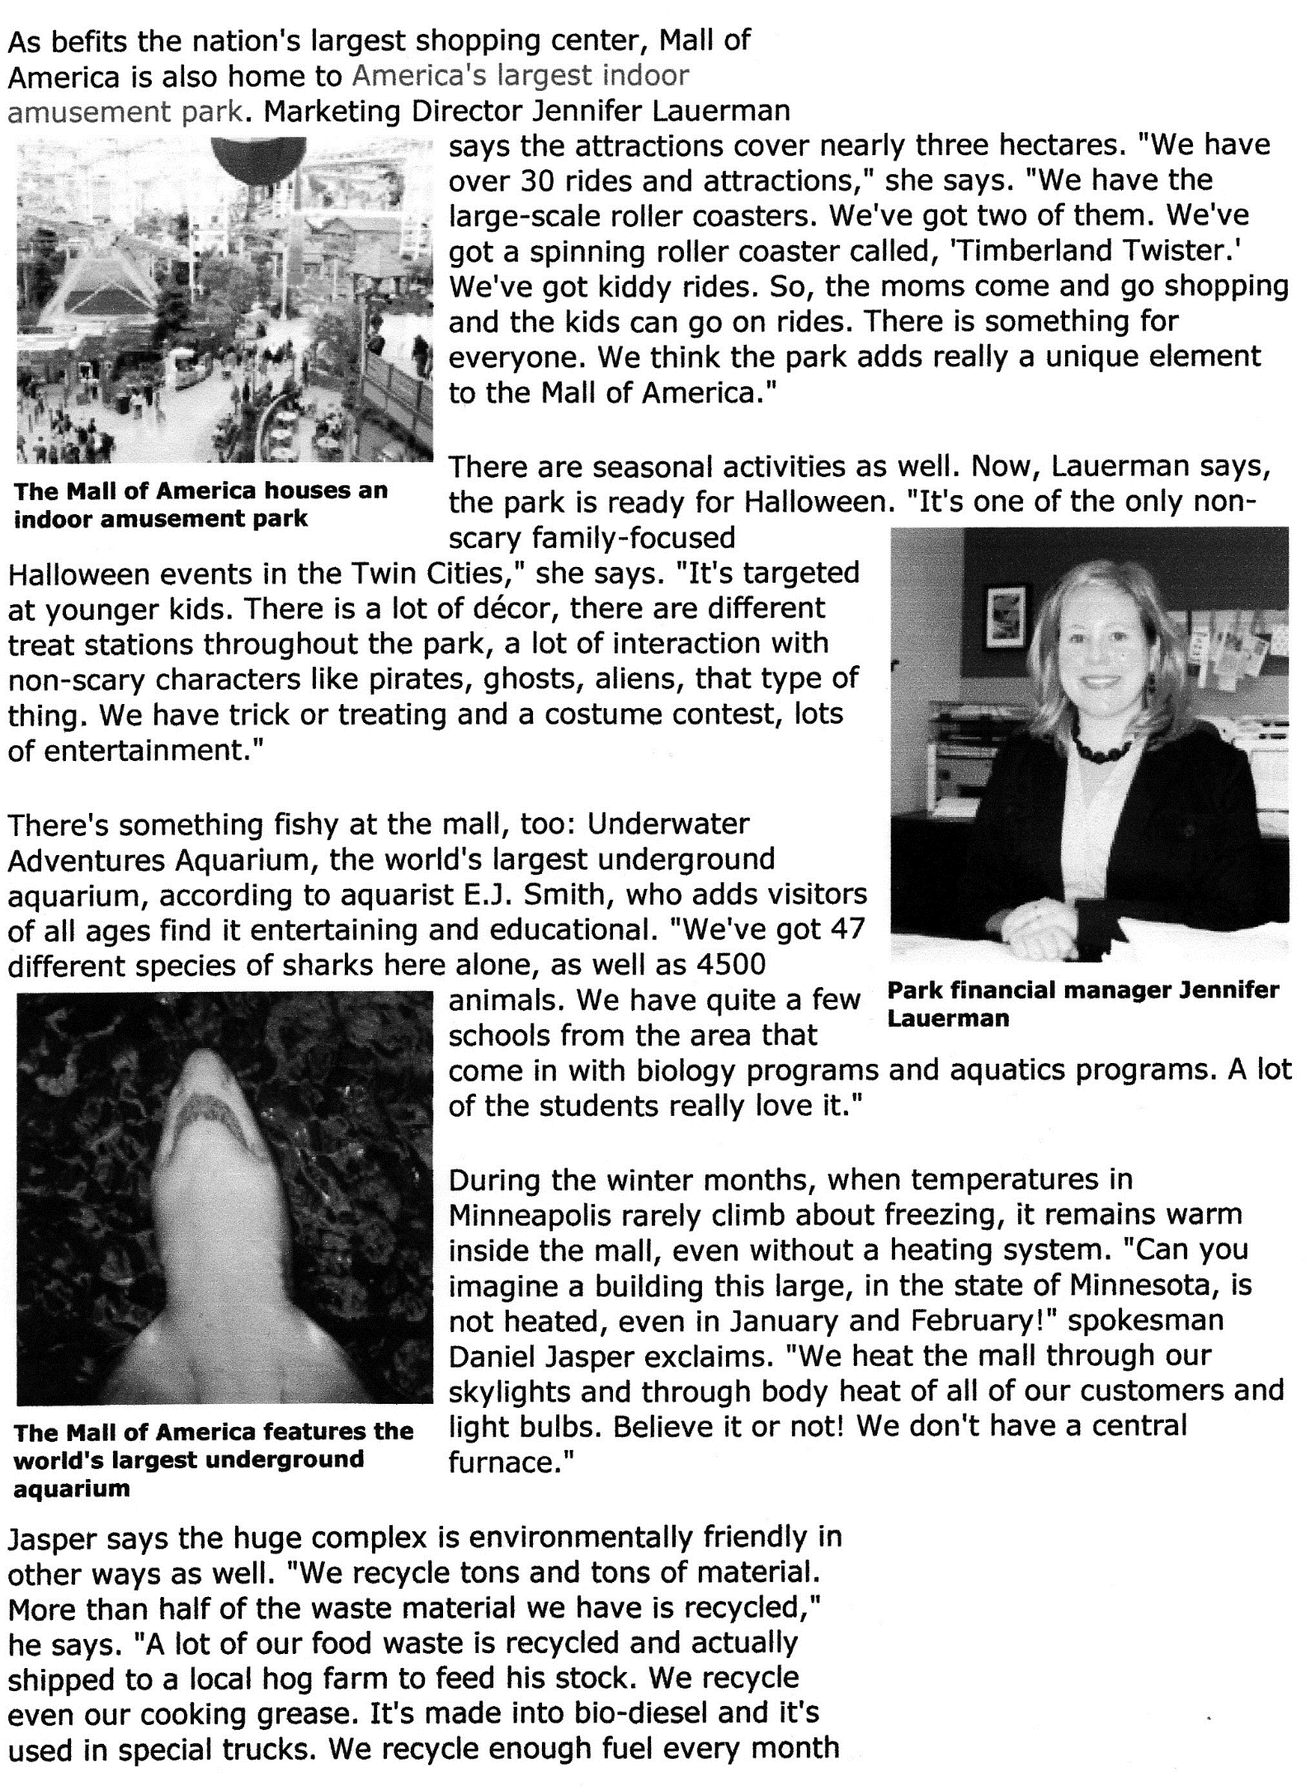

Read the text about the Mall of America and answer the following questions.

- What´s the name of the mall?
- Where is it situated?
- When did it open?
- How many diners does it house?
- How many stores can you find there?
- How many visitors do they have annually?
- Can a couple get married at the mall?
- What´s the most interesting thing for the children?
- How many shark species have they got?
- Do they have a central heating system? If no, why not?
- Why is the complex considered to be environmentally friendly?

Discuss in class.

Do you think it is romantic to get married at the mall?
Would you like to have such a big mall in Slovenia?
Discuss sections of the text and compare Slovenia and America. Where are the differences connected to shopping?

