Hello, dear 7th graders and greetings from Vrhnika!

I hope you and your families are happy and healthy. I know you miss school very much and probably cried the whole weekend because you have to stay at home. Luckily for you, I have many ideas about what you can do while we can’t see each other every day. Please check out my instructions every Monday, Tuesday, Wednesday and Thursday!

Your job for today is:
- Learn how to use online classrooms, forums and chatrooms.
- Let me know if you have any trouble.
- Read this letter and translate unknown words (remember, use, PONS and not Google Translate!
- Read the instructions for future work below and see if you understand everything. If you don’t understand, ASK ME.
- Choose your topic and let me know what it is! I opened a thread in the forum and you can let me know there or find me in the chatroom. If you’re still having trouble with the forum and the chatroom, your parents can e-mail me and I’ll try to help.
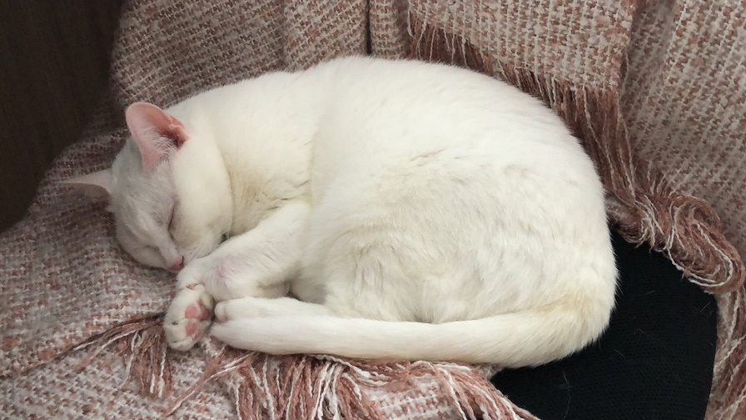
- Admire the daily picture of my cat.
PRESENTATION INSTRUCTIONS

This year, each of you is going to present a country. You can choose your own country and let me know in the forum or the chatroom. Each student must choose a different country, so choose quickly!
TOPIC: Countries
LANGUAGE: English
LENGTH: about 7 minutes
SUPPORT: a Powerpoint presentation or a poster

Your presentation should include:
- Basic information (capital city, inhabitants, language, religion, president ... )
- Interesting points from history (use the Past Simple tense!)
- Customs and traditions
- At least one celebrity
- At least 5 famous monuments or sights
- Some questions or an exercise for your classmates
You can of course do more than that, these are just some ideas to get you started.
Good luck and have fun with your presentation!
Teacher Martina
POMEMBNO: Sedmošolci ste že zelo spretni pri angleščini in večinoma ne potrebujete slovenskih navodil, vendar se vsakemu kdaj zatakne. Če česa ne razumeš ali nisi prepričan glede angleških navodil, me samo vprašaj in z veseljem ti bom pomagala!

