Hello, dear 8th graders and greetings from the faraway land of Vrhnika!

I hope you and your families are happy and healthy. I know you miss school very much and probably cried the whole weekend because you have to stay at home. I can’t even imagine your despair when you learned that there was no test on Friday! Luckily for you, I have many ideas about what you can do while we can’t see each other every day. Please check out my instructions every Monday, Thursday and Friday!

Your job for today is:
- Learn how to use online classrooms, forums and chatrooms.
- Let me know if you have any trouble.
- Read this letter and translate unknown words (remember, use, PONS and not Google Translate!)
- Read the instructions for future work below and see if you understand everything. If you don’t understand, ASK ME.
- Choose your topic and let me know what it is! I opened a thread in the forum and you can let me know there or find me in the chatroom. If you’re still having trouble with the forum and the chatroom, your parents can e-mail me and I’ll try to help.
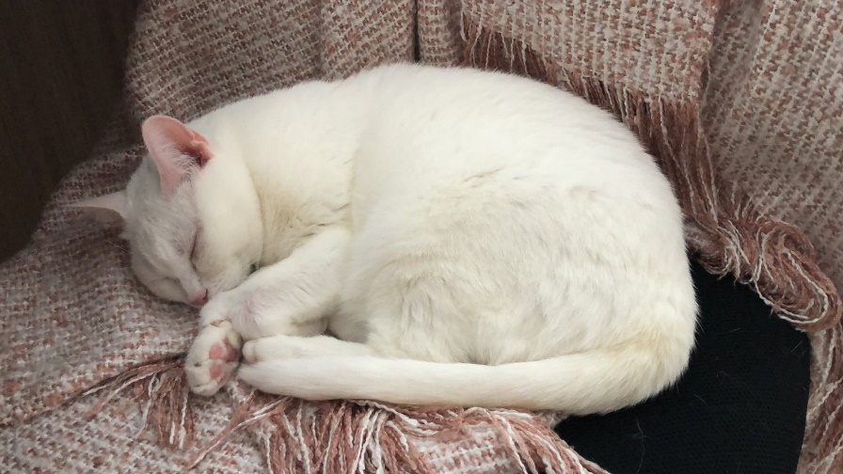
- Admire the daily picture of my cat.
PRESENTATION INSTRUCTIONS

This year’s presentations are going to be done in pairs. Thanks to the world’s most popular virus, I expect you to cooperate online, not to visit each other in person! Please choose your topic on the forum and let me know which pair of students wants to do which title. The rule is “first come, first serve”, so don’t wait too long!
General instructions:
TOPIC: Ecology related
LANGUAGE: English
LENGTH: at least 5 minutes of speaking each plus exercises
SUPPORT: a Powerpoint presentation or a poster
FOR YOUR CLASSMATES: include some questions, an exercise or another type of challenge

We’ll talk more about the presentations in the future and you can ask me anything you want on the forums. For now, stay health and safe. All best to you and your families!

Teacher Martina
POMEMBNO: Osmošolci ste že zelo spretni pri angleščini in večinoma ne potrebujete slovenskih navodil, vendar se vsakemu kdaj zatakne. Če česa ne razumeš ali nisi prepričan glede angleških navodil, me samo vprašaj in z veseljem ti bom pomagala!

