Hello, dear students!

I hope you are happy and healthy. I miss you and I can't wait to see you again. But for now, let's see what we can do at home!

Takole, za vsako uro angleščine boste od mene dobili navodila za delo in sliko moje mačke. Danes je na vrsti tale:

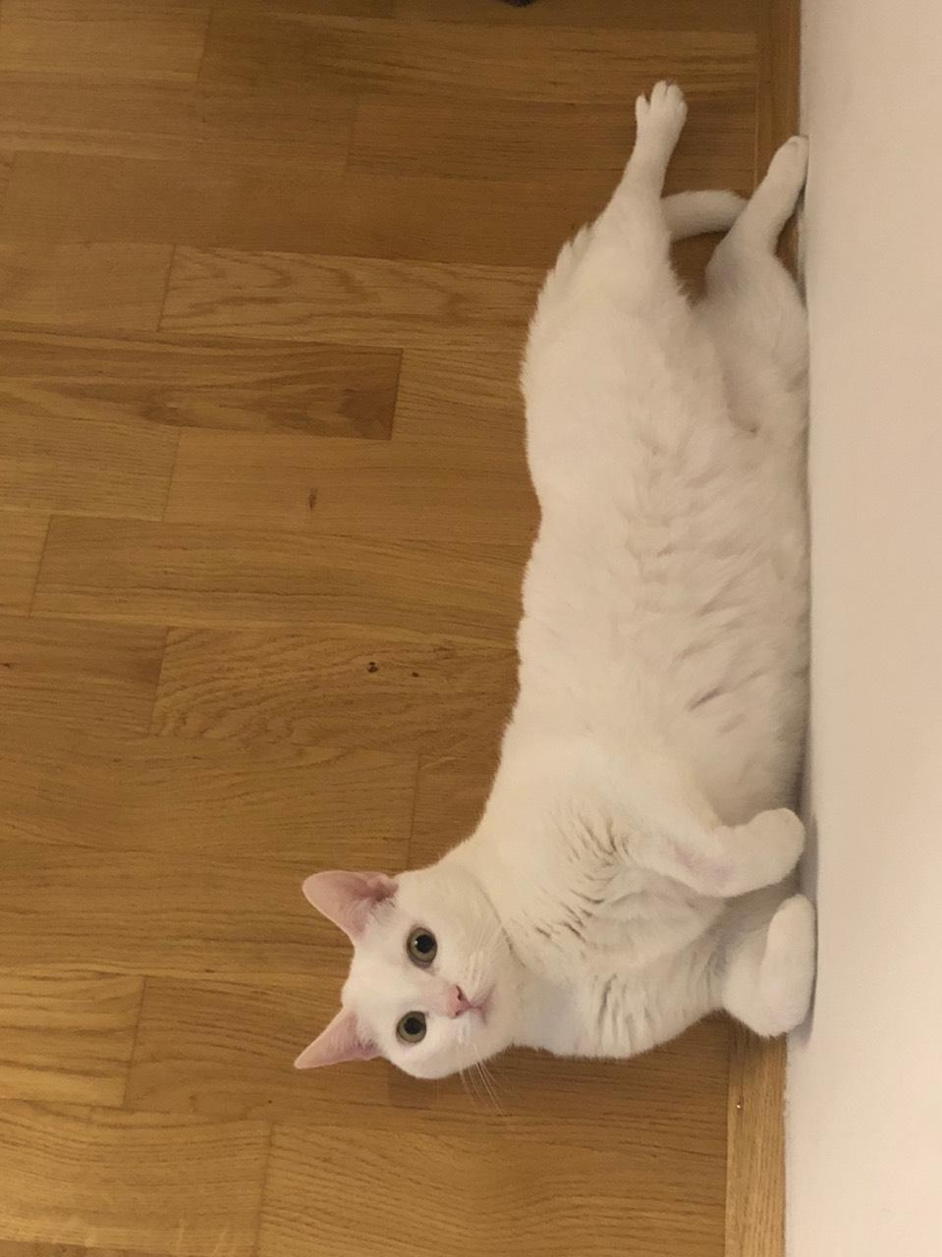

Danes pa, prosim, naredite naslednje.
- Malo se razglejte po spletnih učilnicah, forumih in klepetalnicah ter poiščite forum TJA 5.C, kjer se bomo lahko pogovarjali o angleščini ali celo v angleščini

- Preglejte domačo nalogo v DZ na str. 67/12. Rešitve so (vrstni red ni pomemben):
- Denis likes fish, but he doesn't like hamburgers.
- Denis likes milk, but he doesn't like coffee.
- Denis likes juice, but he doesn't like Coca-Cola / soda / fizzy drinks.
- Denis likes ice-cream, but he doesn't like cake.
- Denis likes lettuce, but he doesn't like pizza.
- Denis likes pineapple, but he doesn't like potato chips / fries.

- Iz učbenika na str. 68 prepiši pesmico DADDY'S MAKING DINNER v zvezek. Neznane besede poišči v slovarju in jih zapiši v zvezek. Uporabi PONS spletni slovar ali papirnati slovarček, izogibajmo pa se Google prevajaniku. Pridi na forum povedat, kakšna se ti je zdela pesmica!
- Reši nalogi b in c pod pesmico. Lahko ju prepišeš v zvezek ali v učbenik nalepiš listek.

Good luck and see you soon!
teacher Martina

