- Answer the question: What was for your homework? Odgovori na vprašanje: Kaj je bilo za domačo nalogo?
(Odgovor: V zvezek napisati naslov THE SMARTEST GIANT IN TOWN – KEY VOCABULARY in nato v stolpcu prepisati besede 1. in 2. naloge z učnega lista št. 26, ki ga imaš v mapi. Angleškim besedam je bilo potrebno pripisati tudi slovenski prevod.
PRIMER: a shirt – srajca
a belt - pas

- If your homework is not done yet, do it now.
Če domače naloge še nisi naredil(a), jo naredi zdaj.

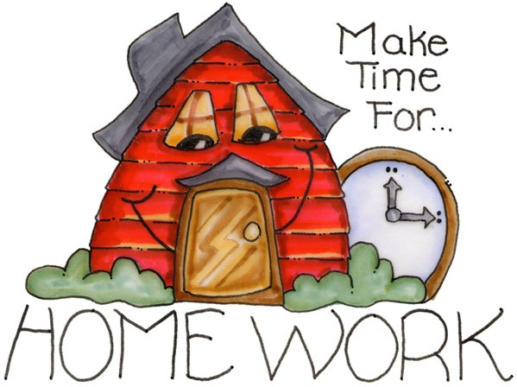


- Check your homework. Tick the correct words , and correct the wrong ones.
Preveri, da si pravilno naredil(a) domačo nalogo. Besede, ki so pravilne (tudi zapis) označi s kljukico , nepravilne pa popravi:

 | ENGLISH | SLOVENE
1 | a belt | pas
2 | sandals | sandali, opanki
3 | a tie | kravata
4 | a gown | halja
5 | socks | nogavice
6 | trousers | hlače
7 | a shirt | srajca
8 | shoes | čevlji
9 | a goat | koza
10 | a dog | pes
11 | a mouse | miš
12 | a giraffe | žirafa
13 | a fox | lisica
14 | a scarf | šal
15 | a sail | jadro
16 | a house | hiša
17 | a bog | močvirje, barje
18 | a boat | čoln
19 | a bed | postelja

- Click on the link below. Listen and read the story.
Klikni na spodnjo povezavo. Poslušaj in beri zgodbo.

https://www.youtube.com/watch?v=iGxl-OV9190

- Cut and order the story. Then glue it in your notebook. Don't forget to write the title.
Razreži in postavi odstavke v pravilni vrstni red. Pomagaj si z zgodbo pod točko 6.
Nato odstavke prilepi v zvezek. Ne pozabi napisati naslova.
Če zgodbe ne moreš natisniti, oštevilči odstavke v pravilnem vrstnem redu. Tisti, ki ste v petek bili v šoli, ste ta učna lista že dobili.

George had to hop along the road now, but he didn't mind. As he hopped, he sang to himself. Then he came to a campsite. Beside a tent stood a fox who was crying. It was his sleeping bag. It dropped in a puddle and was completely wet. George took off one of his socks with diamonds up the sides. The fox snuggled into it happily. It made a very fine sleeping bag.

George was a giant, the scruffiest giant in town. He always wore the same pair of old brown sandals and the same old patched-up gown. He wished he wasn't the scruffiest giant in town.

You gave a scarf
to a cold giraffe.
Your shirt's on a boat
as a sail for a goat.
Your shoe is a house
for a little white mouse.
One of your socks
is a bed for a fox.
Your belt helped a dog, who was
crossing a bog.
So here is a very
fine crown,
to go with the sandals and gown
of the KINDEST giant in town.

Outside his front door stood all the animals he had helped. They were carrying an enormous present. George untied the ribbon. Inside was a beautiful gold paper crown and a card. George put the crown on his head and opened the card. Inside, it said,

George hopped on, singing to himself. He came to a big squelchy bog. Beside the bog stood a dog who was howling. He couldn't get across, he kept getting stuck in the mud. George took off his smart new belt and laid it down over the bog. It made an excellent path. The dog could cross the bog.

But one day, George noticed a new shop. It was full of smart clothes. So he bought a smart shirt, a smart pair of trousers, a smart belt, a smart stripy tie, some smart socks with diamonds up the sides, and a pair of smart shiny shoes. He was now the smartest giant in town. George left his old clothes behind in the shop.

As George strode towards home, he sang to himself. He came to a river. On a boat stood a goat who was bleating loudly. The goat needed a new sail because the old sail was blown away by the wind. George took off his new white shirt and tied it to the mast of the goat's boat. It made a magnificent sail. The goat was very grateful.

He was about to go home when he heard a sound. On the pavement stood a giraffe who was sniffing sadly. The giraffe wished for a long and warm scarf because her neck was so very long and cold. George took off his stripy tie and wound it round and round the giraffe's neck. It made a wonderful scarf. The giraffe thanked him politely.

The wind started to blow, but George didn't mind. He hopped on, singing to himself when suddenly his trousers fell down! He was the coldest giant in town! He felt sad and shivery and not at all smart. He stood on one foot and thought. He decided he needed to buy some more clothes. He turned round and hopped all the way back to the shop. But when he got there, it was CLOSED! He sank down onto the doorstep and a tear ran down his nose. He felt as sad as all the animals he had met on his way home. Then, out of the corner of his eye, he saw a bag with something familiar poking out of the top. George took a closer look… It was his old gown and sandals! George put them on. They felt wonderfully comfortable. He was the cosiest giant in town dancing back home along the road.

George strode on, singing to himself when he came to a tiny ruined house. Beside the house stood a white mouse with lots of baby mice. They were all squeaking. Their house burned down and now they had nowhere to live. George took off one of his shiny shoes. The shoe made a perfect home for them. The mice were very happy.

- Here you can check the order of the story.
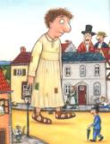
Tukaj lahko preveriš, če si odstavke razvrstil(a) pravilno.

THE SMARTEST GIANT IN TOWN no. 27
George was a giant, the scruffiest giant in town. He always wore the same pair of old brown sandals and the same old patched-up gown. He wished he wasn't the scruffiest giant in town.
But one day, George noticed a new shop. It was full of smart clothes. So he bought a smart shirt, a smart pair of trousers, a smart belt, a smart stripy tie, some smart socks with diamonds up the sides, and a pair of smart shiny shoes. He was now the smartest giant in town. George left his old clothes behind in the shop.
He was about to go home when he heard a sound. On the pavement stood a giraffe who was sniffing sadly. The giraffe wished for a long and warm scarf because her neck was so very long and cold. George took off his stripy tie and wound it round and round the giraffe's neck. It made a wonderful scarf. The giraffe thanked him politely.
As George strode towards home, he sang to himself. He came to a river. On a boat stood a goat who was bleating loudly. The goat needed a new sail because the old sail was blown away by the wind. George took off his new white shirt and tied it to the mast of the goat's boat. It made a magnificent sail. The goat was very grateful.
George strode on, singing to himself when he came to a tiny ruined house. Beside the house stood a white mouse with lots of baby mice. They were all squeaking. Their house burned down and now they had nowhere to live. George took off one of his shiny shoes. The shoe made a perfect home for them. The mice were very happy.
George had to hop along the road now, but he didn't mind. As he hopped, he sang to himself. Then he came to a campsite. Beside a tent stood a fox who was crying. It was his sleeping bag. It dropped in a puddle and was completely wet. George took off one of his socks with diamonds up the sides. The fox snuggled into it happily. It made a very fine sleeping bag.

George hopped on, singing to himself. He came to a big squelchy bog. Beside the bog stood a dog who was howling. He couldn't get across, he kept getting stuck in the mud. George took off his smart new belt and laid it down over the bog. It made an excellent path. The dog could cross the bog.
The wind started to blow, but George didn't mind. He hopped on, singing to himself when suddenly his trousers fell down! He was the coldest giant in town! He felt sad and shivery and not at all smart. He stood on one foot and thought. He decided he needed to buy some more clothes. He turned round and hopped all the way back to the shop. But when he got there, it was CLOSED! He sank down onto the doorstep and a tear ran down his nose. He felt as sad as all the animals he had met on his way home. Then, out of the corner of his eye, he saw a bag with something familiar poking out of the top. George took a closer look… It was his old gown and sandals! George put them on. They felt wonderfully comfortable. He was the cosiest giant in town dancing back home along the road.
Outside his front door stood all the animals he had helped. They were carrying an enormous present. George untied the ribbon. Inside was a beautiful gold paper crown and a card. George put the crown on his head and opened the card. Inside, it said,
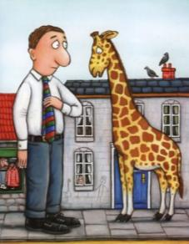
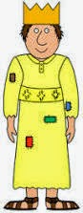
You gave a scarf
to a cold giraffe.
Your shirt's on a boat
as a sail for a goat.
Your shoe is a house
for a little white mouse.
One of your socks
is a bed for a fox.
Your belt helped a dog, who was
crossing a bog.
So here is a very
fine crown,
to go with the sandals and gown
of the KINDEST giant in town.

