16. 3. 2020 | TJA – 6. razred | The Time Machine 2 uri

Dear pupil,

Carefully follow the instructions and I am certain you will manage to complete all the tasks.

Your English teacher

Look at the picture. This is a time machine. Imagine you are a time traveller. Answer the questions below.
Oglej si sliko. To je časovni stroj. Predstavljaj si, da si popotnik v času. Odgovori na spodnja vprašanja.
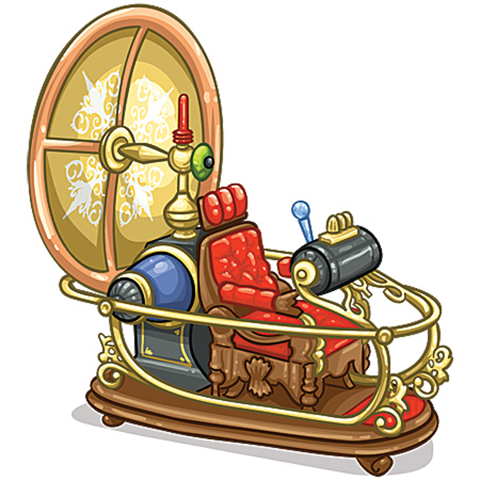
- Which year would you travel to? Would you go back into the past (= preteklost) or would you travel into the future (= prihodnost)? Why?
- What can you see/ hear/ smell?

Have you heard of H. G. Wells?
Read a few facts about him in your book, p. 118, ex. 7 a.
Si že slišal/-a za H. G. Wellsa?
V učbeniku, str. 118, nal. 7 a, preberi nekaj dejstev o njem.

Now do ex. b, p. 119. Make sure you read the instructions. If you aren’t sure, use the glossary. You can also find the glossary online: http://www.e-gradiva.com/dokumenti/T6/T6/SLOVAR.pdf
Sedaj naredi nal. b na str. 119 – preberi navodilo. Če nisi prepričan, si pomagaj s slovarčkom (priložen v delovnem zvezku). Najdeš ga tudi na spletu: http://www.e-gradiva.com/dokumenti/T6/T6/SLOVAR.pdf

Take a look at the picture on p. 119. Answer the questions. You don’t have to write anything down.
Oglej si sliko na str. 119. Odgovori na vprašanja. Ničesar ti ni treba zapisati.

What can you see in the picture? (Describe it.) Which season is it? What year is it? What are the people doing?

Now read the text (c) and “replace” the pictures with words.
Sedaj preberi besedilo (c) in “nadomesti” slike z besedami.
Turn to page 120, take a look at the picture and answer the same questions you did with the previous picture.
Obrni na str. 120, oglej si sliko in odgovori na ista vprašanja kot pri prejšnji sliki.

Now read the text and “replace” the pictures with words.
Sedaj preberi besedilo in “nadomesti” slike z besedami.

Do ex. e – in the text, underline the Present Continuous forms.
Naredi nalogo e – v besedilu podčrtaj oblike Present Continuous.

Example: The Time Traveller is sitting in his time machine. He is looking through the window. He is looking at the park outside. It is spring and the trees are green. People are walking up and down the street…

Bodi pozoren. V ležeče tiskani povedi, čas ni Present Continuous, temveč je Present Simple.

Then in your notebook put down the title Exercise. Write down the underlined verbs in their basic form and use them in a story.
Nato v zvezek zapiši naslov Exercise. Izpiši podčrtane glagole v njihovi osnovi obliki in jih uporabi v zgodbi.

Example: sit, look, walk…

It is a beautiful sunny day. Sally is walking in the park. She is looking around. An old couple is sitting on the bench…
(Lahko nadaljuješ ali pa si izmisliš svojo zgodbico.)

Open your book on p. 121 and read the text in ex. 8 a. Imagine you are The Time Traveller. In your notebook, write down the title The Time Traveller in 1990 and say what is happening. Start your story as given.
Odpri učbenik na str. 121 in preberi besedilo v nal. 8 a. Predstavljaj si, da si The Time Traveller. V zvezek zapiši naslov The Time Traveller in 1990 in zapiši, kaj se dogaja. Začni svojo zgodbo kot je dano.

It is 1990 now. Many things are different. Instead of an old house, I can see a tall building. There are 4 floors and people are doing different things. The woman in room 1 is talking on the phone and the family in room 2 is watching television…

Tu pa je rešitev naloge b in c.

b)
6 2
10 5
8 12
13 7
1 3
11 9
4

c)
str. 119: window / trees / street / dress / first / white / happy / time machine
str. 120: time / horses / house / kitchen / cards / daughter

6. a-razred:
Read the explanation of The Present Continuous Tense in your book at p. 122 and the notes in your notebook.
Preberi razlago Present Continuous časa v učbeniku na str. 122 in zapiske v zvezku.

6. b-razred:
Read the explanation of The Present Continuous Tense in your book at p. 122 and make notes in your notebook. Put down the title Present Continuous and include the following cues.
Preberi razlago Present Continuous časa v učbeniku na str. 122 in si naredi zapiske v zvezek. Napiši naslov Present Continuous in vključi spodnje iztočnice:

Present Continuous

Tvorba:
trdilni stavki
nikalni stavki
vprašalni stavki

Raba:
dejanja, ki se dogajajo ta trenutek

Pravopisna pravila pri zapisu končnice –ing:
glagoli, ki se končajo na -e
nekateri kratki glagoli podvojijo končni soglasnik

You have successfully completed your first English lesson on your own.
Uspešno si končal/-a svojo prvo samostojno učno uro.

Za dodatna vprašanja sva na voljo učiteljici angleščine:
- Vesna Možek Oblak: vesna.mozekoblak@ucitelj.oskm.si
- Ksenija Mrzel: ksenija.mrzel@ucitelj.oskm.si

